Tamweel Aloula Financing Company
KSA
Consolidated BSDD - Murabaha
Islamic Finance Module-Transact
Date: February 17, 2025



Document History
Author | Version | Date | Description
Farhan Ullah Khan | V1.0 | 17th FEB 2025 | BSDD
Kashif Umair | V1.0 | 18th FEB 2025 | Reviewed and updated

Table of Contents
1. Scope of the Document 6
2. Navigation Tips 6
3. Glossary 7
4. Agreed LMS process functionalities 7
4.1 Step 1: Offer Acceptance: 7
4.2 Step 2: Credit Admin Function (LOS) 7
4.3 Step 3: Contract Stage: 8
4.4 Step 4: Promissory Note Stage: 8
4.5 Step 5: IVR Authentication: 8
4.6 Step 6: Transact GL Entries: 8
4.7 Step 7: Repayment Schedule & Tawtheeq: 8
4.8 Cancellation During Cooling Period: 8
5. Existing Functionalities 8
5.1 IS.PARAMETER (WS03-MUR-01) 8
5.2 Asset Capture (WS03-MUR-02) 11
5.3 IS Contract Booking (WS03-MUR-03) 12
5.3.1 Input New Contract 13
5.3.2 Accounting Entries – IS Contract 15
5.3.2.1 Approval Stage 15
5.3.2.2 Purchase Stage 15
5.4 Payment to Vendor (WS03-MUR-04) 16
5.4.1 Accounting Entry - Payment to Vendor 18
5.5 Credit Arrangement 19
5.5.1 Arrangement Creation (WS03-MUR-05) 19
5.5.2 Payment Schedule (WS03-MUR-06) 22
5.5.3 SAMA Payment Schedule (WS03-MUR-07) 22
5.5.4 Arrangement Overview 23
5.5.5 Accounting Entries - AA Arrangement 24
5.6 Maintenance Activities 24
5.6.1 Cancellation within Cooling Period (WS03-MUR-08) 24
5.6.2 Deferment of Instalments (WS03-MUR-09) 32
5.6.3 Early Pay off (WS03-MUR-010) 37
5.6.4 Write Off (WS03-MUR-11) 45
5.6.5 Partial Settlement (WS03-MUR-12) 49
5.6.5.1 AA - Compression Payment 49
5.6.5.2 AA – Principal Decrease 56
5.7 Restructuring (WS03-MUR-13) 64
5.7.1 Request Stage 64
5.7.2 Approval Stage 65
5.7.3 Purchase Stage 66
5.7.4 Arrangement Booking 67
5.7.5 Commodity Restructuring Stage 68
5.7.6 Financial Entries 70
5.8 Enquiries (WS03-MUR-14) 71
6. Deltas 74
7. Detailed Description of Deltas 75
7.1 List of Vendors - WS03-MUR-04-01 75
7.2 Validation for sufficient funds - WS03-MUR-02-01 75
7.3 Maintenance Activities - WS03-MUR-09-01 75
7.4 Assets Details - WS03-MUR-02-02 76
7.5 E-Invoice for VAT - WS03-MUR-05-01 76
7.6 STMT Transaction - WS03-MUR-05-02 77
7.7 Advance/Partial Payment - WS03-MUR-12-01 77
7.7.1 Worksheet details: 77
7.8 Limit Attachment before Arrangement -WS03-MUR-05-03 77
7.9 Discount - WS03-MUR-05-04 77
7.9.1 Worksheet details: 77
7.10 Cooling period Cancelation - WS03-MUR-08-01 78
7.11 Reversal of Admin fee - WS03-MUR-05-05 78
7.12 Straight Through Process - STP - WS03-MUR-02-03 78
7.13 Restructuring - WS03-MUR-13-01 79
7.14 Offer Letter, Contract Generation and Other Letters- WS03-MUR-02-04 79
7.14.1 Worksheet details: 79
7.15 Post Write-Off Recovery- WS03-MUR-11-01 79
7.16 Bullet Payment and EPC (Early Payoff Charges) WS03-MUR-10-06 80
7.17 File Upload of Repayments through IBFT – WS03-MUR-05-06 80
7.17.1 Worksheet details: 80

Scope of the Document
The scope of this document is to provide users with end-to-end functionality of Murabaha product in Transact along with deltas noted during onsite BPR session. This document has two main sections. Section -5 is existing functionalities that explains end to end journey of LMS with respect to subject product. The other section-7 explains the deltas. Each existing functionality has a reference number that has prefix as WS03, for instance WS03-PRODUCT CODE-PROCESS NO. (WS03-MUR-01). Whereas on delta if any gap has been highlighted for the specific existing functionality, then it will be marked as WS03-PRODUCT CODE-PROCESS NO. SEQUENCE (WS03-MUR-01-01).
The pre-requisite of this document is to review agreed end-to-end process flow from LOS to LMS. This document also refers some working sheets that were finalized during onsite BPR session. Under each existing functionality or Delta there is a separate heading named as “Worksheet details” which will cite the reference document / sheet name.

Navigation Tips
This button refers to ‘Validate’ a record on T24. It is placed on top of the screen while input of any transaction on T24. After filling out all mandatory and necessary information, user can press this button to check for core errors or any missing component on the record.
This button refers to ‘Commit’ a record on T24. This button is pressed to make the record part of T24.
This button is used to ‘Delete’ the record. (Only unauthorized records can be deleted from the system)
This button is used to ‘Authorize’ the record. Only upon Authorization marking the record is made the part of LIVE file.
This Button is used to put the record on ‘Hold’.

Glossary
Abbreviations | Description
CBS | Core Banking System
BRD | Business Requirement Document
BSDD | Business Solution Design Document
BPR | Business Process Review
IS.CONTRACT | Islamic Finance Contract
AA | Architectural Arrangement (Loan)
WS | Workstream
STP | Straight Through Process
CUC | Customer
LOS | Infinity or new digital
LMS | Transact

Agreed LMS process functionalities
Please refer to ProcessFlow-TA-Murabaha-v1.3.3
Process Cycle Overview (3 Working Days)

Step 1: Offer Acceptance:
- Customers have 24 hours to accept the offer.
- Actions required: Admin fee payment with VAT (if applicable and was generated in E2E process flow).
- This process has expiry duration of 24 hours

Step 2: Credit Admin Function (LOS)
- Purchase Order (PO) generation by the Credit Admin (LOS) for PO base financing.
- Voucher details to be input by the Credit Admin (LOS) for Voucher base financing.

Step 3: Contract Stage:
- Contract is generated and signed by the customer via ND.
  - Reversals (if applicable): Admin fee with VAT in case customer rejects at any above stages
  - The process 4.2 and 4.3 have expiry duration of 48 hours.

Step 4: Promissory Note Stage:
- Creation and acceptance of the Promissory Note by the customer via NAFITH.
  - Reversals (if applicable): Down payment and admin fee.

Step 5: IVR Authentication:
- Customers must authenticate via IVR.
- Reversals (if applicable): Admin fee and Promissory Note.

Step 6: Transact GL Entries:
- Asset Purchase
- IS Contract

Step 7: Repayment Schedule & Tawtheeq:
- Repayment Schedule on AA Arrangement (APR generation).

Cancellation During Cooling Period:
- If the process is cancelled within the cooling-off period means after disbursement, the following reversals are Required:
  - Promissory Notes.
  - Tawtheeq Registration.

Existing Functionalities

IS.PARAMETER (WS03-MUR-01)
IS.PARAMETER is the parameter table to define the Islamic Banking product related features.
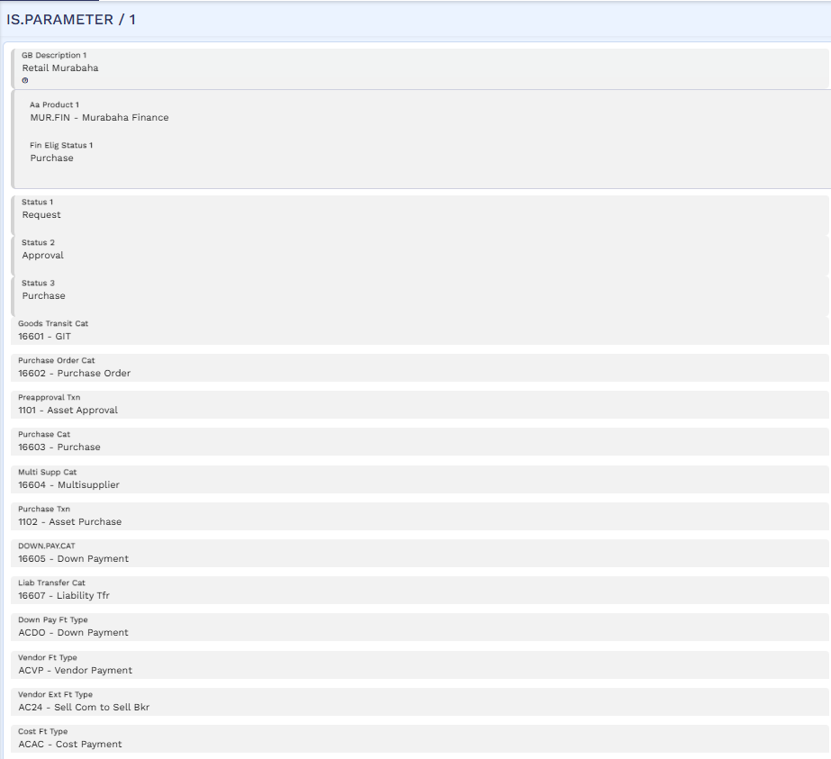
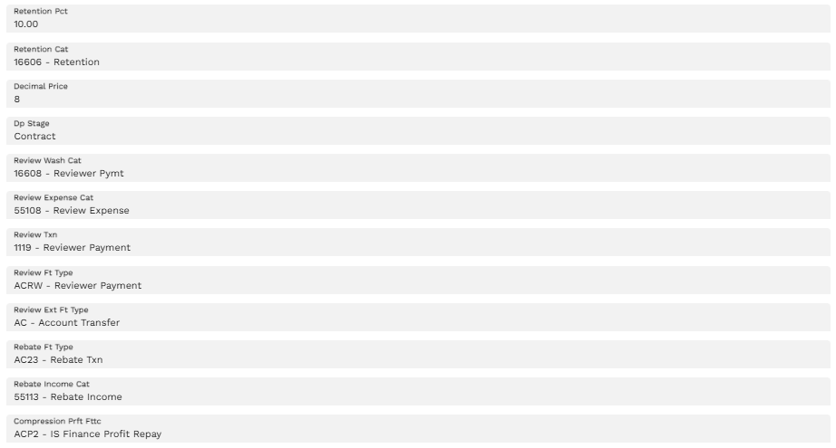

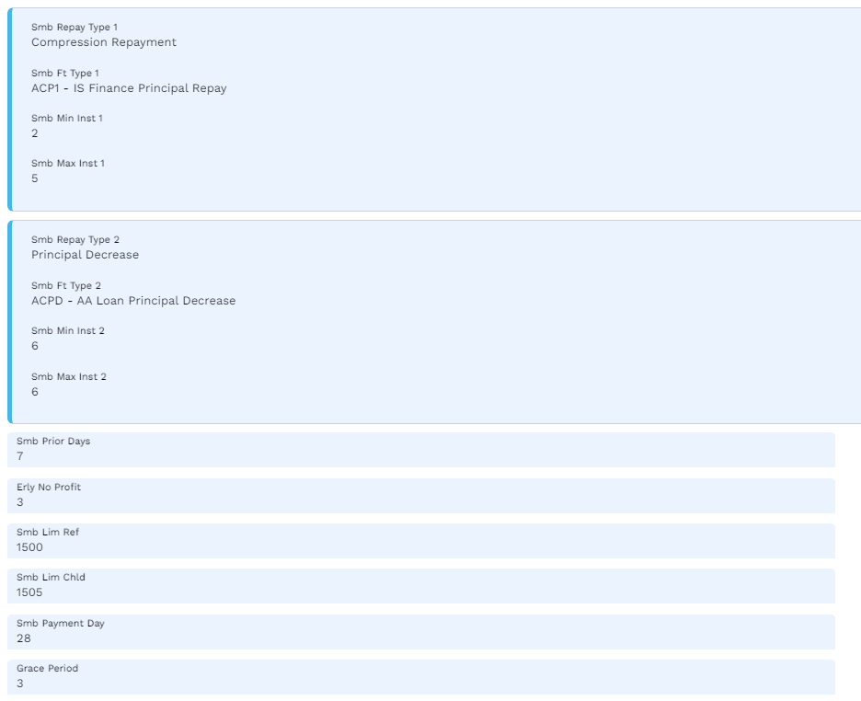

Asset Capture (WS03-MUR-02)
This table capture the details of assets to be financed. Below are mandatory fields that needs to be input by user. Upon authorization of asset capture this record will be available to record IS contract.
FIELDS | INPUT | Definition
Customer | "200027" | CIF ID
Currency | “SAR” | Country Currency
Vendor | “Vendor CIF” | Vendor who buy the asset
Unit Price | “250,000” | Price of the asset
Asset Description | “Nissan Patrol” | Description of the purchasing asset
Asset Short Title | Nissan Patrol 6th Generation | Asset short description
For other fields will
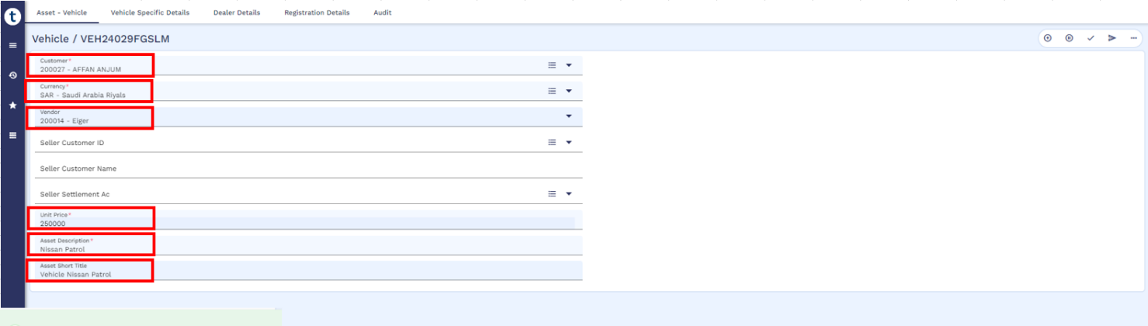

IS Contract Booking (WS03-MUR-03)
The application is used to record all information pertaining to financing of assets. The entire workflow of the product with different statuses is captured in this application. The contract evolves into different statuses like REQUEST, APPROVAL, PURCHASE based on the workflow defined in the product parameter file IS.PARAMETER.
Below fields will need to be input by user or integrated. In case of TA Ijarah, the below process is automated and will be generated through LOS.
Transcript | Data | Description
Customer | 200027 | CIF ID
Product | 3 | Product ID as per IS Parameter.
Status Value Date | 29 Jan 2024 | Date on which the Status is effective. Defaulted to the date given in the field VALUE.DATE.
Currency | SAR | CURRENCY
Value Date | 29 Jan 2024 | Value date of contract
GB Asset Description | Vehicle Nissan Petrol | The Description of the contract or the Asset being captured.
Request Amount | 250,000 | Finance Amount requested by customer.
Commodity.1 | 1 – Vehicle | Commodity / Assets to be purchased.
Unit Price.1.1 | 250,000 | Unit Price pf commodity or assets being purchased.
Purchase Quantity.1.1 | 1 | This field specifies the quantity of the asset being requested.
Customer Account | 2000000453 | Repayment Account

Input New Contract
Request Stage
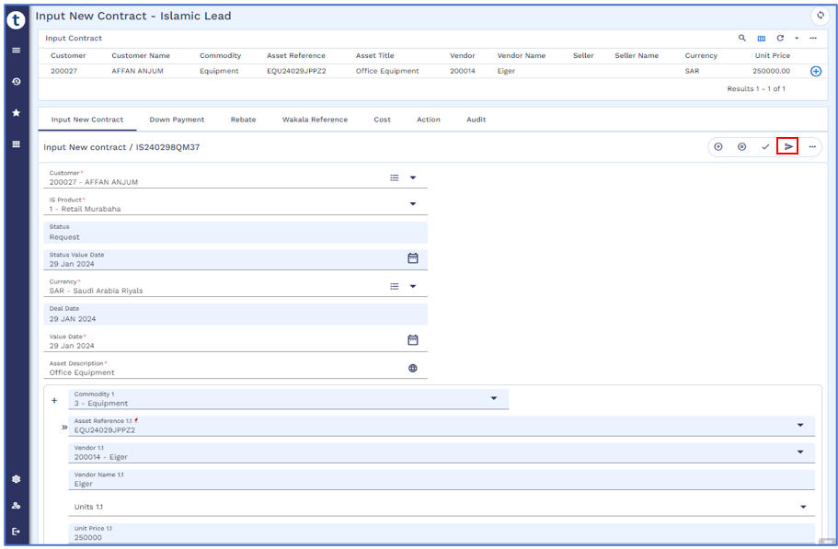
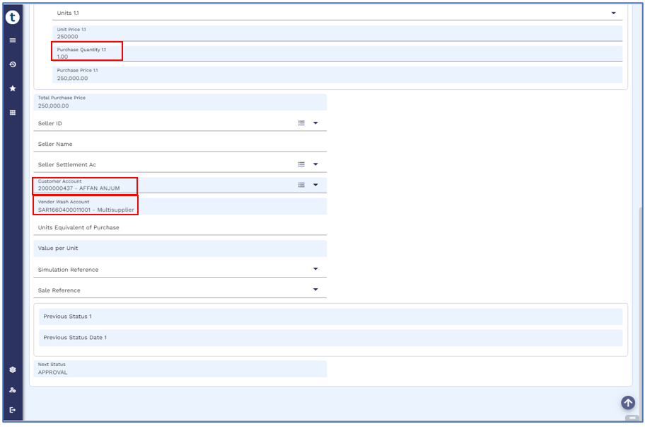
Approval Stage
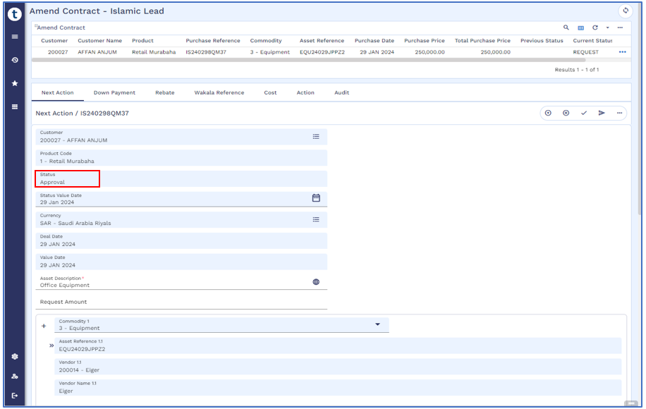
Purchase Stage
Once the contract is authorized then it will be forwarded to next stage of “Purchase” as defined in IS Parameter.
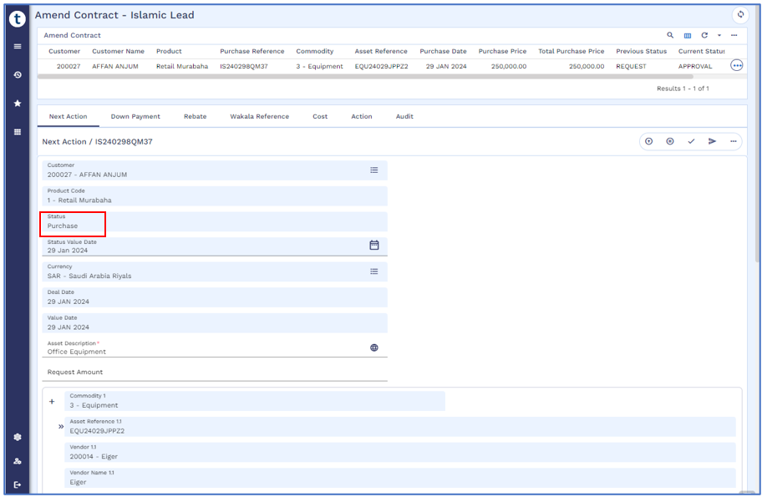

Accounting Entries – IS Contract

Approval Stage
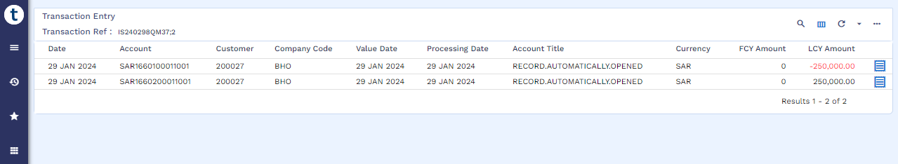

Purchase Stage
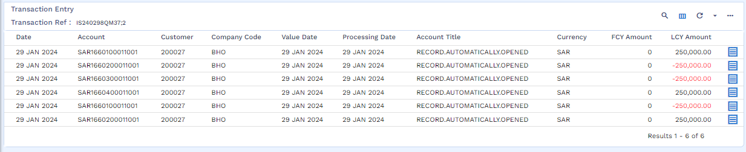

Payment to Vendor (WS03-MUR-04)
Steps of setup Vendor in Transact are as follows:
- Open CIF of the Vendor
- Open Account of the Vendor
- Tag CIF and Account in the Vendor Management Setup
Vendor Management
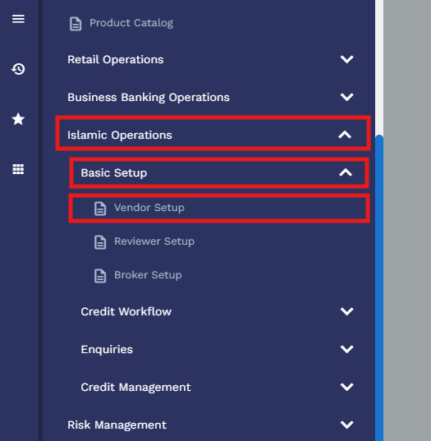
Add CIF of Vendor as stated in point 1 above, in the Vendor Setup From
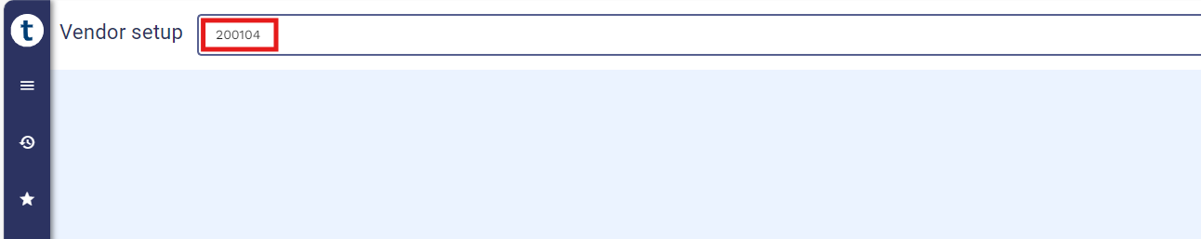

Then add Vendor Related Details, e.g. Name, Company, Currency and then add Vendor account in the account field as stated in point 2 above.
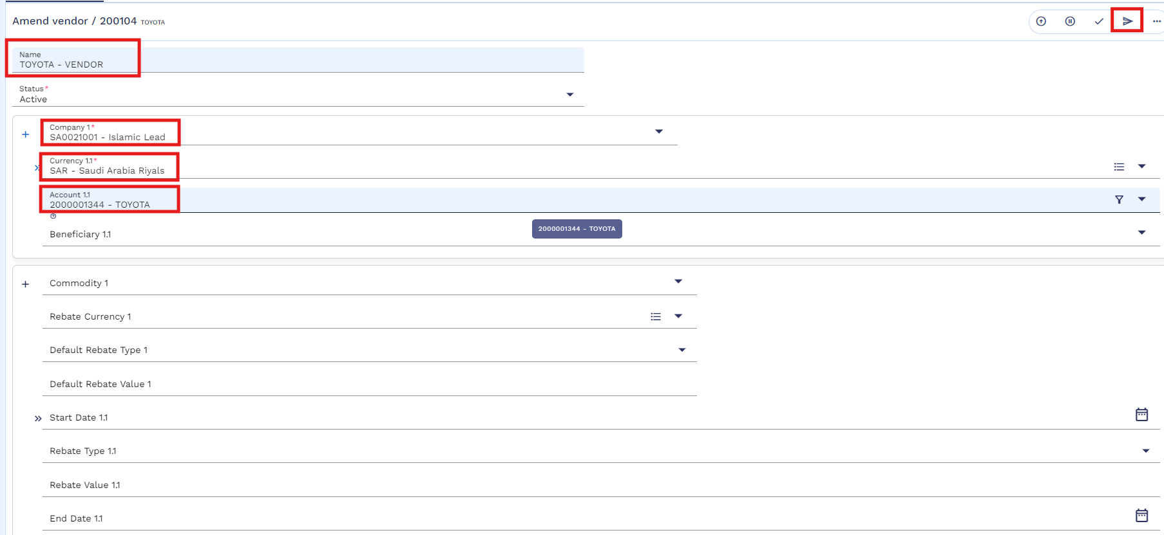
In order to make the payment to asset vendor user needs to execute FT. Below fields that need to be input by user to execute vendor payment FT. In case of TA this process is automated. Once this transaction is executed, a payable to vendor is generated to a pool account from where TA finance team can execute IBFT.
Transcript | Data | Description
Customer No | 200027 | Customer CIF ID
Contract Reference | IS24029ZYNDP | IS Contract # against which asset purchase is made.
Asset Reference | VEH24029VMG2L | Valid asset reference record against IS contract initiated.
Debit Amount | 250,000 | Amount to be paid to asset vendor.
Credit Account | 2000000143 | Vendor account number.
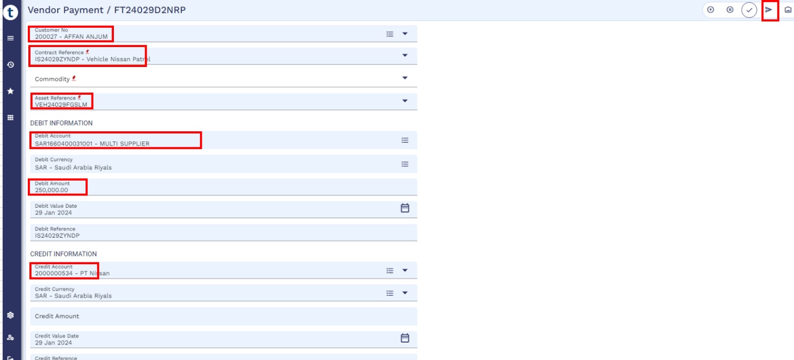

Accounting Entry - Payment to Vendor

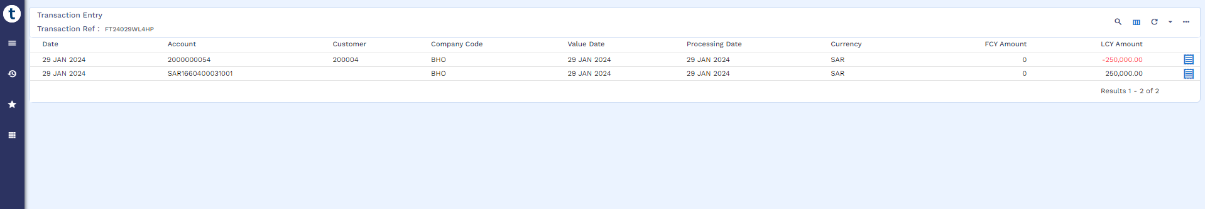

Credit Arrangement

Arrangement Creation (WS03-MUR-05)
Upon the receipt of finance asset, AA Arrangement will be booked in order to deliver the asset to customer. Moreover, repayment schedule will also be generated at this time along with APR
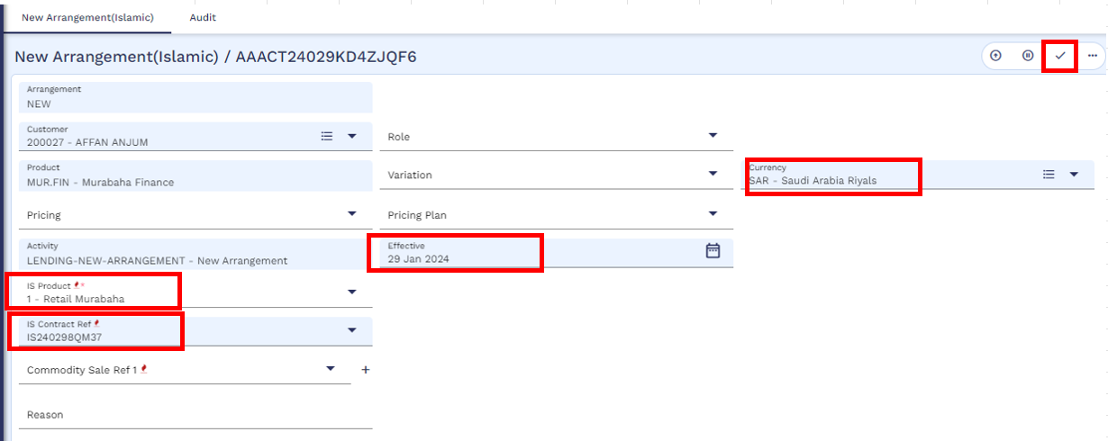
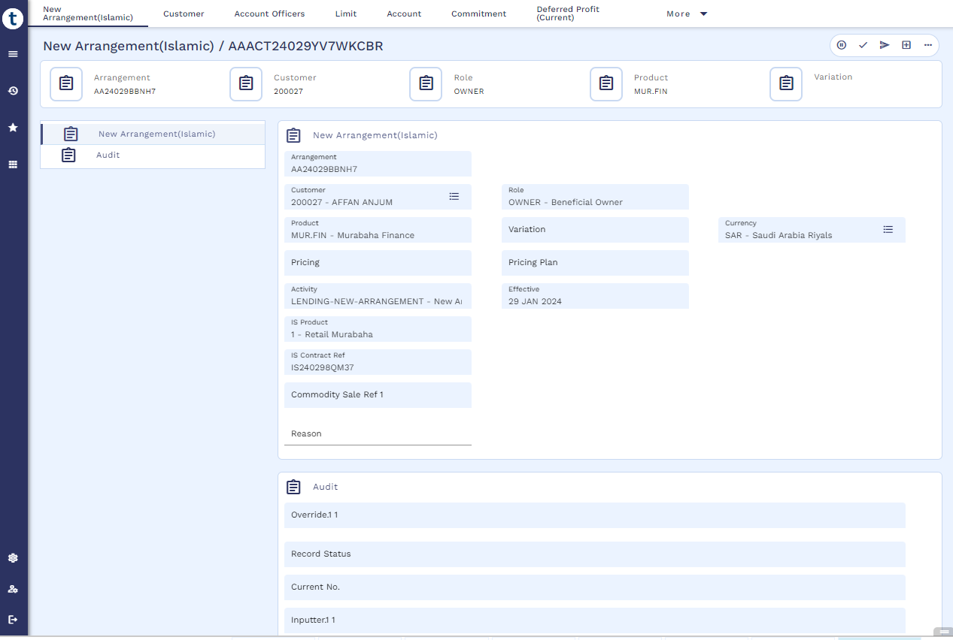
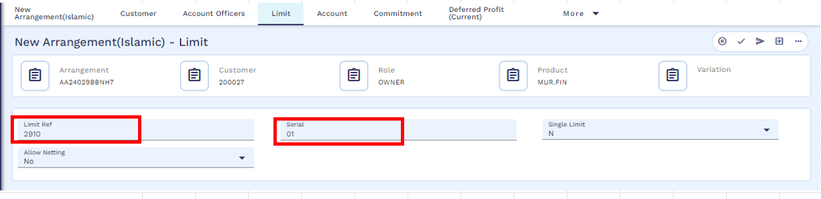

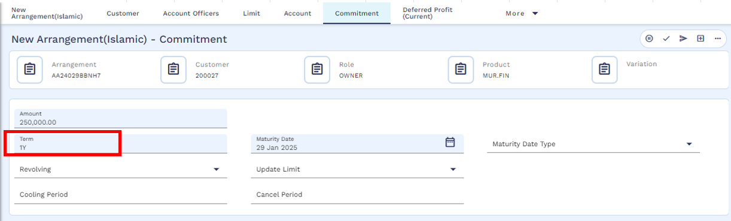
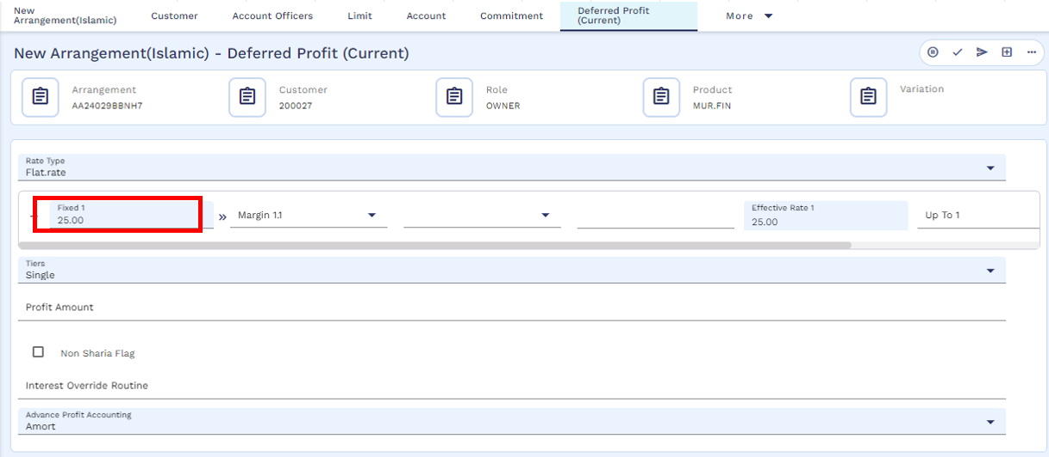
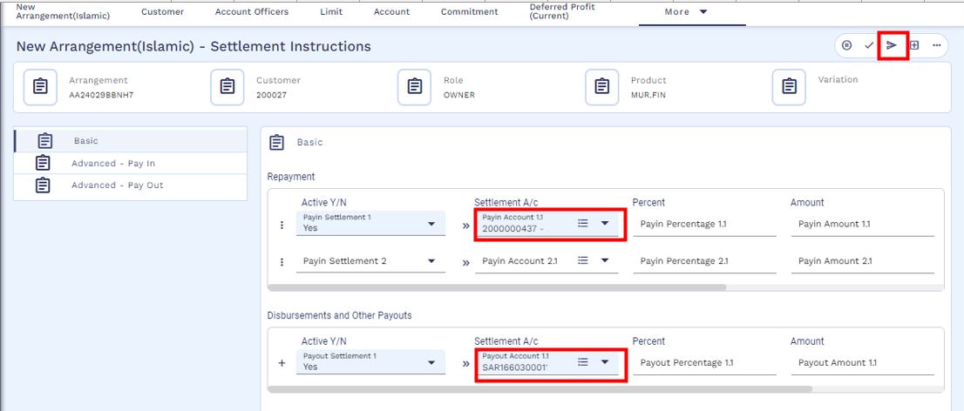
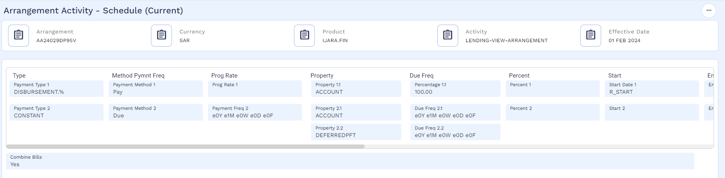

Payment Schedule (WS03-MUR-06)
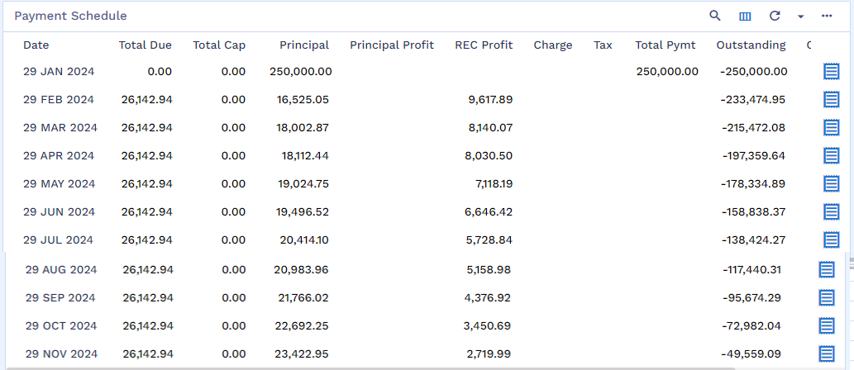

SAMA Payment Schedule (WS03-MUR-07)
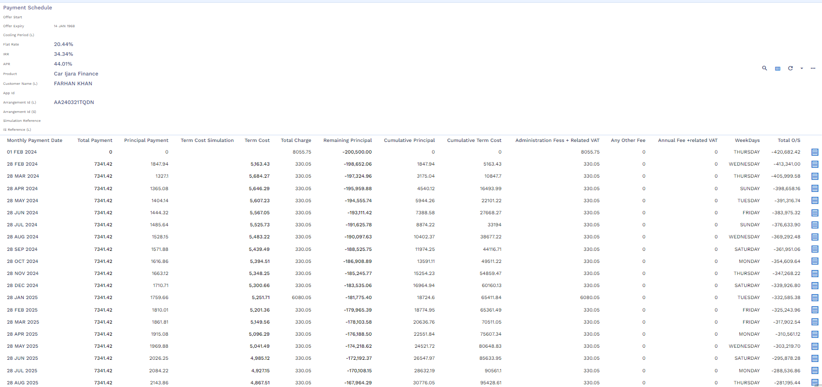

Arrangement Overview
After creation of AA arrangement user can view the arrangement details by navigating through Find Finance Enquiry.
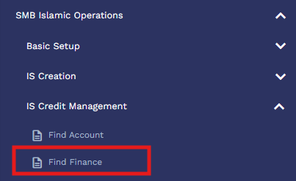
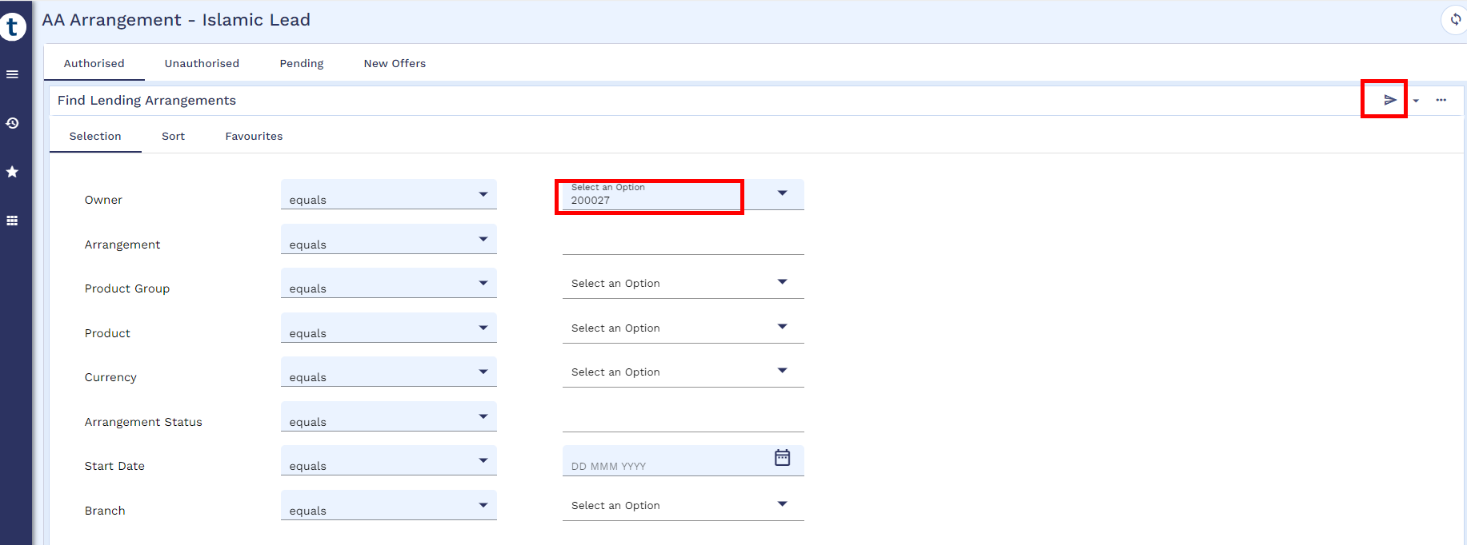
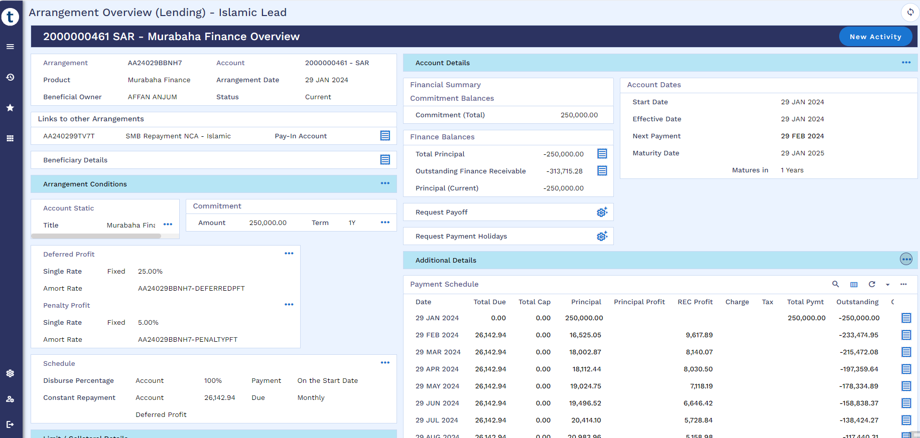

Accounting Entries - AA Arrangement
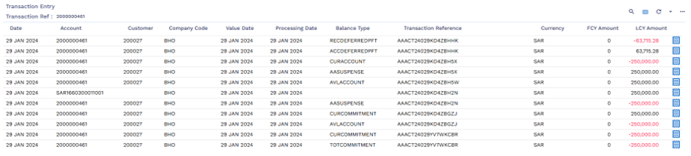

Maintenance Activities
User can perform below Post Disbursement Activities and same activities can be used for servicing app. For servicing app. a separate document needs to be developed for integration purpose, however, calculations and accounting entries will be same in Transact as mentioned in this document as a manual process.

Cancellation within Cooling Period (WS03-MUR-08)
Cancellation can only be performed after disbursement and when the arrangement is on cooling period. This cooling period starts from the date of loan account creation.
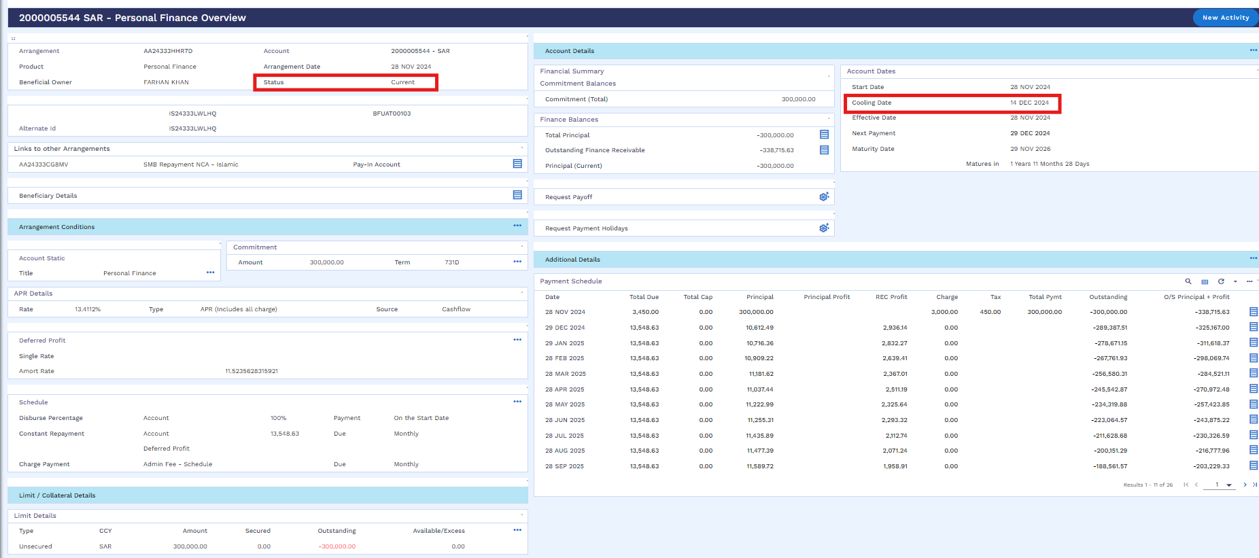
User can perform cancellation as per below navigation.
SMB Islamic Operation → Cooling Period Early Pay Off → Cooling Period Payoff Simulation
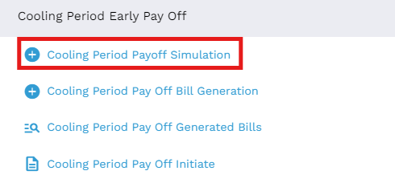

User will click on the new icon
User will put the arrangement reference and click on the validate icon
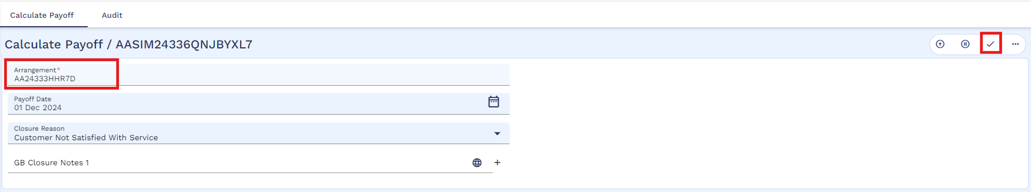
User will validate and commit the below window
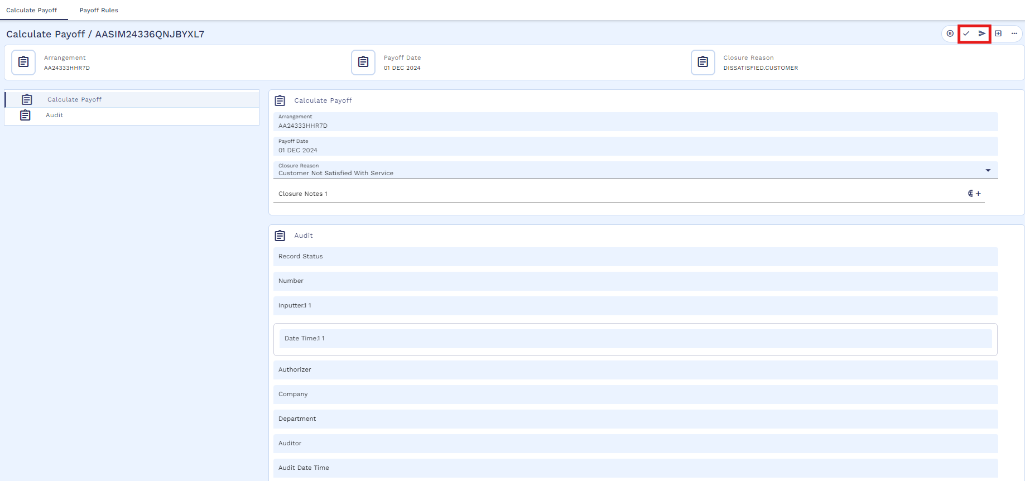
After that Simulation will start processing
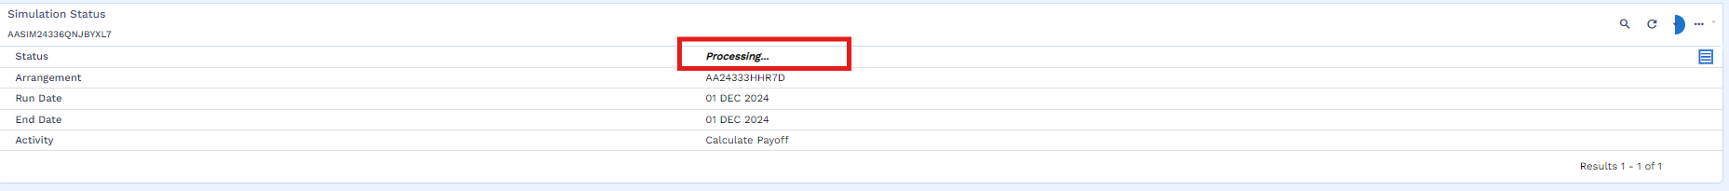
Once the simulation is executed successfully, user will click on the view icon
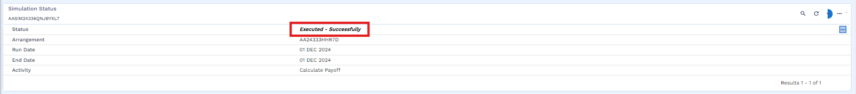

Simulation result is attached below
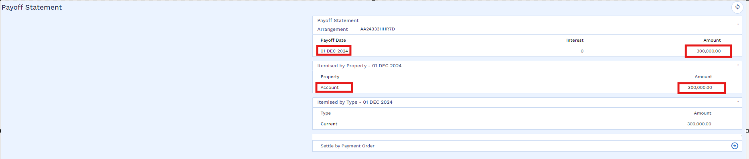
After that user will go for bill generation by following the below navigation
SMB Islamic Operation → Cooling Period Early Pay Off → Cooling Period Payoff Bill Generation
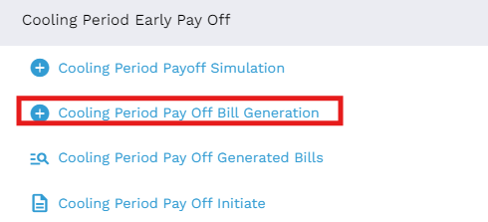
Below window will be opened upon clicking Cooling Period Pay Off Bill Generation in which user will input Loan Application ID and Source of Income then validate and hold then record.
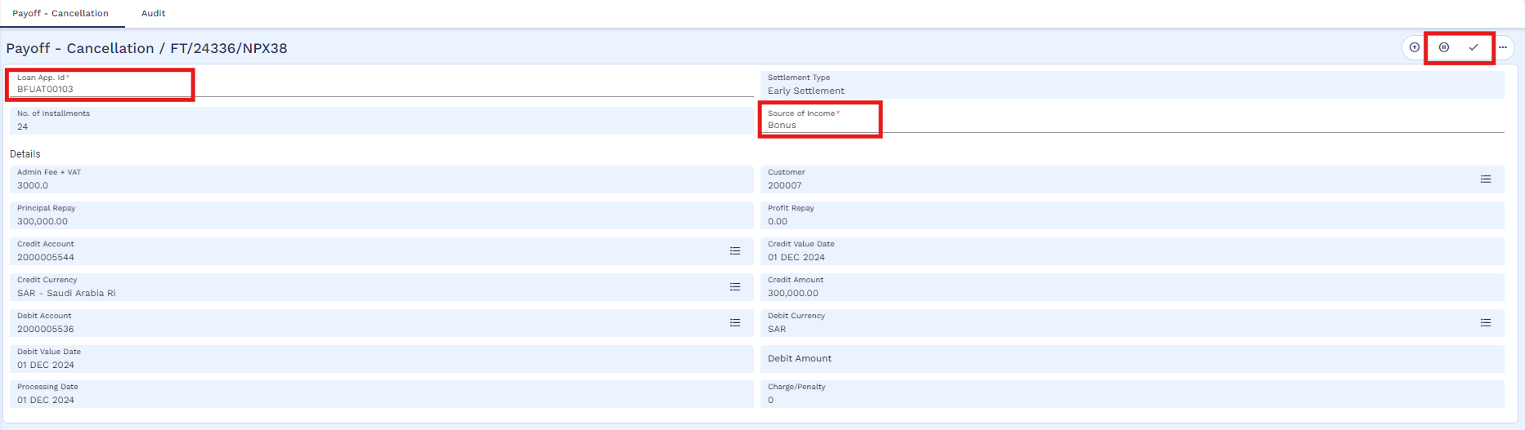
After that bill process is completed
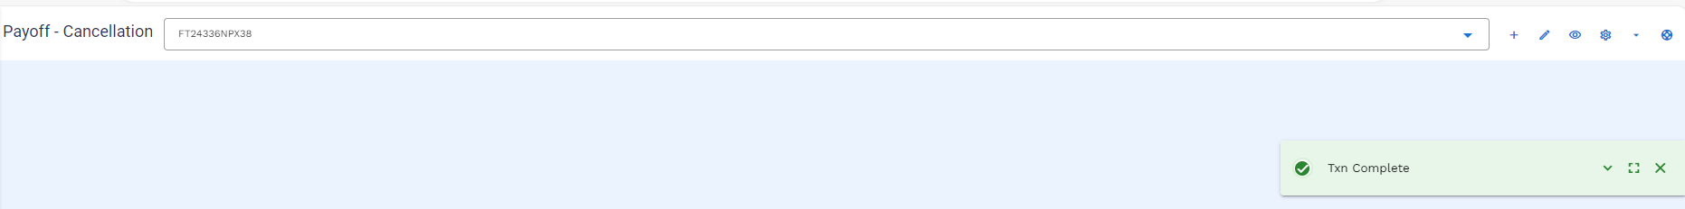

User can view the bill through below navigation
SMB Islamic Operation → Cooling Period Early Pay Off → Cooling Period Payoff Generated Bills
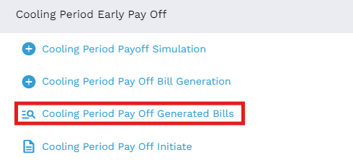
User will put the application ID and then click on the find icon
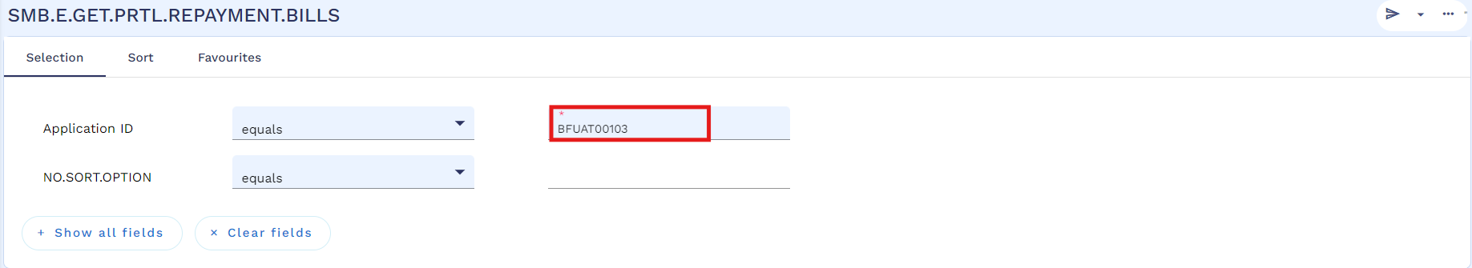
Below enquiry will extract bill details for user review.
Below is the generated bill template which will be used to generate bill for any payment gateway, in this case it is SADAD.
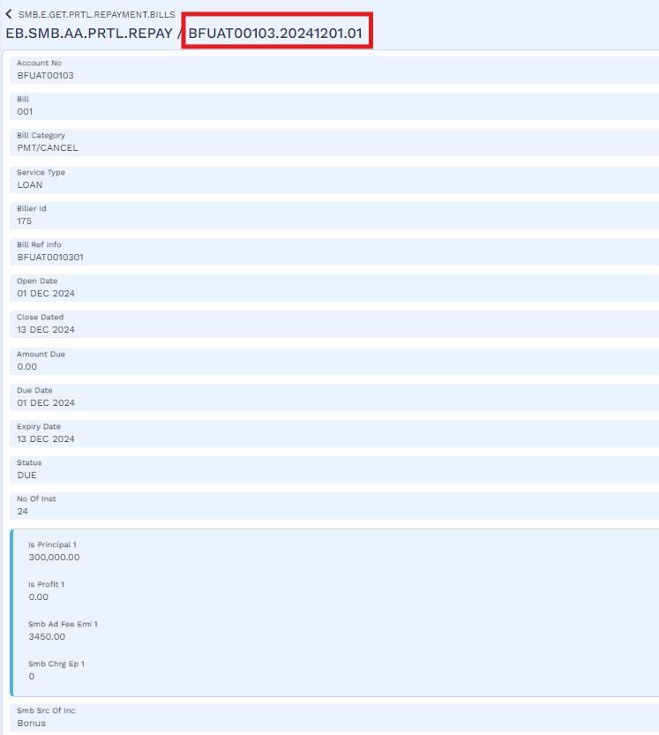

User will make funds available is customer’s repayment account through below navigation
SMB Islamic Operation → IS Credit Management → Finance Transaction → Arrangement Activities (FT) → AA-Fund Transfer
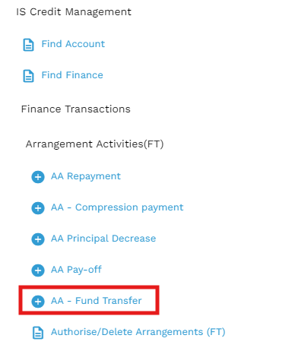
User will mention Credit account as customer repayment account and the debit account of AL Rajhi Bank (2000003363) in which customer has deposited funds as per bill due amount. Then validate and commit the record.
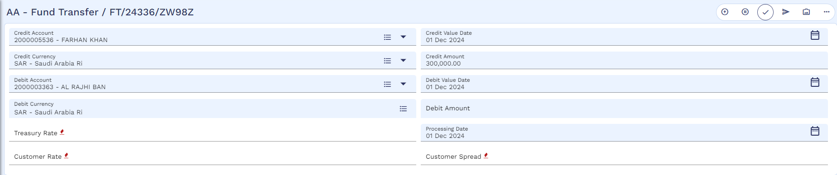
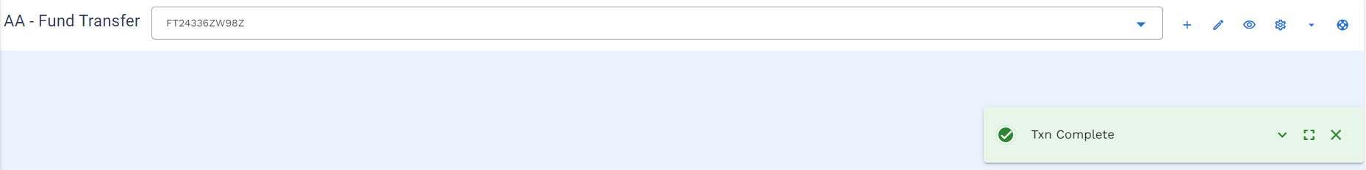

The authorizer will authorize the FT by following the below navigation
SMB Islamic Operation → IS Credit Management → Finance Transaction → Arrangement Activities (FT) → Authorize / Delete Arrangements (FT)
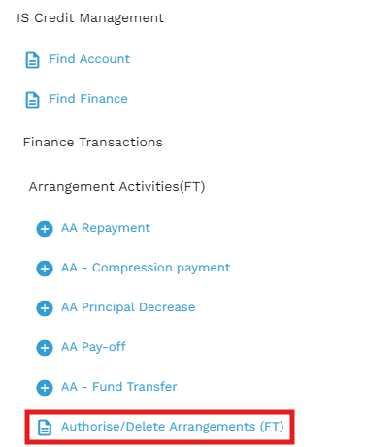
Authorizer will review the FT by using view icon
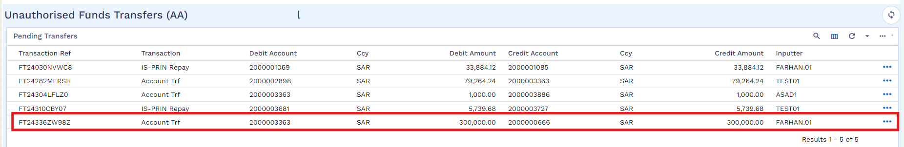
then view and authorize the FT
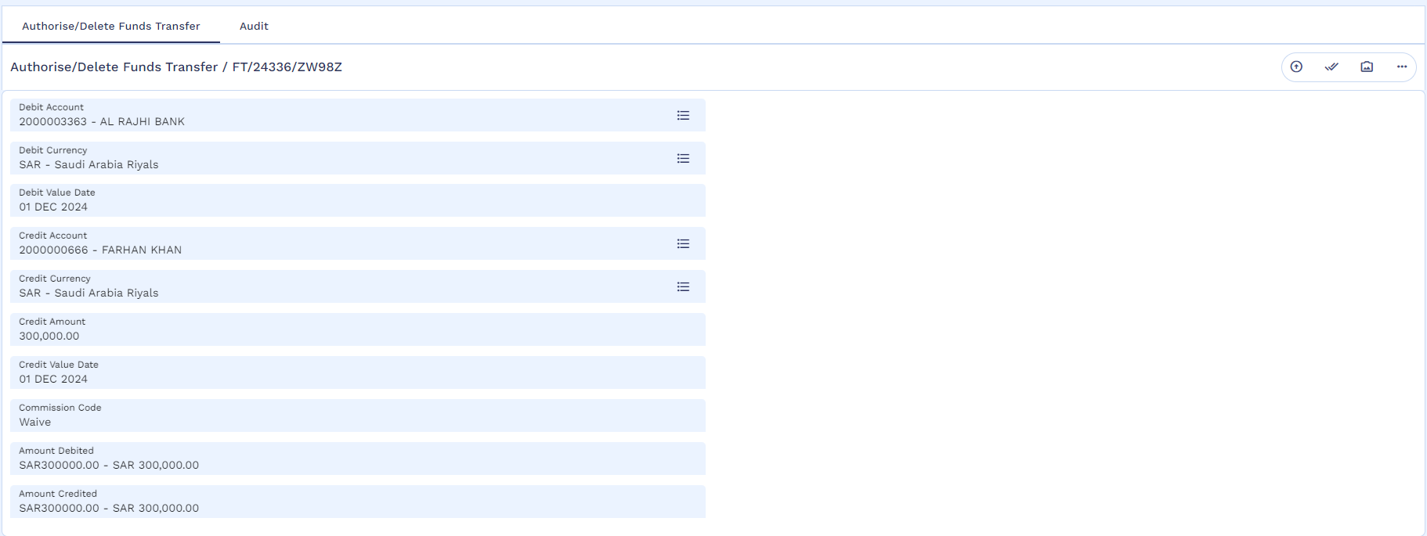
Authorization is completed
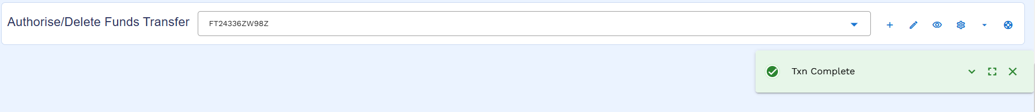

User will initiate cancellation by using following navigation
SMB Islamic Operation → Cooling Period Early Pay Off → Cooling Period Pay Off Initiate
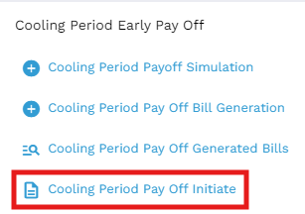
User will put the application ID and icon on the edit icon
Then user will be mentioned bill reference no then validate and commit the record.
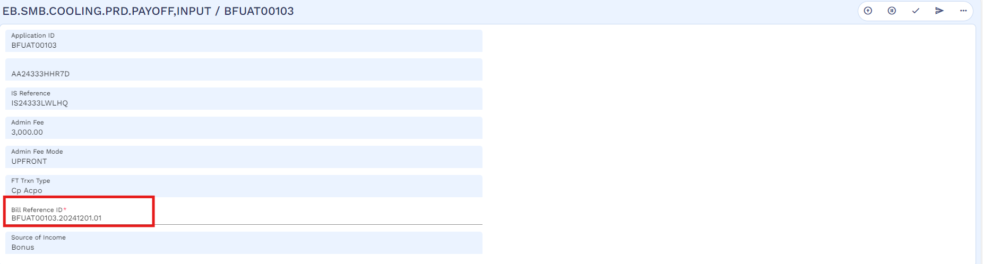
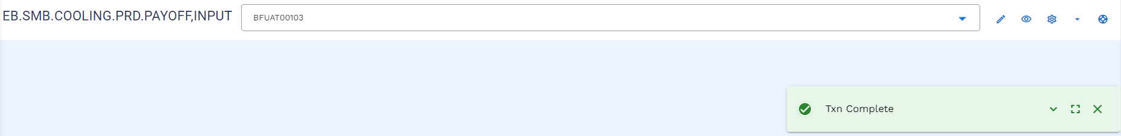
Once the cancellation process is completed, user needs to open the Arrangement to see the status of the arrangement which changed to the “Pending Closure”.
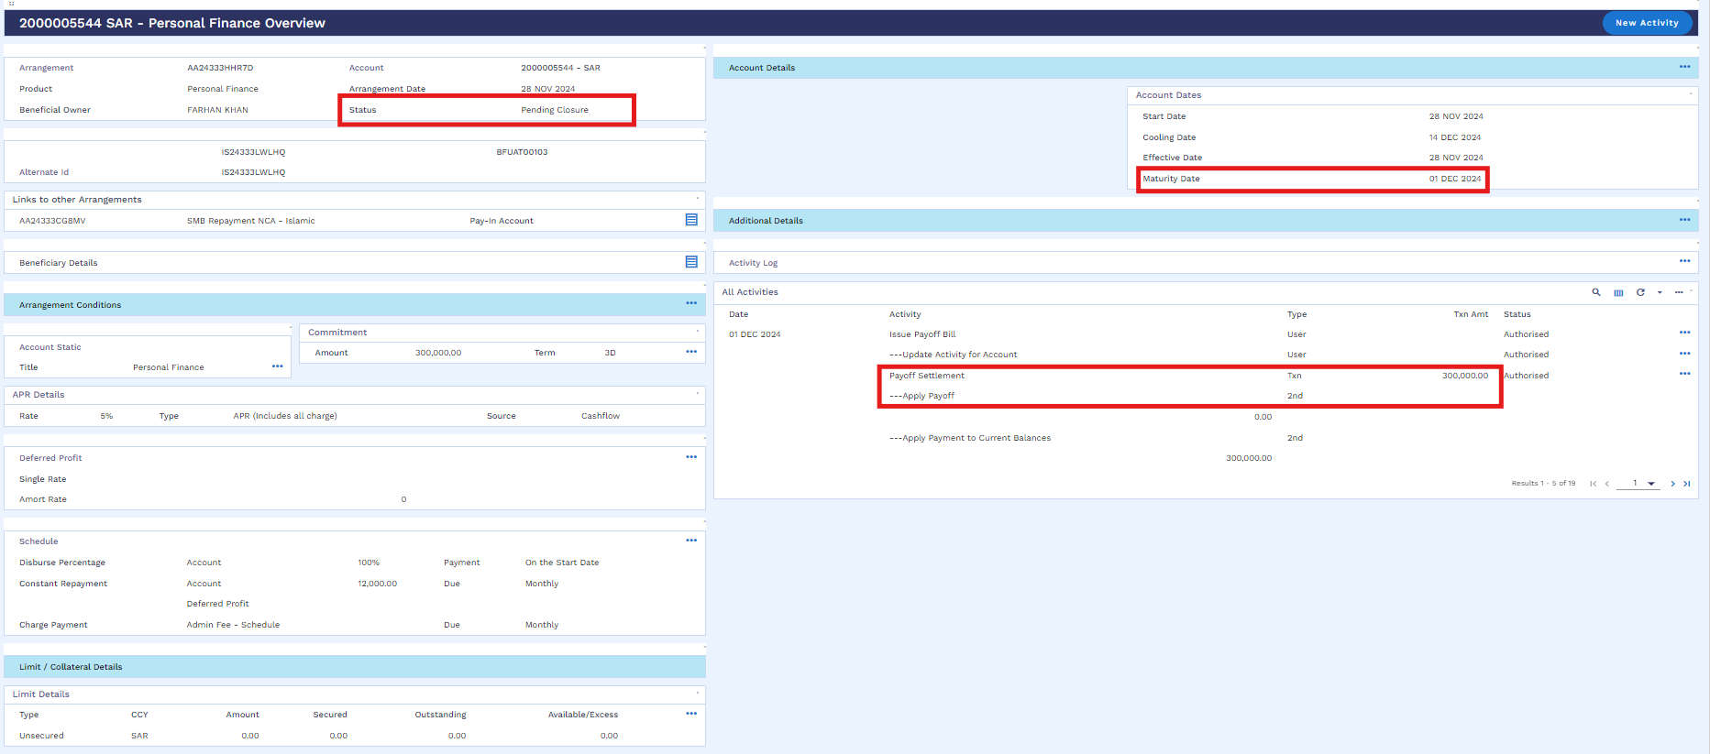

Worksheet details:
- File name : Murabaha Working Sheet
- Sheet name : Cancellation and SADAD Accounting Entries-TA

Deferment of Instalments (WS03-MUR-09)
For installment deferment/ skip, customer will follow the following navigation:
SMB Islamic Operation → Installment Deferment → Installment Deferment
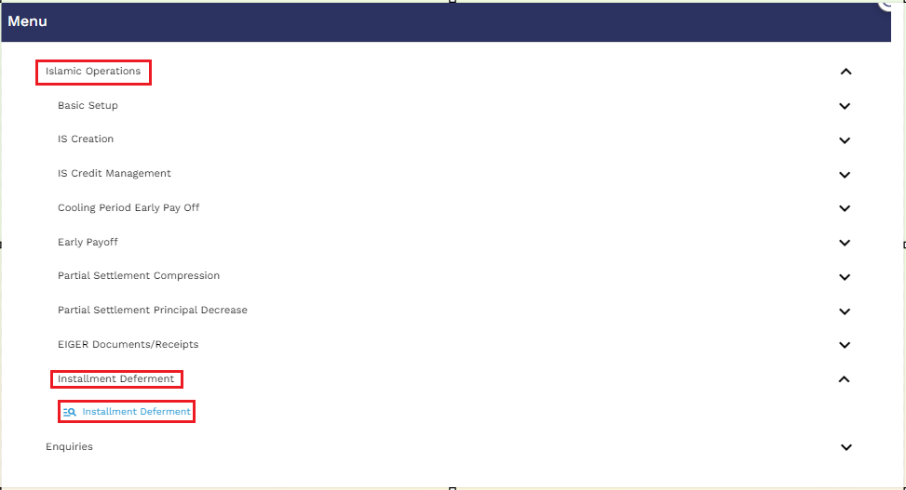
User will put the application ID and click on the find icon
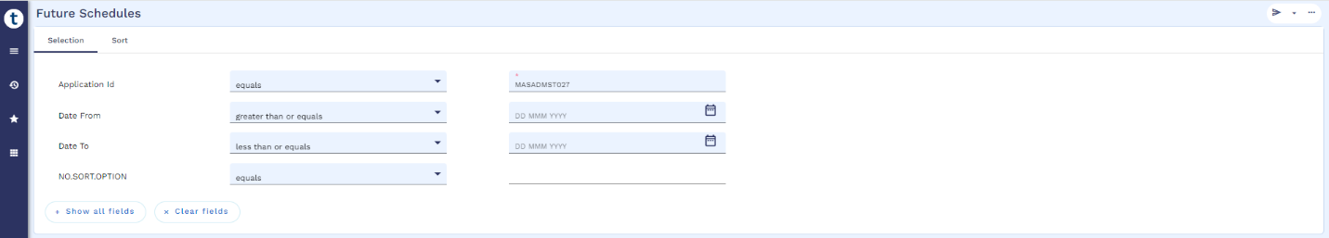
For illustration the upcoming installment on 28 Feb 2024 is going to defer which means there is an increase in tenor by 1 month of the arrangement.
The user will click on the icon located on the right side, which pertains to installments, and then proceed to click on "Simulate."
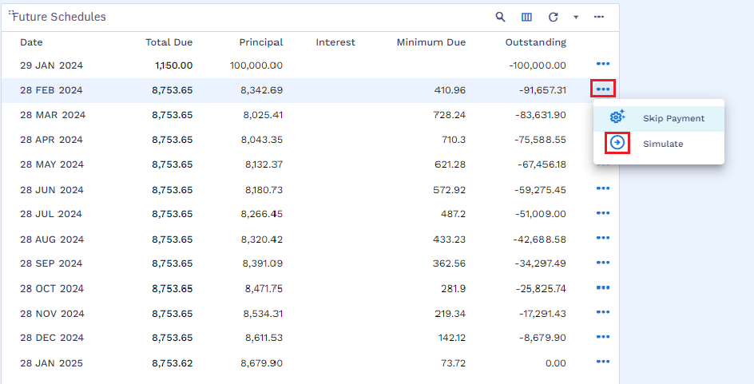

Next, validate the activity by using the icon specified in the screenshot below.
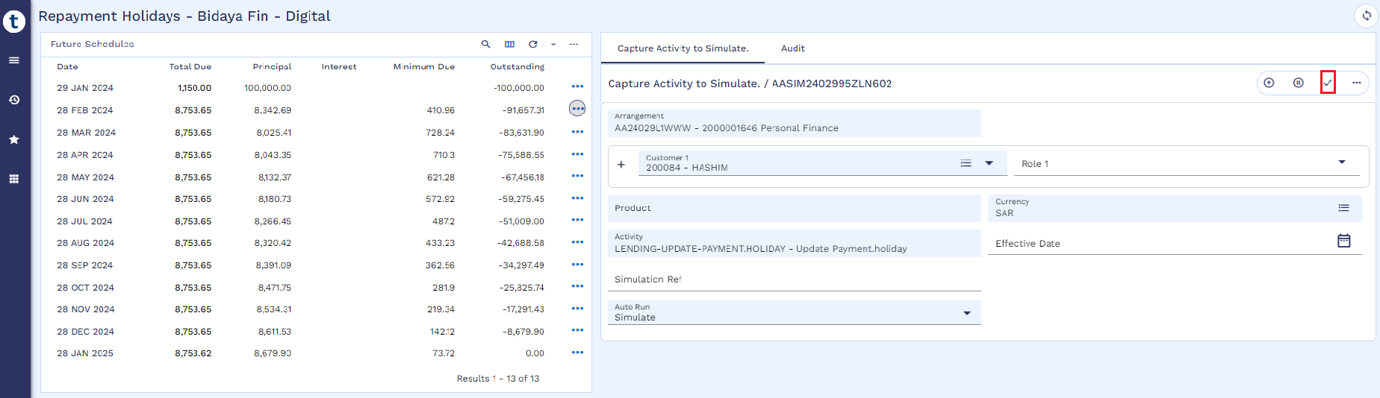
The user will select the "Payment Holiday" tab as indicated in the screenshot below.
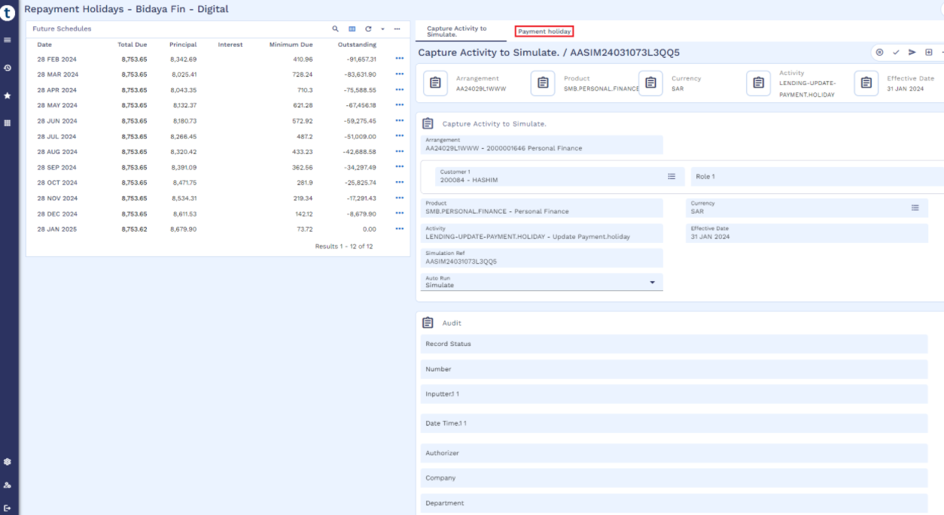
The user will input "1" in the installment field and select "Residual" for recalculation, where system will skip the instalment and add the same in last instalment.
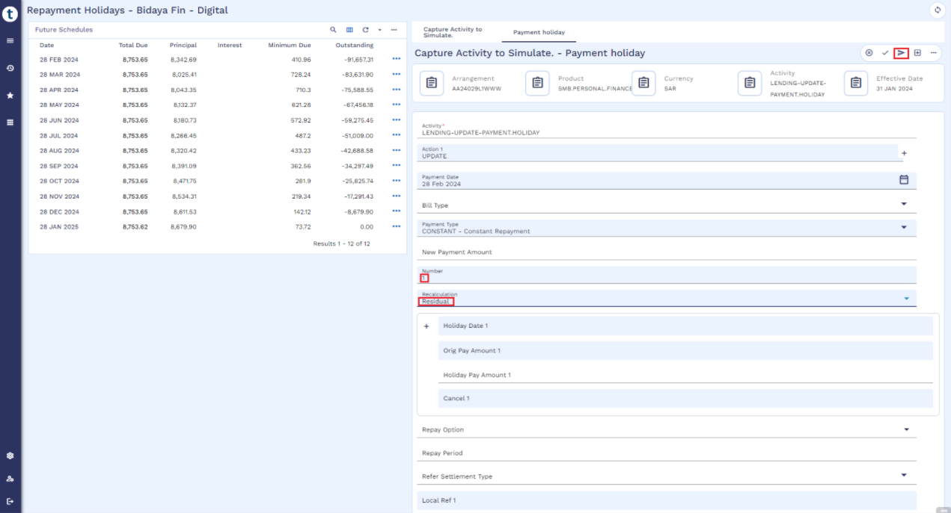

Below are some other options that can be used for payment holidays with below functionalities.
- Payment – the payment amount will be changed.
- Term – the term of the arrangement will be altered.
- Residual – the residual amount will be changed.
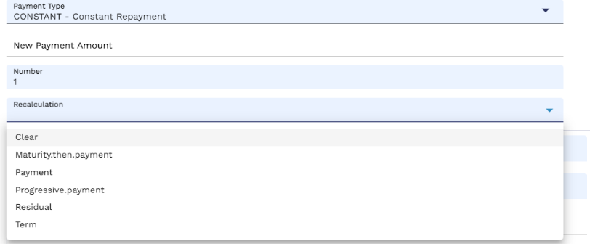
Following that, the simulation process will commence.
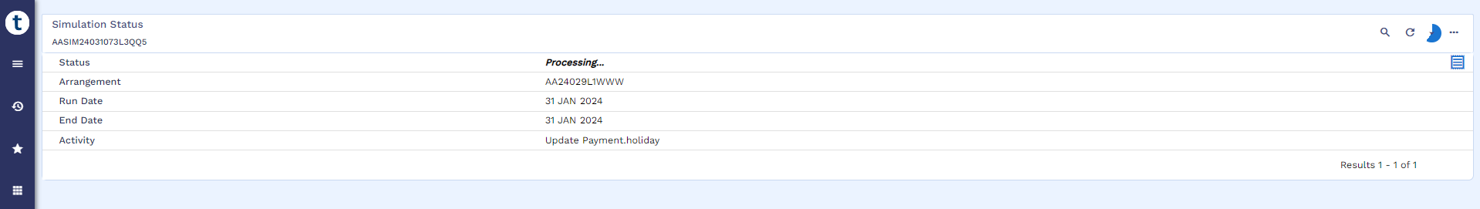
Once the simulation is completed, the user will click on the overview icon as indicated in the screenshot below.
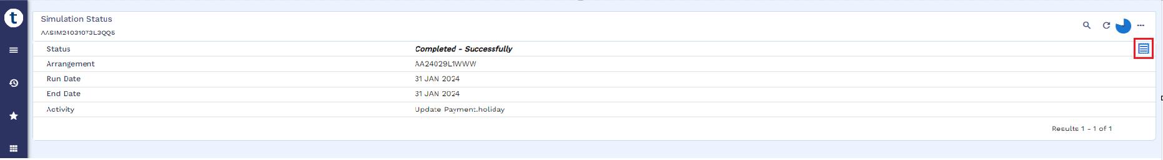

In the overview, the user can verify that the deferred installment dated February 28, 2024, displays a zero amount, as shown in the screenshot below.
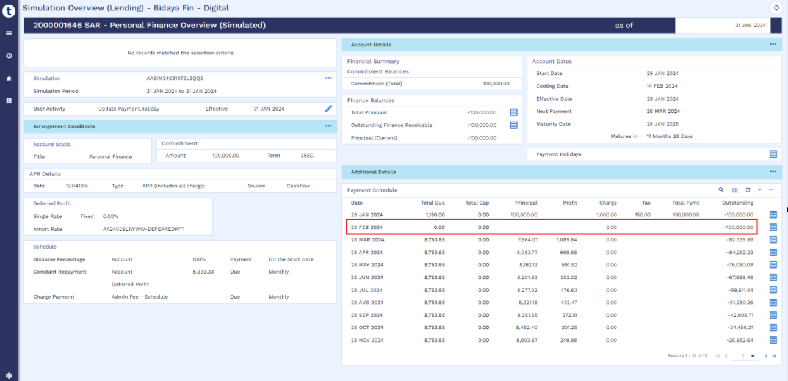
User can also check the last installment amount has increased as it includes the deferred installment amount. User can execute the simulation as mentioned in the below screen short
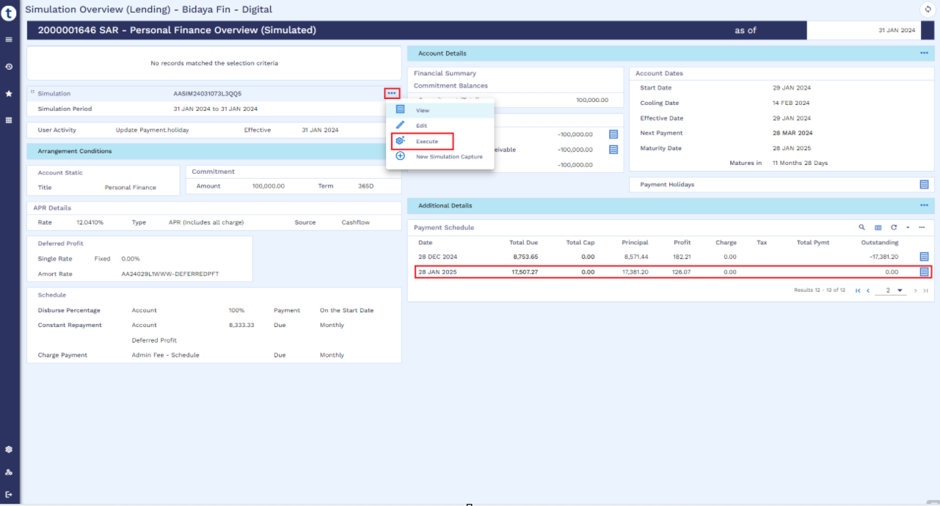
The user will finalize the simulation by committing the Simulation Runner.
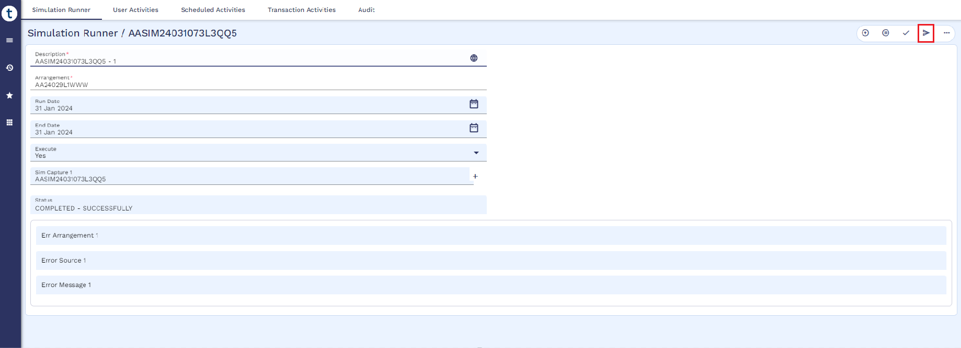

The simulation will begin processing.
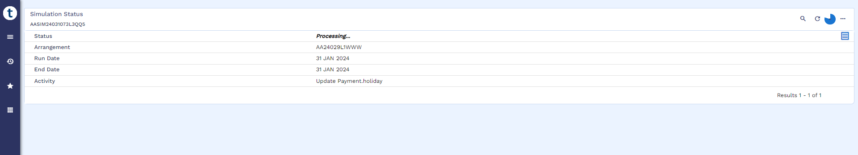
After a few minutes, the execution will be completed, as depicted in the screenshot below.
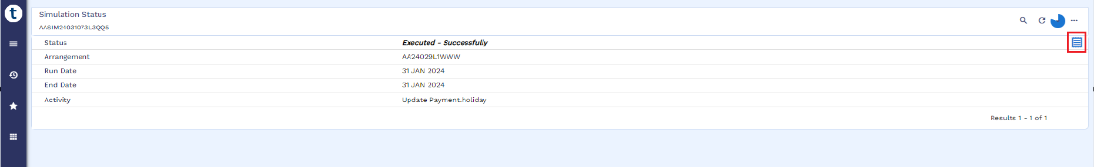
Worksheet details:
- File name : Murabaha Working Sheet
- Sheet name : Deferment

Early Pay off (WS03-MUR-010)
Post cooling period, if customer comes to any FI for early settlement, then Transact provides an option to exercise Payoff functionality. This can be executed from 360 overview of arrangement as mentioned below. A payoff statement is generated that contains all the financial information like, income receivable, principal receivable, any overdue item and fee etc. All such information is part of product setup sheet which is used as client/regulatory specific product requirements.
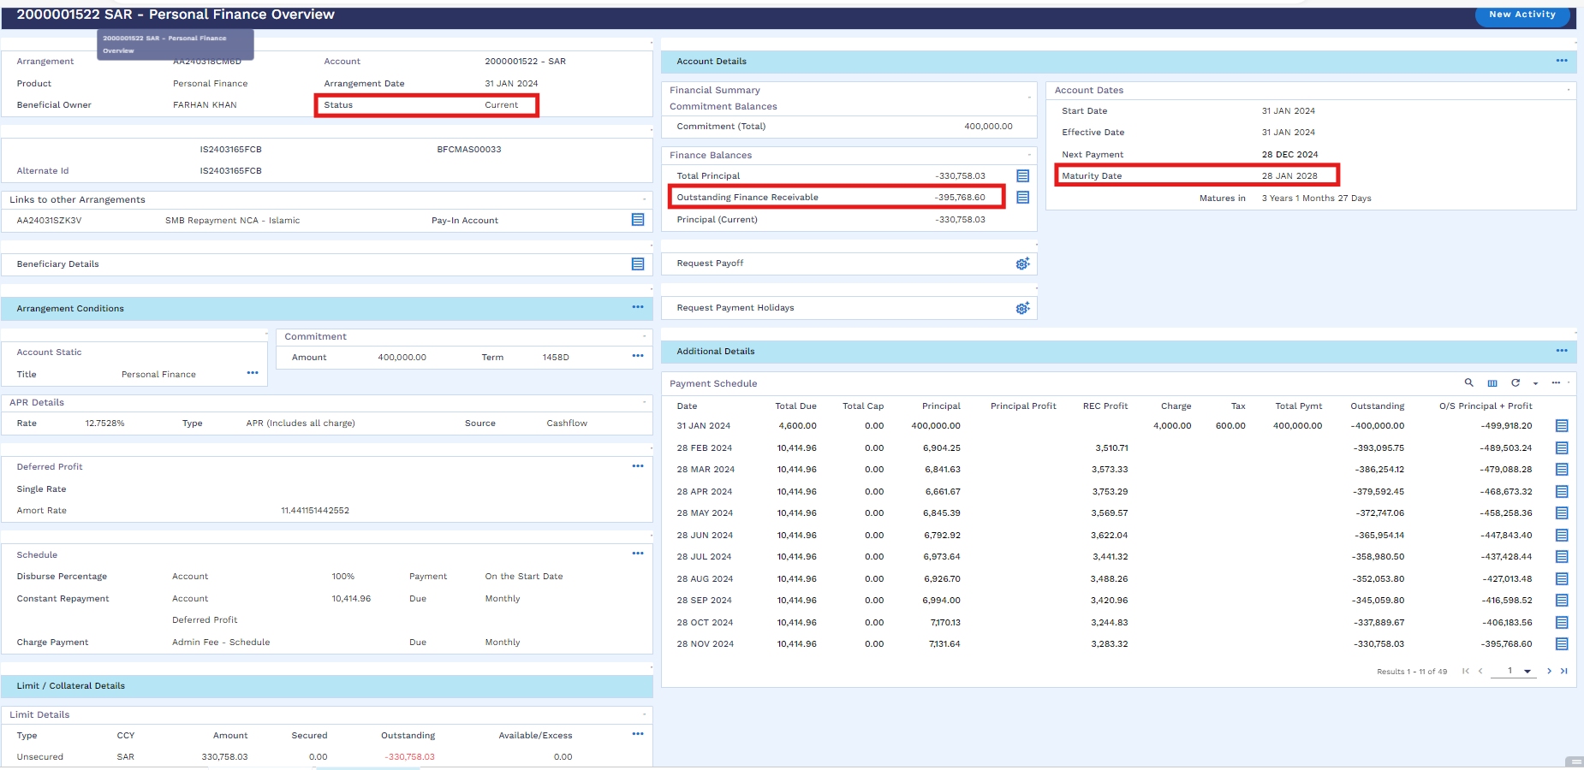
User can perform cancellation as per below navigation.
SMB Islamic Operation → Early Payoff → Early Payoff Simulation
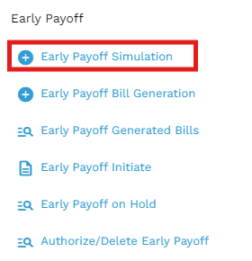
Upon clicking Early Payoff Simulation below window will open in which user need to input Arrangement Reference and Closure Reason and then validate.
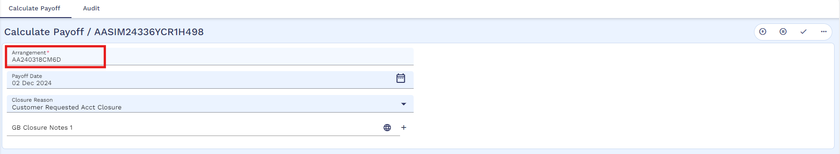
User will validate and commit the below window
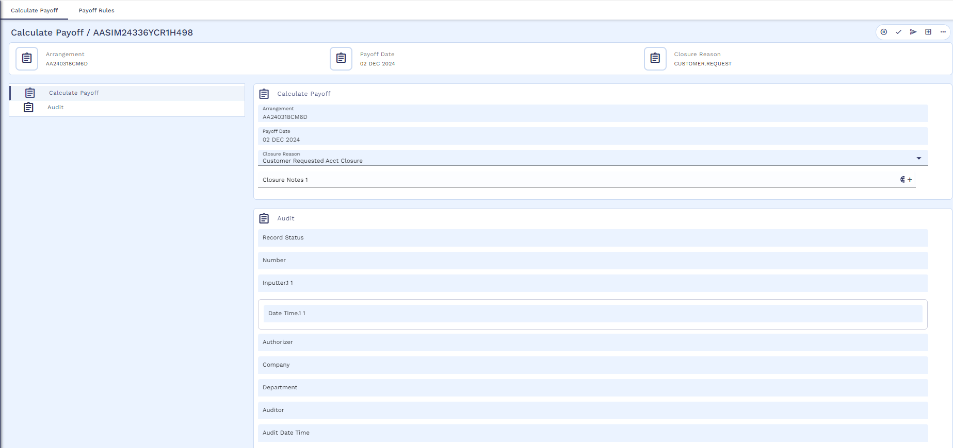
After that Simulation will start processing
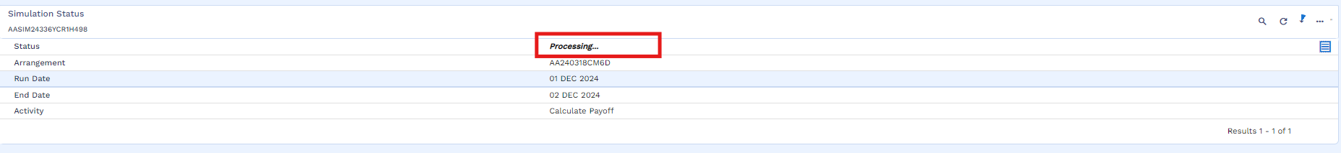
Once the simulation is successful, user will click on the view icon
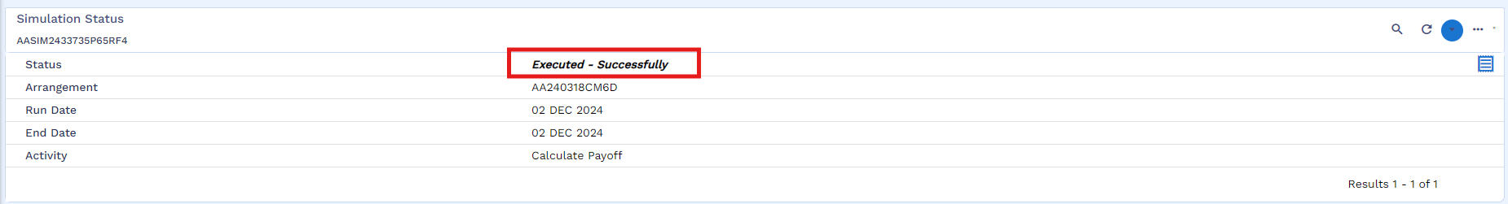
Simulation result is attached below
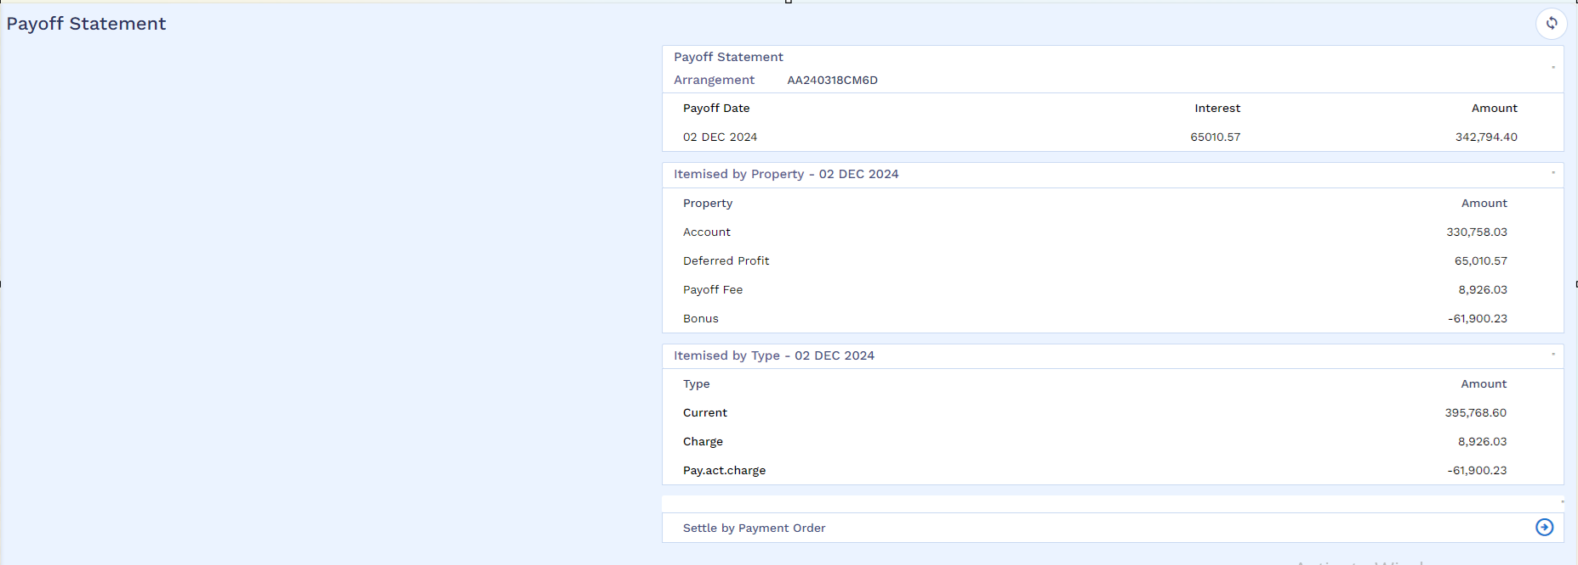
After that user will go for bill generation by following the below navigation
SMB Islamic Operation → Early Payoff → Early Payoff Bill Generation
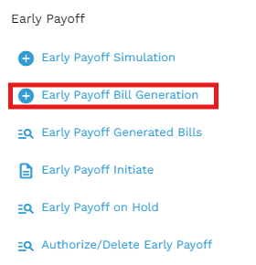
User will put the application ID and mention the source of income then validate and hold the record.
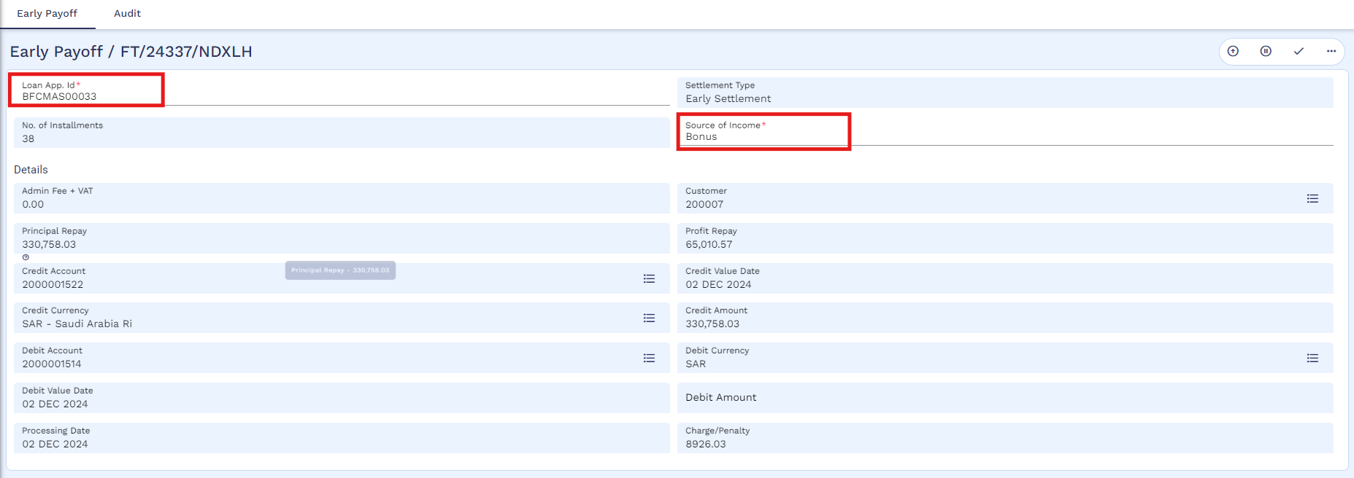
After that bill process is completed
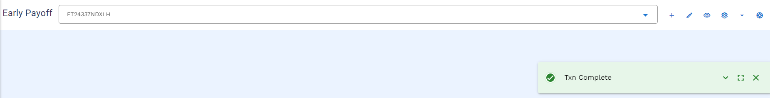
User can view the bill through below navigation
SMB Islamic Operation → Early Payoff → Early Payoff Generated Bills
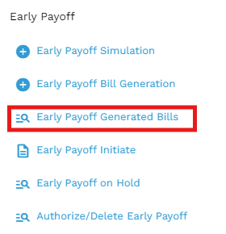
User will put the application ID and then click on the find icon
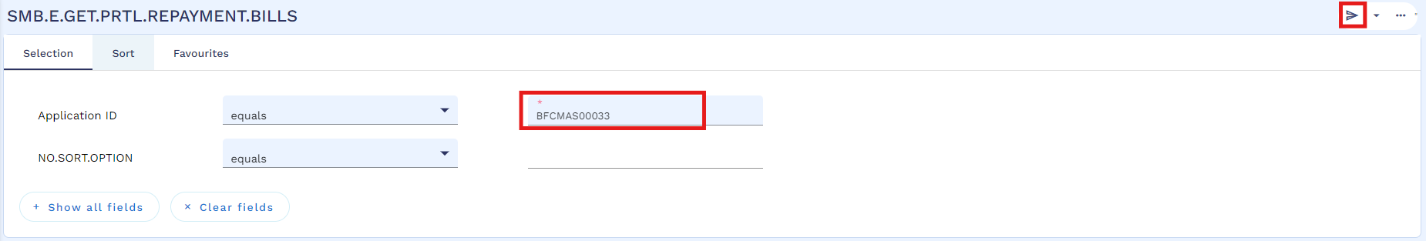
User will click on the view icon
Below is the generated bill template which will be used to generate bill for any payment gateway, in this case it is SADDAD.
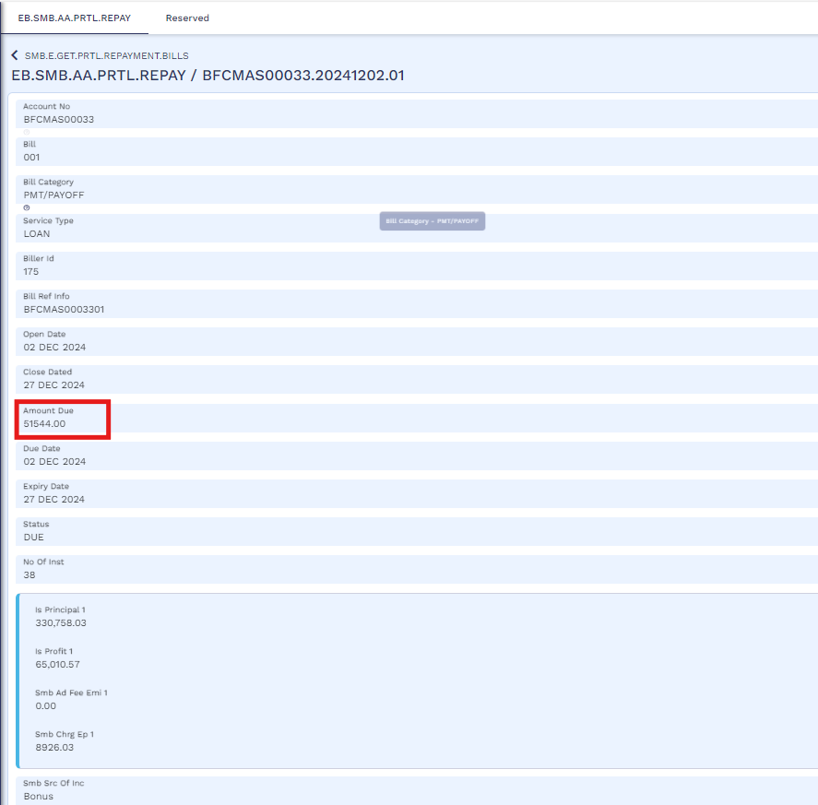

SADAD bill generation and upload rules.
This rule has been developed in order to manage both monthly instalment invoice and early settlement invoice that can be requested at any time.
If the payoff invoice is issued between 29th of the current month till 27th SOD of the following month (considering 28th is cycle date of product) then expiry of the same invoice will be 27th EOD of the following month this is because monthly invoice can be generated on 27th EOD. The early settlement charge will be 3 months starting from next month.
If the invoice is generated on 28th there is no extra accrual and only 3 months early settlement charge starting from the next month will be collected expiry of this invoice will be 28th EOD.
Once customer will pay the Sadad bill then d funds are transferred to customer’s repayment account which is maintained by Transact, then an automated process will be run to settle customer’s loan account and balances. Below is the manual process of the same. There is another process of bulk file upload of FT, for which a format has been designed. Please see sheet name as “DayN-File Upload” in excel file. This is an automated process however user can also manually make FT if required.
Once the required amount is credited to the customer’s account a service will be executed to settle the loan account. Below is manual process as well.
User will initiate cancellation by using following navigation
SMB Islamic Operation → Early Payoff → Early Payoff Initiate
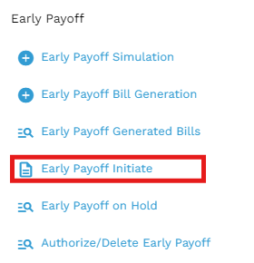
User will put the application ID and icon on the edit icon
Then user will mention bill reference no, then validate and commit the record
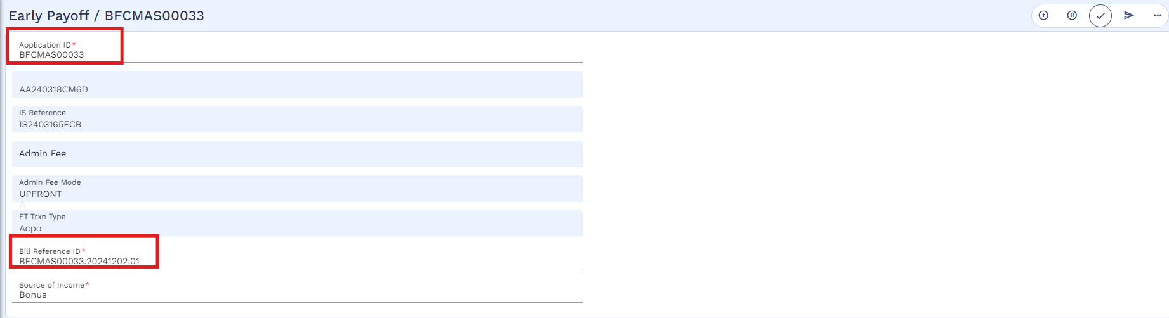
The process has been initiated.
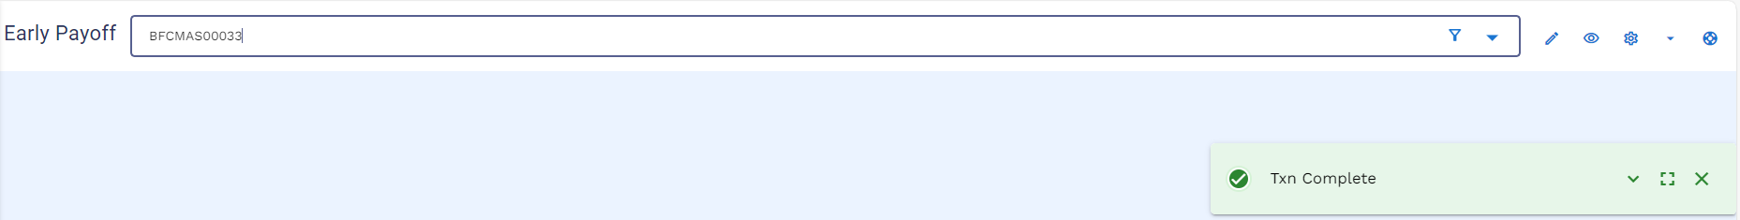
User will check the transaction on Hold stage by using below navigation
SMB Islamic Operation → Early Payoff → Early Payoff on Hold
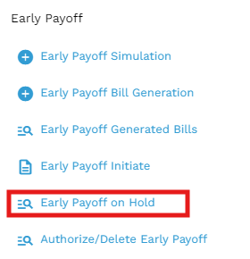
User enters the application ID and click on the find icon
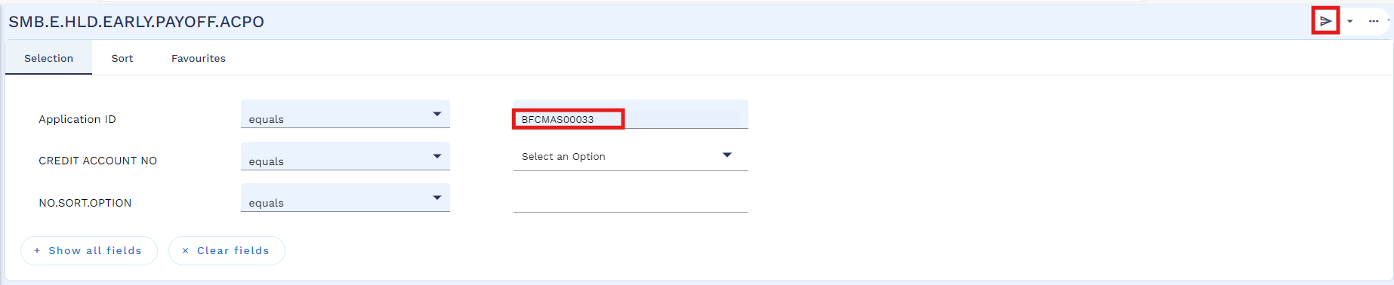
Then user will click on the view icon
User will validate and commit the record
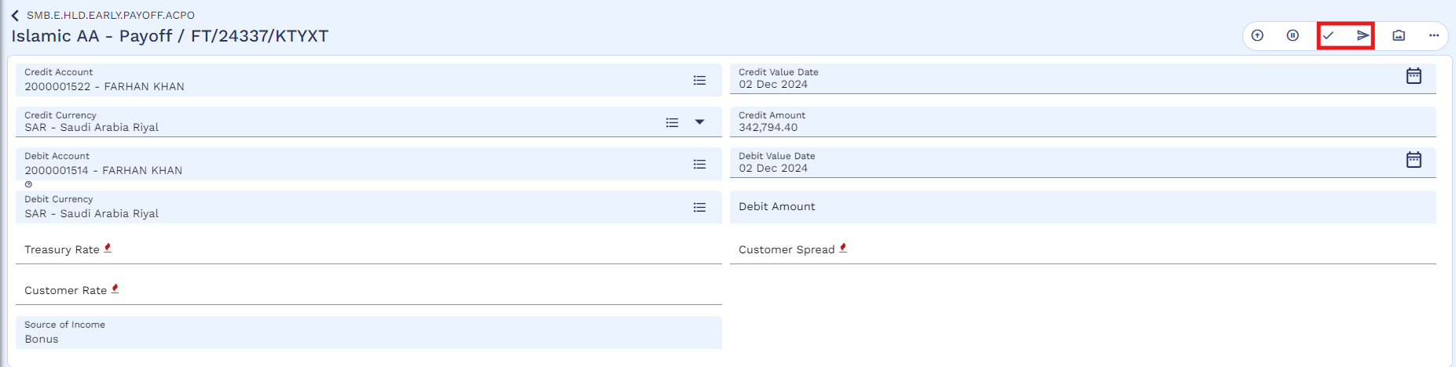
And accept the override
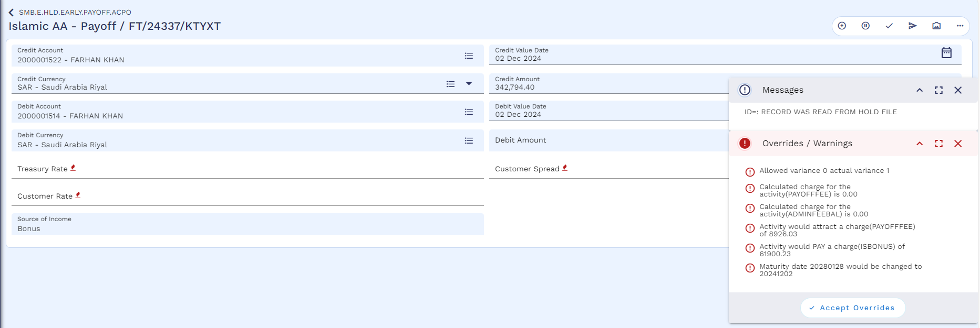
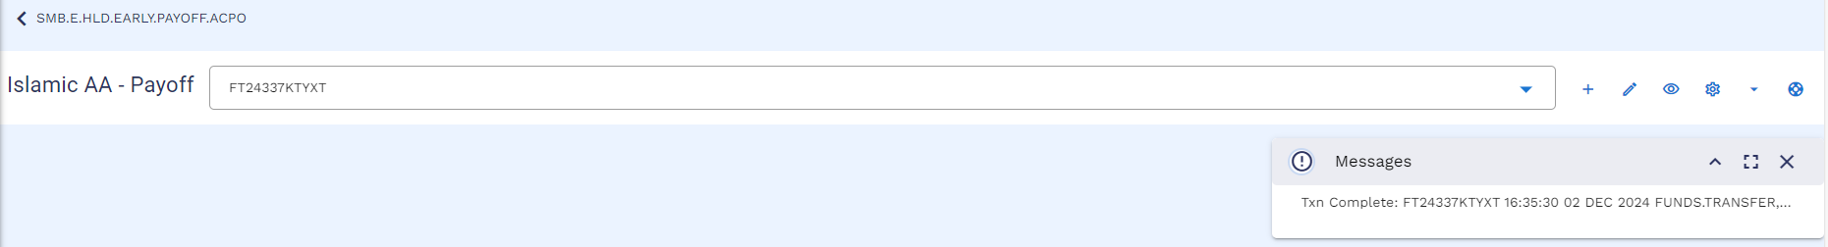
Authorizer will authorize the pay off by using below navigation
SMB Islamic Operation → Early Payoff → Authorize / Delete Early Payoff
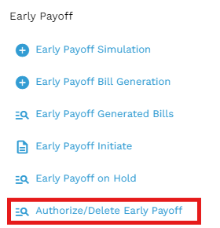
Authorizer will enter application ID and then click on the find icon
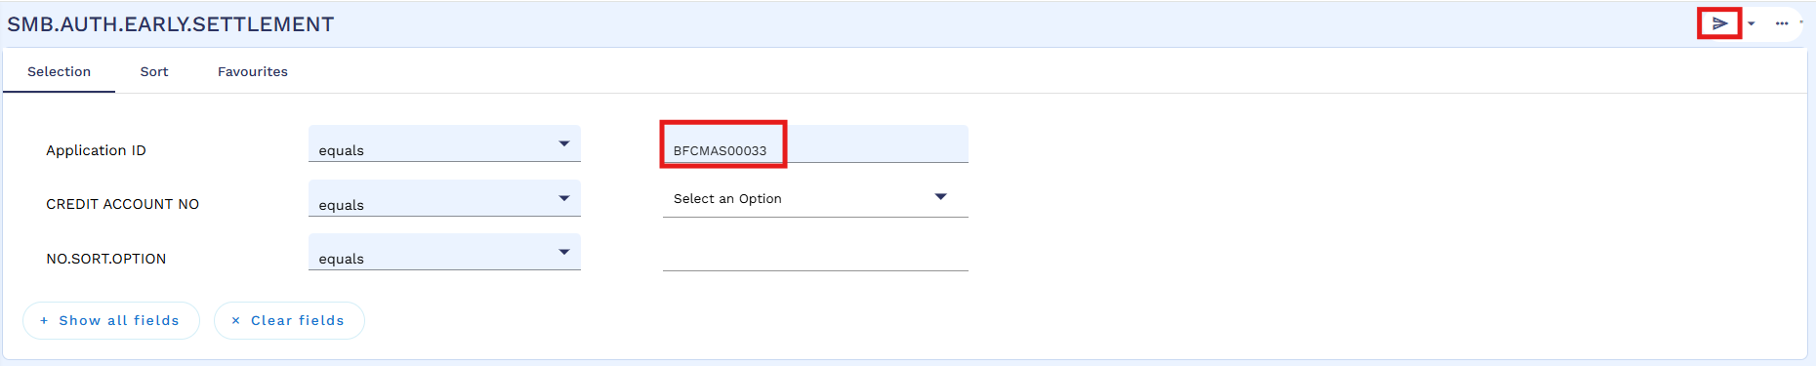
Then click on the view icon
Authorize the transaction
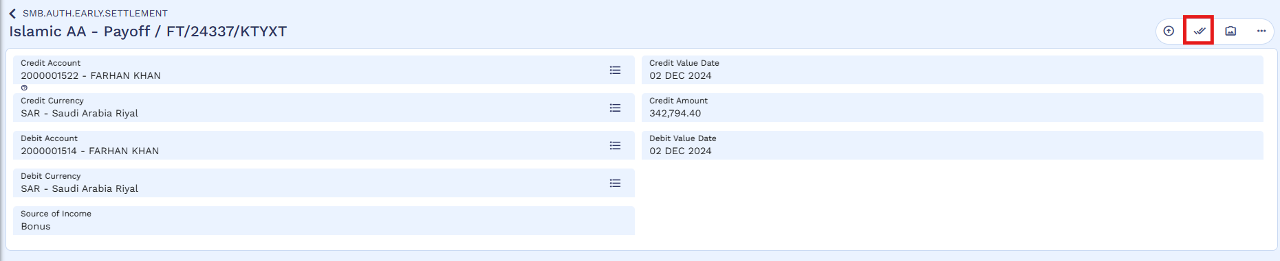
Authorization is completed
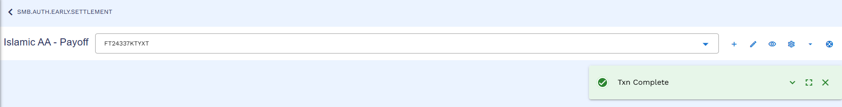
Arrangement status has been changed to “Pending Closure”
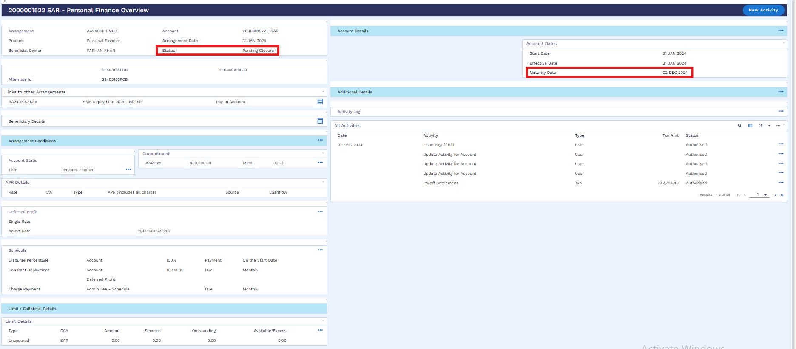

Worksheet details:
- File Name: Murabaha Working Sheet
- Sheet Name: DayN-File Upload

Write Off (WS03-MUR-11)
User can write of the arrangement by following the below steps:
User will open the arrangement overview and click on the “New Activity”
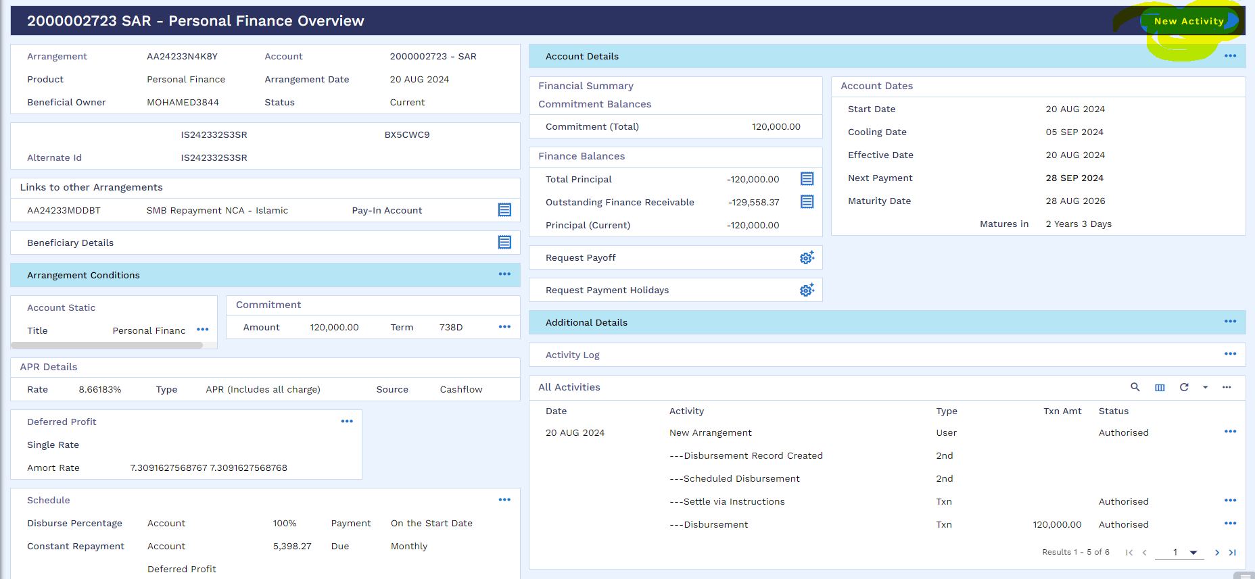
User will go to the “write of Arrangement” and click on “do activity today”
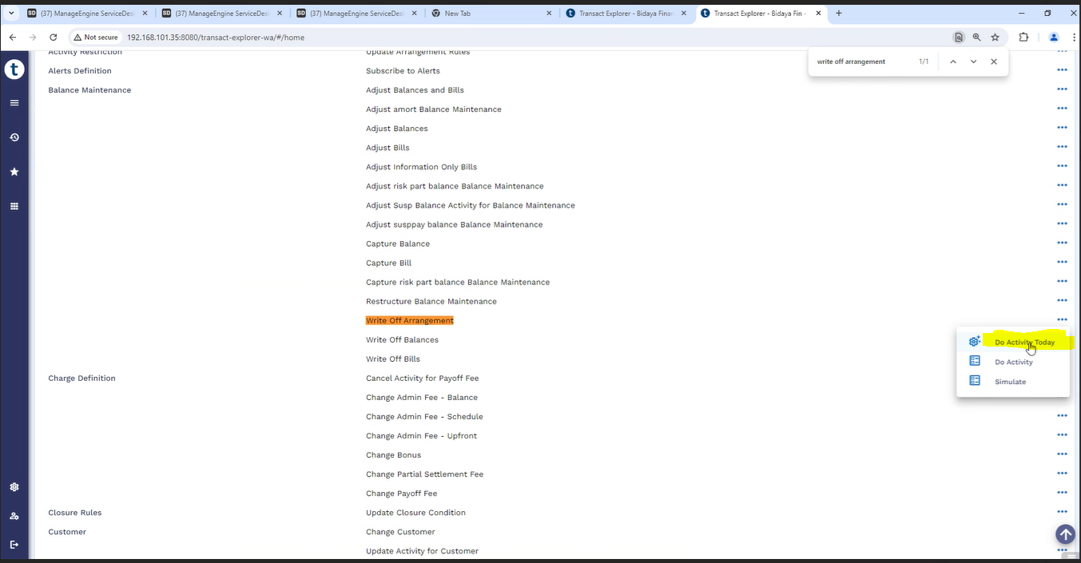
User will click on the balance maintenance tab
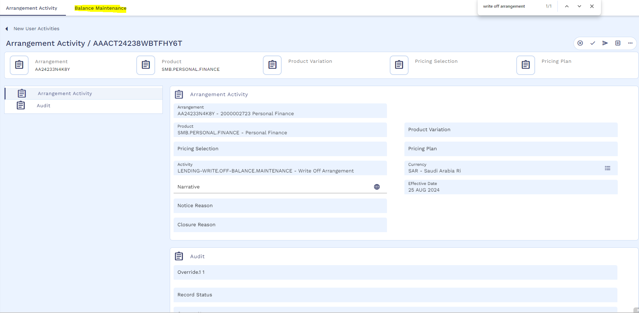
And then click to validate and commit the record.
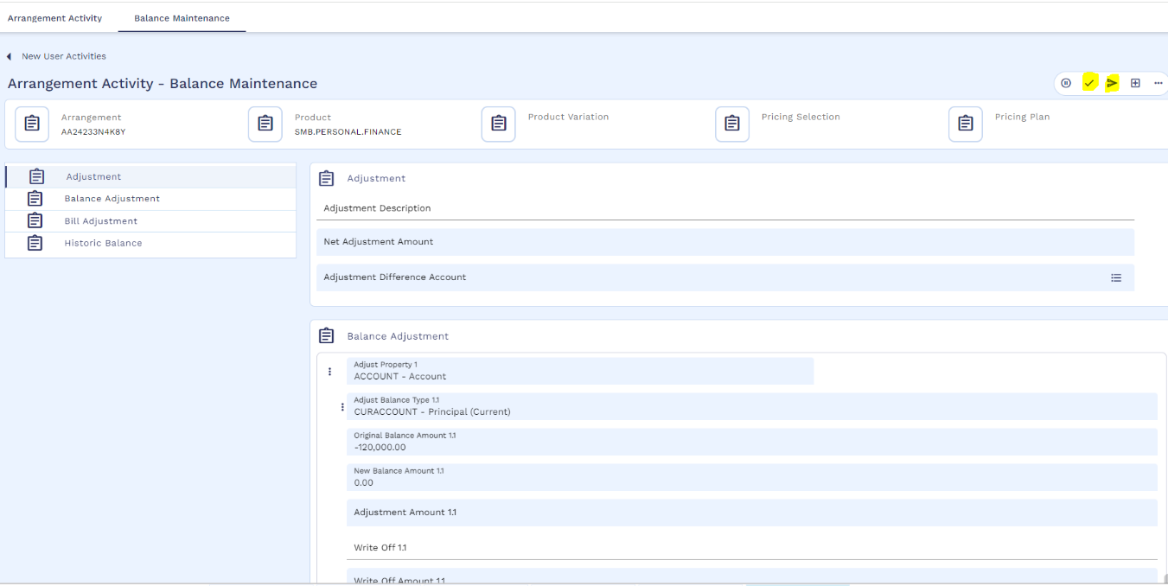
record has been committed.
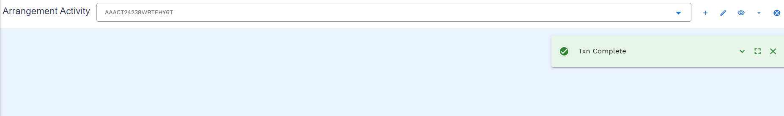
Authorizer can authorize the write off activity from the arrangement overview and click on the menu icon to authorize the activity.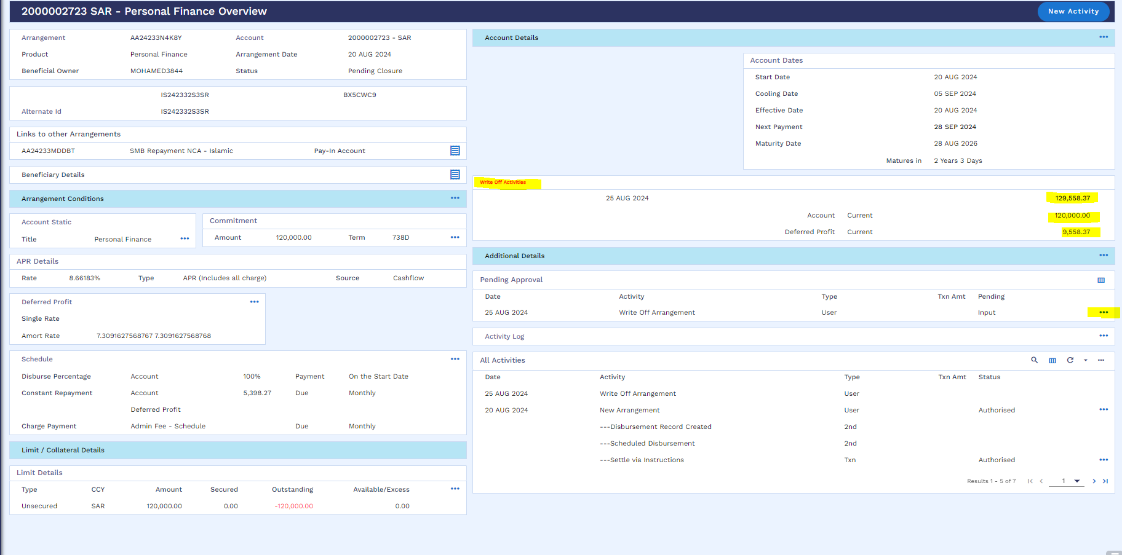
Commit the record to authorize the activity
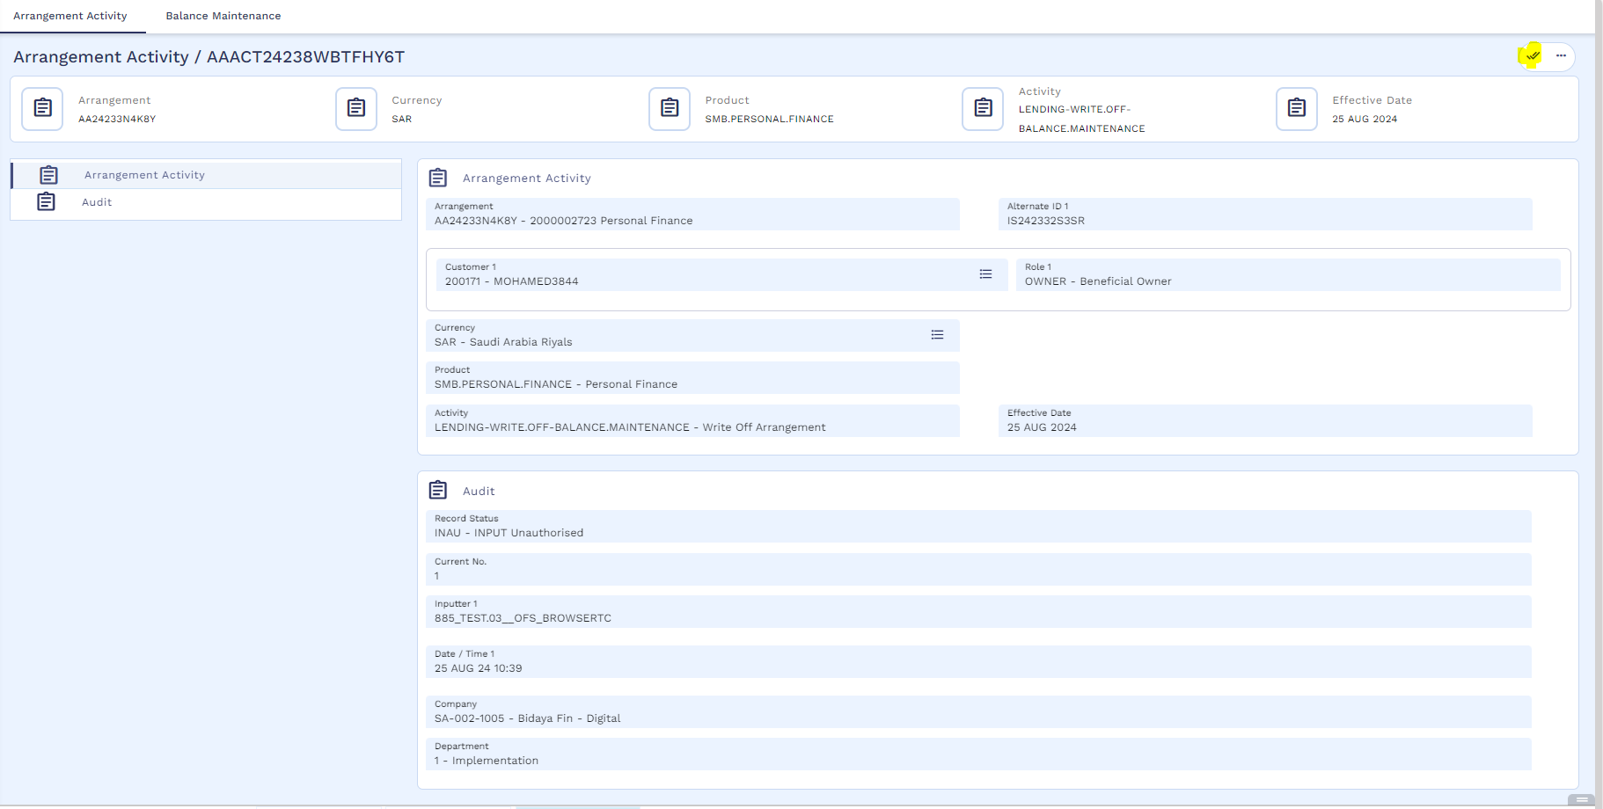
Authorization is completed
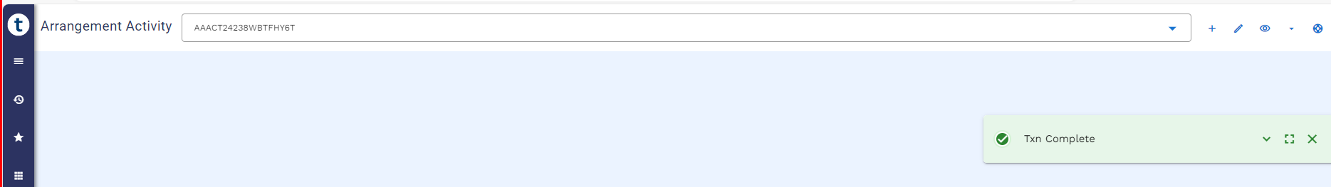

User may check the accounting entries from enquiry section.
Accounting entries
Stage | Debit/Credit | Accounting Entries | Description | Core/ Customized | Account Reflection
Write off of Arrangement | DR | Internal Account / PL | Write-off Internal Account / PL | -100,000.00 | On Balance Sheet
Write off of Arrangement | CR | DUEACCOUNT | AA Arrangement - ACCOUNT | 100,000.00 | On Balance Sheet
Write off of Arrangement | DR | PL/ Expense | PL Category | -10,027.40 | On Balance Sheet
Write off of Arrangement | CR | DUEDEFERREDPFT | Due Profit Receivable | 10,027.40 | On Balance Sheet
Write off of Arrangement | DR | ACCDEFERREDPFT | Unearned Profit | -25,000.00 | On Balance Sheet
Write off of Arrangement | CR | PL/ Expense | PL Category | 25,000.00 | On Balance Sheet
Write off of Arrangement | DR | PL/ Expense | PL Category | -25,000.00 | On Balance Sheet
Write off of Arrangement | CR | RECDEFERREDPFT | Profit Receivable | 25,000.00 | On Balance Sheet

Partial Settlement (WS03-MUR-12)
Partial Settlement can be done in two ways
- AA - Compression payment
- AA Principal Decrease

AA - Compression Payment
In AA – Compression payment customer can settle minimum 2 and 5 maximum instalments. It is on customer’s preference either the customer opt to reduce the instalment or reduce the tenor.
User will follow below navigation for Partial Settlement Compression Simulation
SMB Islamic Operation → Partial Settlement Compression → Compression Simulation
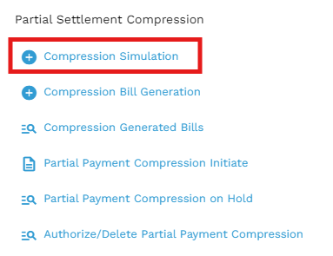
User will input Application ID, Number of Installment and Recalculation Method (Installment/Term) then validate and hold.
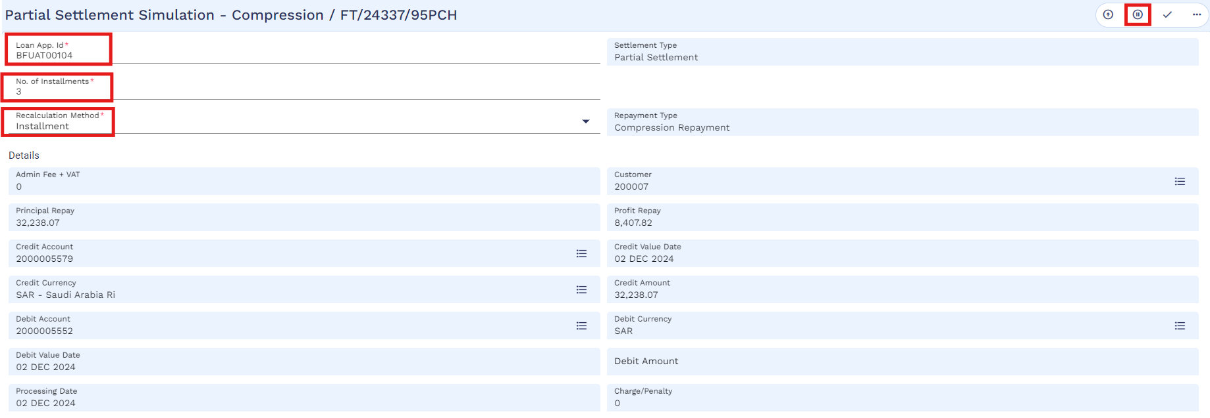

Then user will check the simulated results via 360 overview.
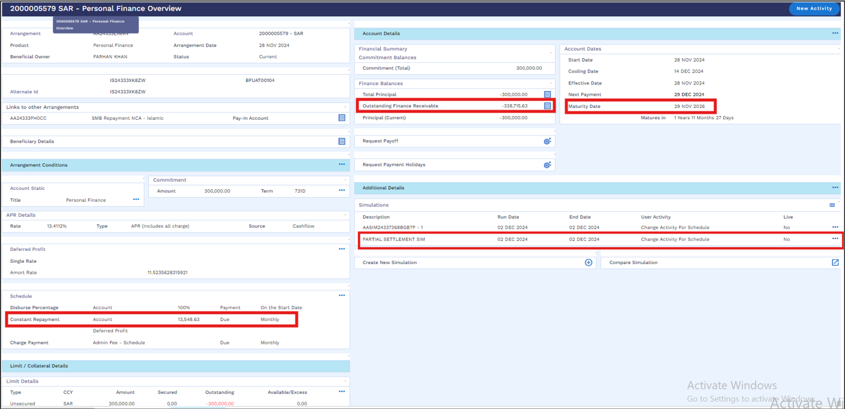
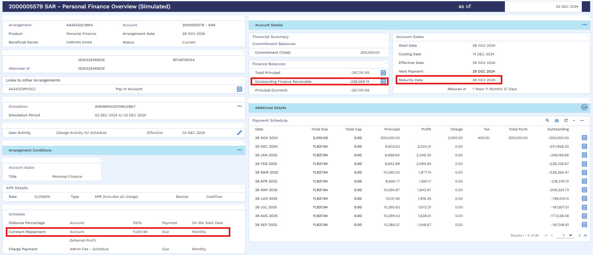
User will follow below navigation for Partial settlement
SMB Islamic Operation → Partial Settlement Compression → Compression Bill Generation
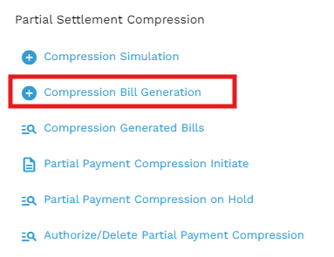
Then user will input Loan App id, No. of instalments, Source of income and Recalculation Method.
There are two recalculation methods available for the user i.e. Term / Installment note that if the customer wants to reduce the Tenor then the Recalculation Method as “Term” should be selected and the customer wants to reduce the installment amount then the Recalculation Method as “Installment” should be selected.
After that the user will validate the activity through a validation icon.
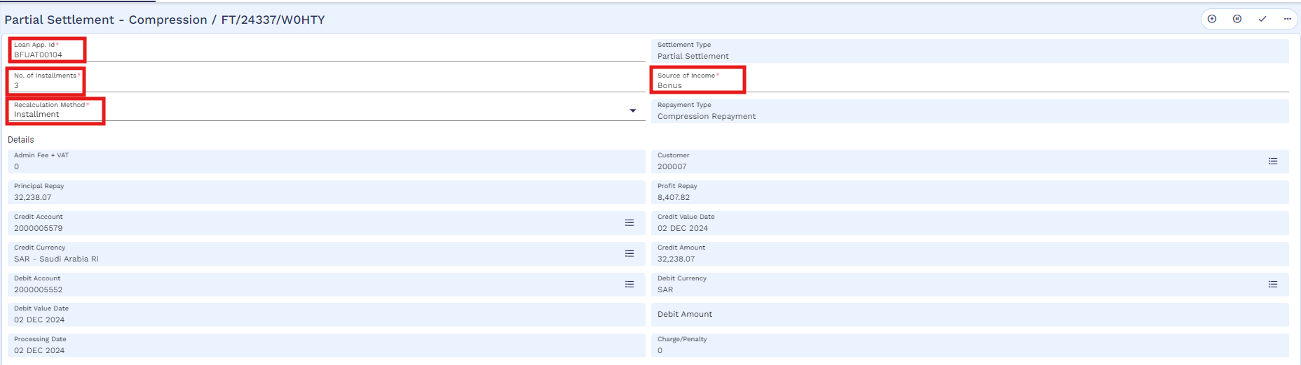
And then commit the record.
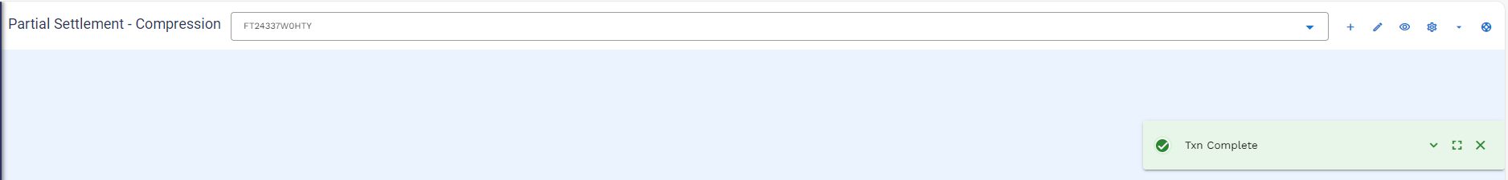
User can check the bill by using below navigation
SMB Islamic Operation → Partial Settlement Compression → Compression Generated Bills
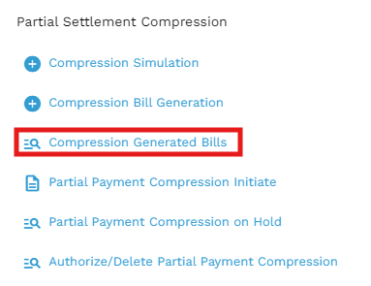
User will put the application ID
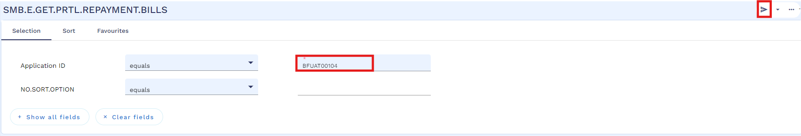
Below window will open, User will click on the view icon
Generated bill as below, through a service this is integrated with SADDAD. Like other processes, this process can also be integrated with servicing app.
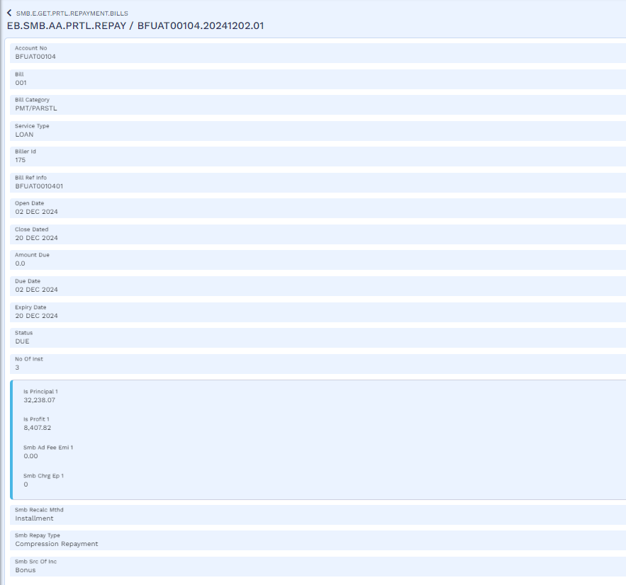
User will make the funds available in customers repayment account as mentioned in early payoff section.
Once the funds are available in customer repayment account, user will initiate compression payment as per below navigation.
SMB Islamic Operation → Partial Settlement Compression → Partial Payment Compression Initiate
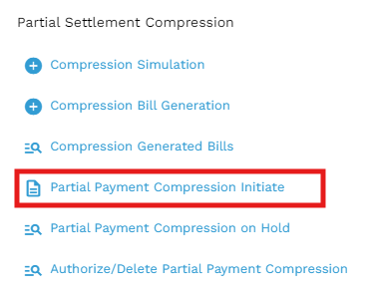
User will enter the application id and then click on the edit icon
After that user will put the bill reference and then validate the activity
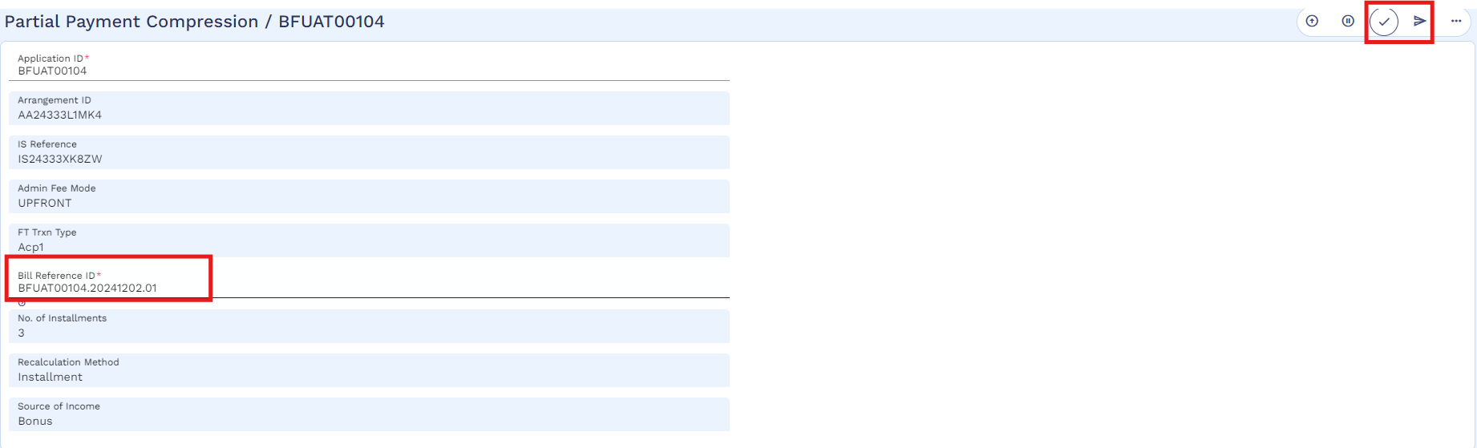
And then commit the record.
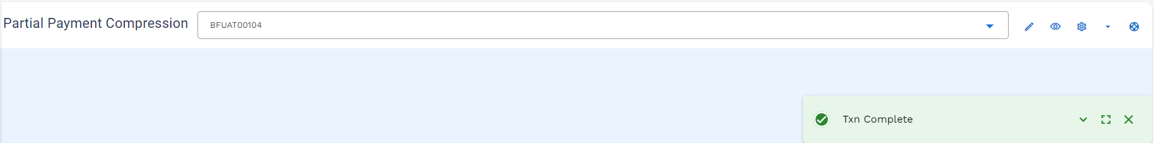
User will follow below navigation to commit the record from hold
SMB Islamic Operation → Partial Settlement Compression → Partial Payment Compression on Hold
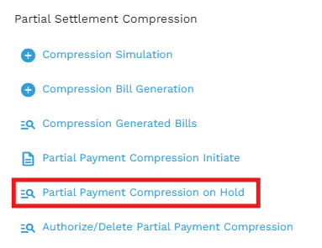
User will put the application id and click to find icon
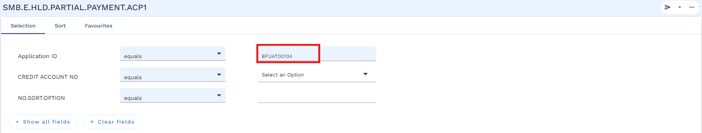
Below window will open, then user will click on the view icon to commit

User will validate and commit the record.
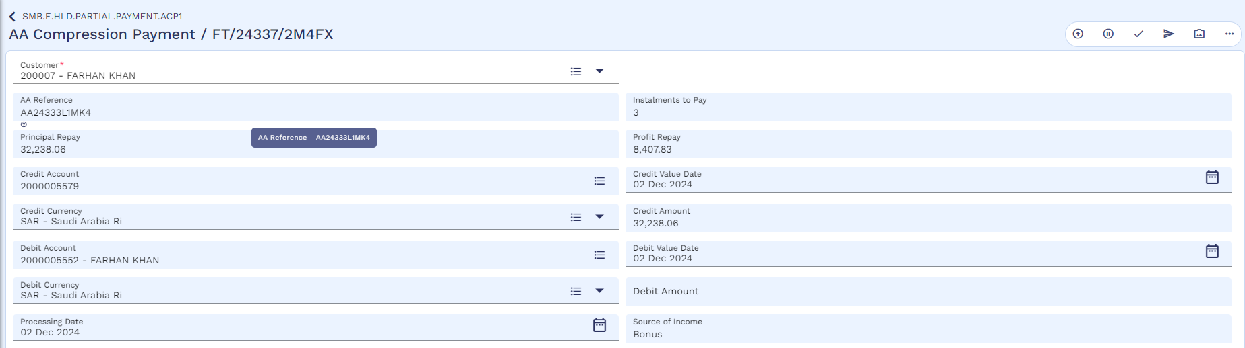
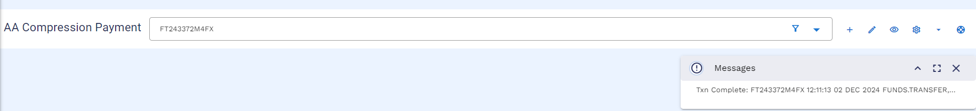
Now the authorizer will authorize the record by following below navigation
SMB Islamic Operation → Partial Settlement Compression → Authorize / Delete Partial Payment Compression
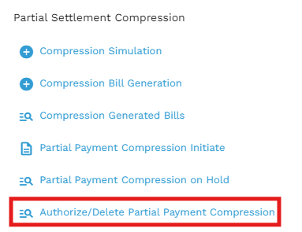
User will put the application id and click on the find icon
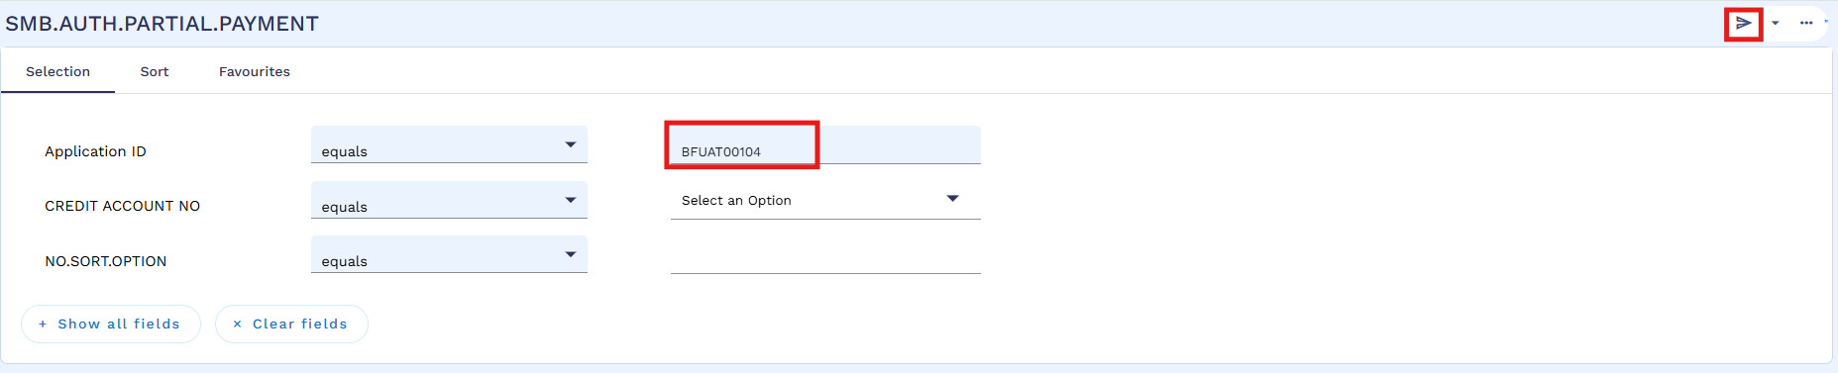
Then click on the view icon
Authorizer will validate and commit the record.
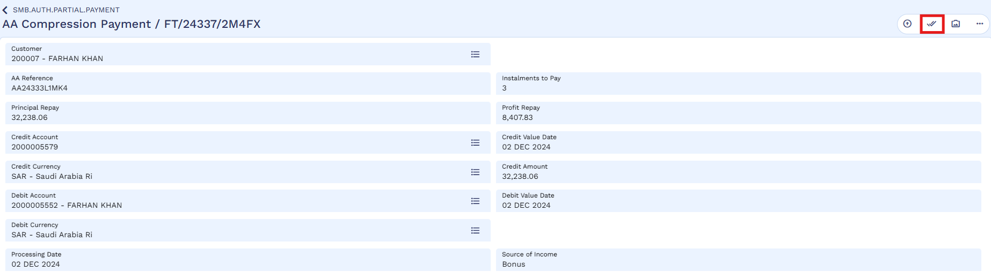
Authorization is completed.
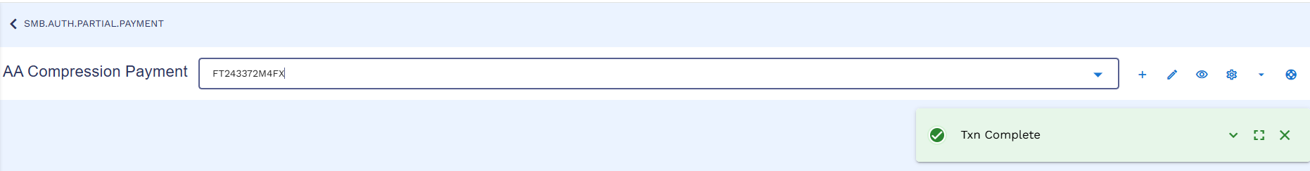
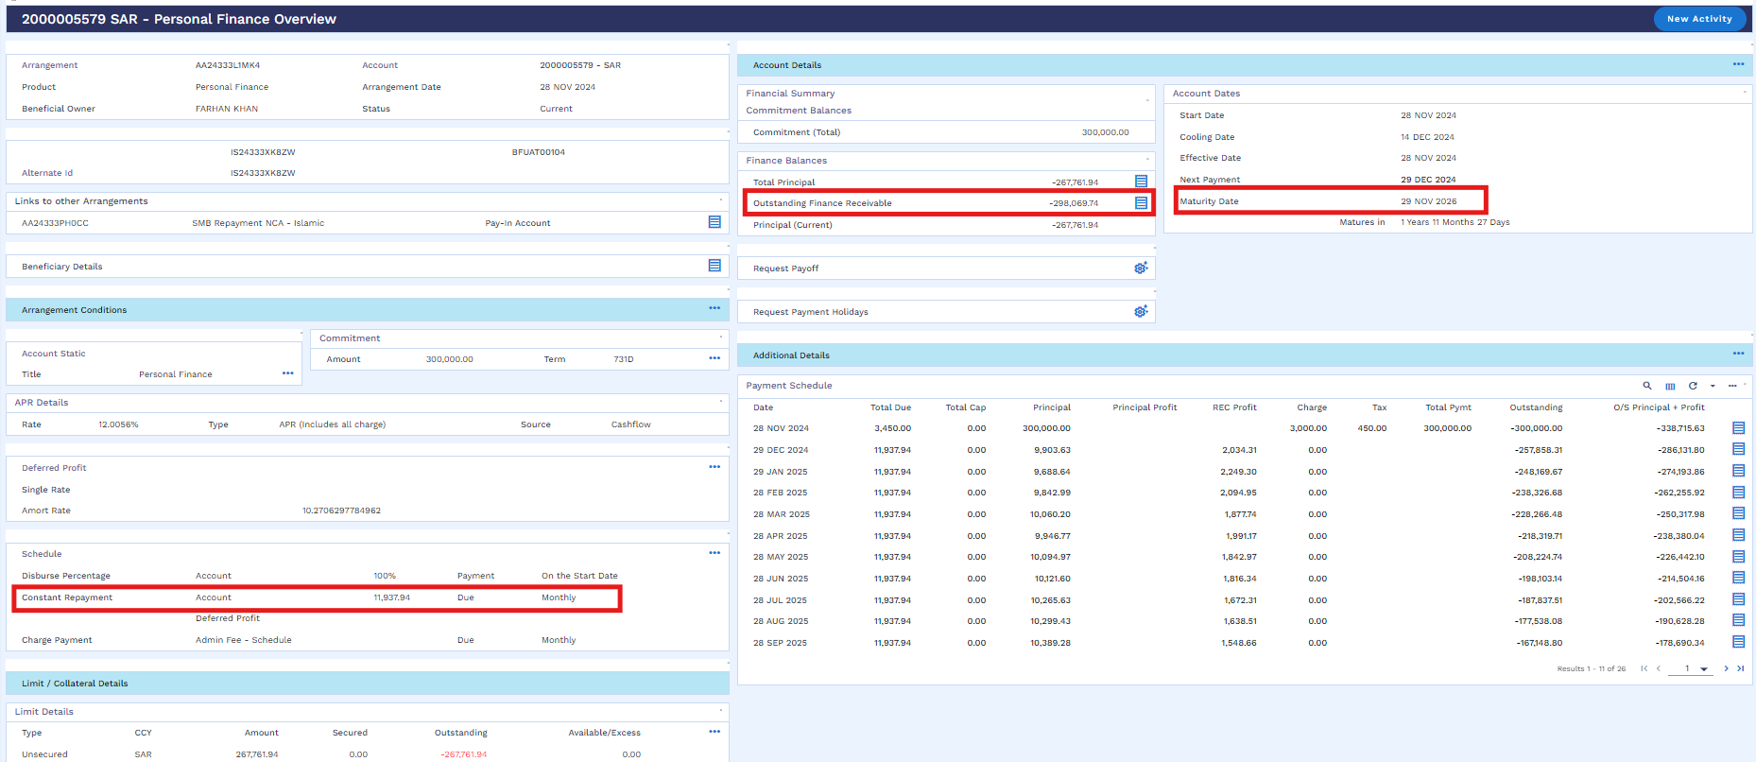

Worksheet details:
- File Name: Murabaha Working Sheet
- Sheet Name: “Partial Settlement - Installment-TA” and “Partial Settlement - Revise Term-TA”

AA – Principal Decrease
The user can conduct a "Principal Decrease" as a partial settlement activity when the customer intends to settle six installments. It's important to note that principal decrease can only be executed when settling six installments.
User will follow below navigation for Partial Settlement Principal Decrease Simulation
SMB Islamic Operation → Partial Settlement Principal Decrease → Principal Decrease Simulation
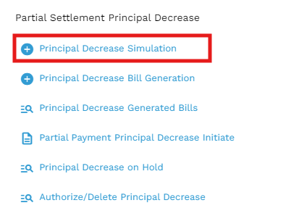
Upon clicking the simulation option below window will open in which user will input Loan App ID, No of Installment and Recalculation Method (Installment/Term) then validate and hold.
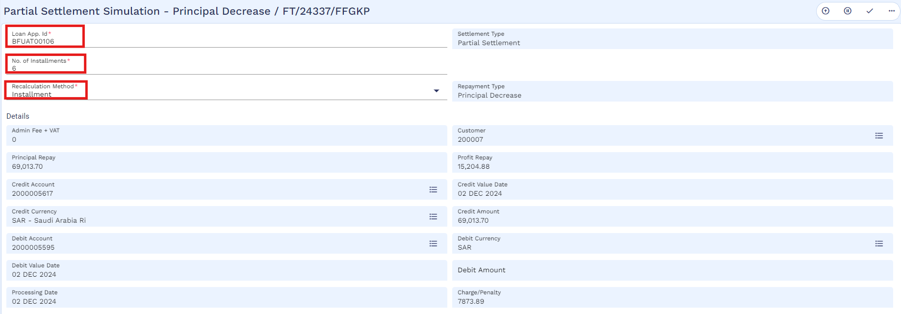
Then user will check the simulated schedule via 360 overview.
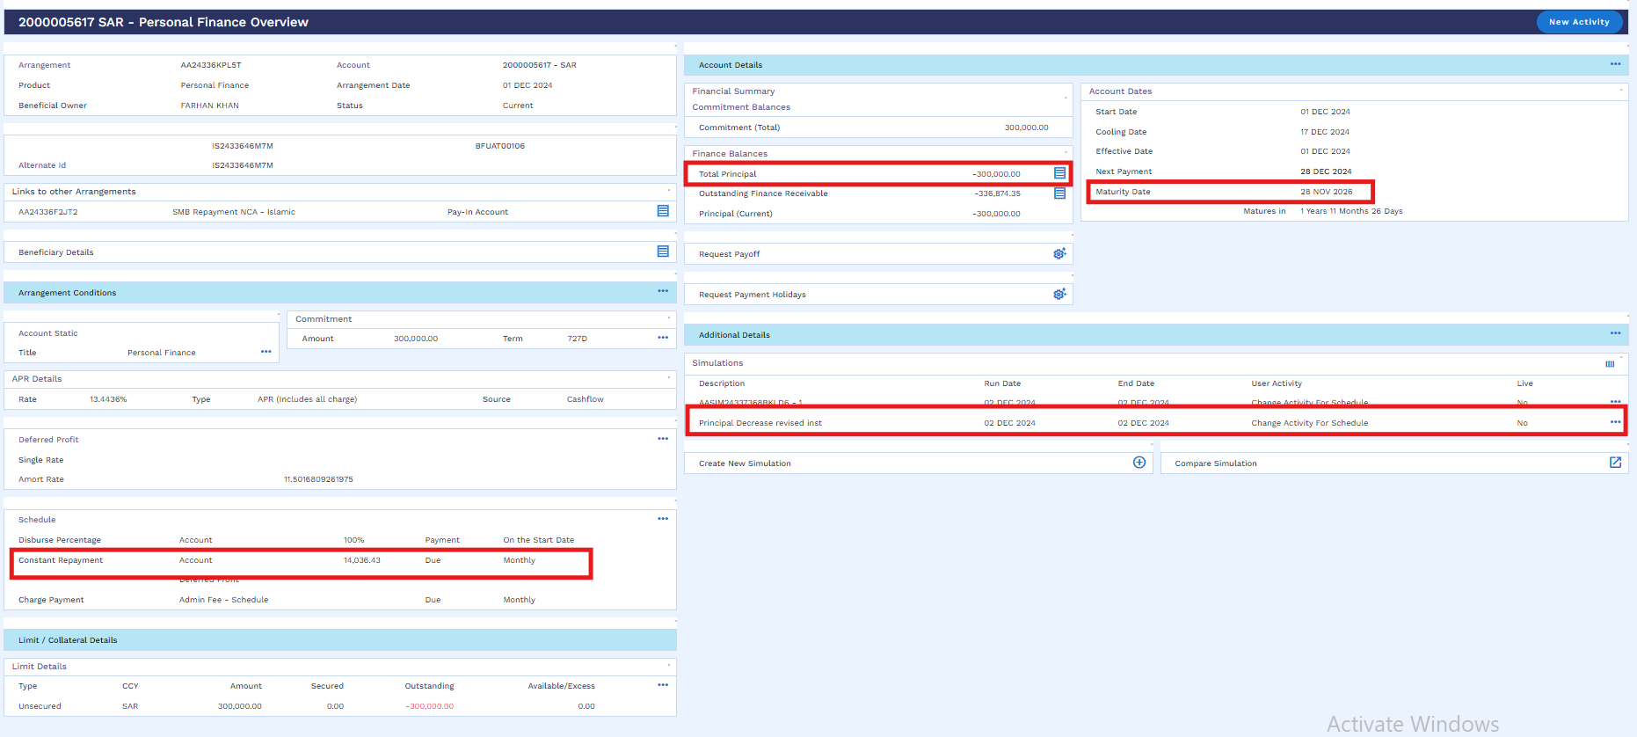
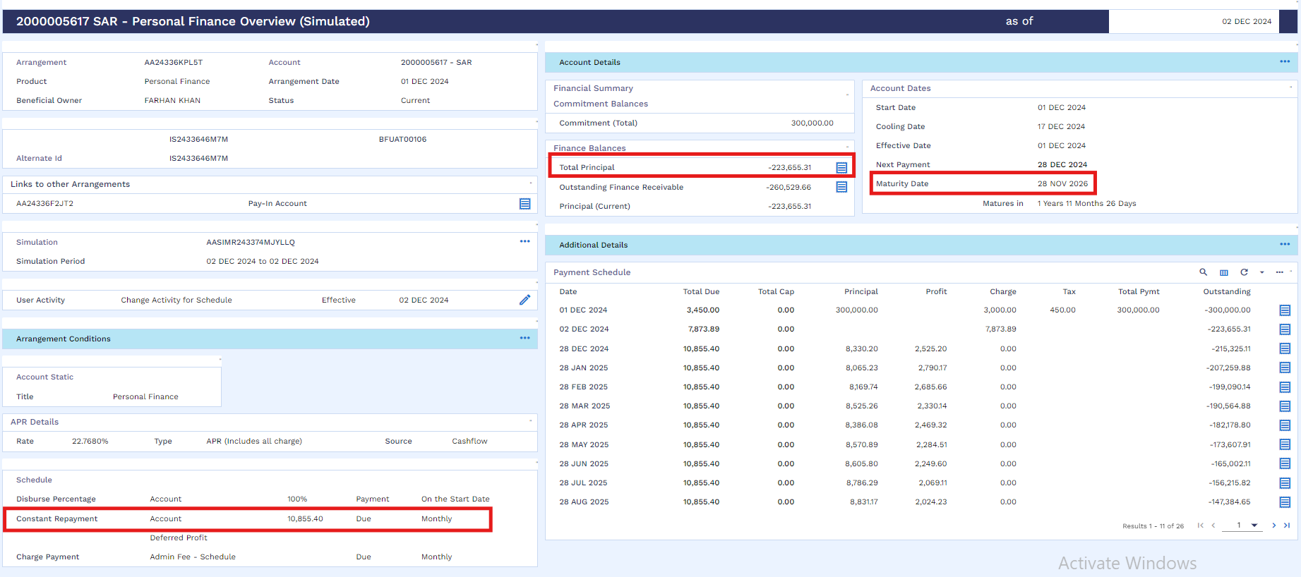
After simulation user will follow below navigation for Partial settlement bill generation.
SMB Islamic Operation → Partial Settlement Principal Decrease → Principal Decrease Bill Generation
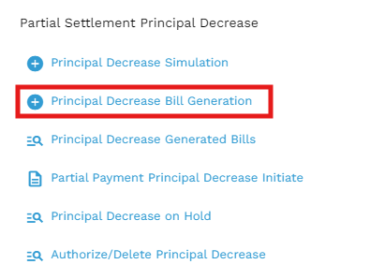
Below window will open in which user will input Loan App id, No of installments, Source of income and Recalculation Method.
There are two recalculation method available for the user i.e. Term / Installment note that if the customer wants to reduce the Tenor then the Recalculation Method as “Term” should be selected and the customer wants to reduce the installment amount then the Recalculation Method as “Installment” should be selected.
After that the user will validate the activity through a validation icon.
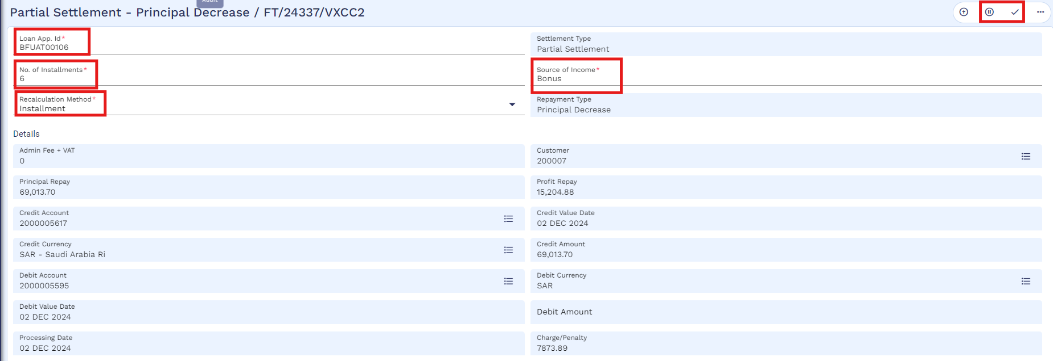
And then commit to the record.
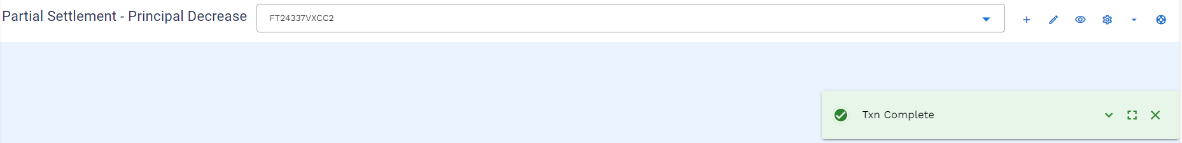
User can check the bill by using below navigation.
SMB Islamic Operation → Partial Settlement Principal Decrease → Principal Decrease Generated Bills
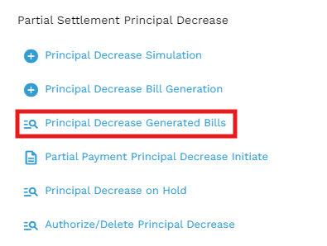
User will put the application ID and click find.
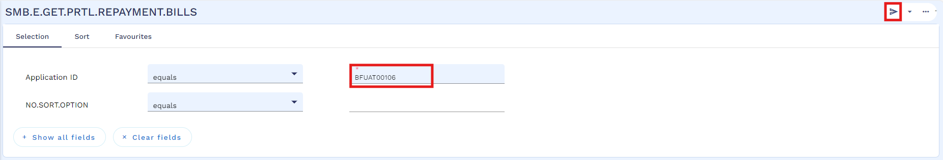
Below window will open, User will click on the view icon to review the generated bill.
Generated bill as below
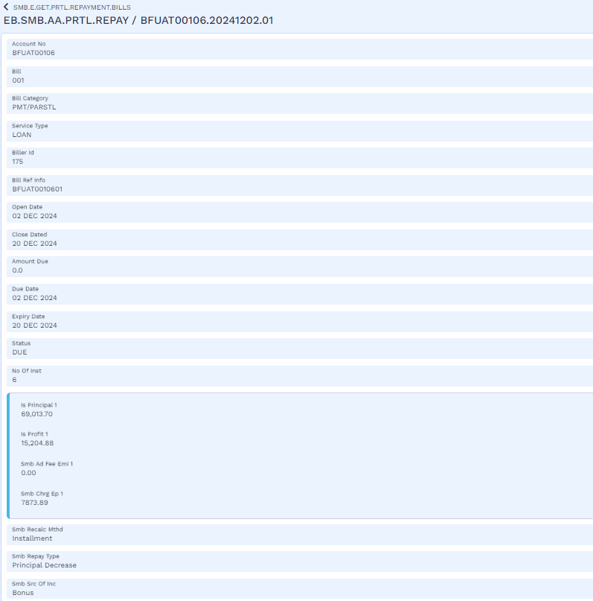
Through a service this is integrated with SADAD. Like other processes, this process can also be integrated with servicing app.
User will make the funds available in customers repayment account as mentioned in early payoff section
Once the funds are available in customer repayment account, user will initiate Principal Decrease payment as per below navigation
SMB Islamic Operation → Partial Settlement Principal Decrease → Partial Payment Principal Decrease Initiate
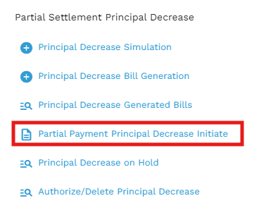
User will enter the application id and then click on the edit icon
After that user will put the bill reference and then validate the activity
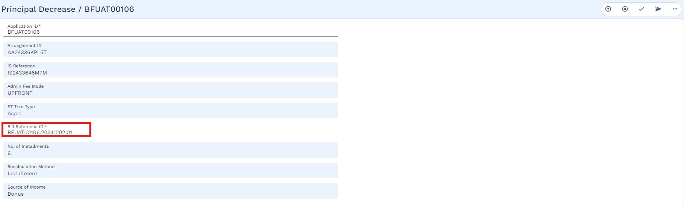
And then commit the record.
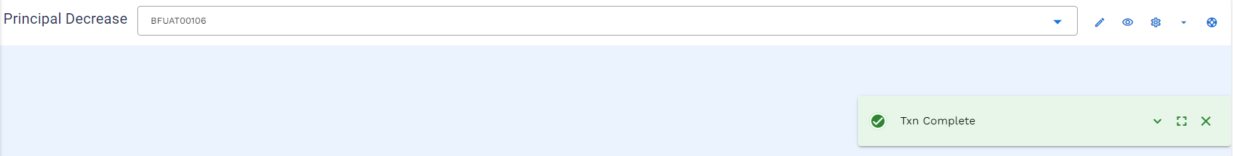
User will follow below navigation to commit the record from hold
SMB Islamic Operation → Partial Settlement Principal Decrease → Principal Decrease on Hold
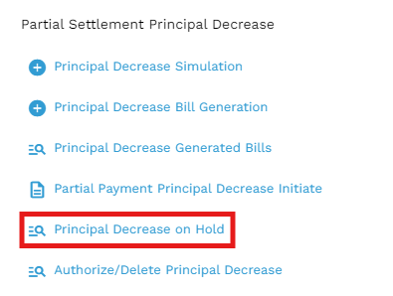
User will put the application id and click to find icon
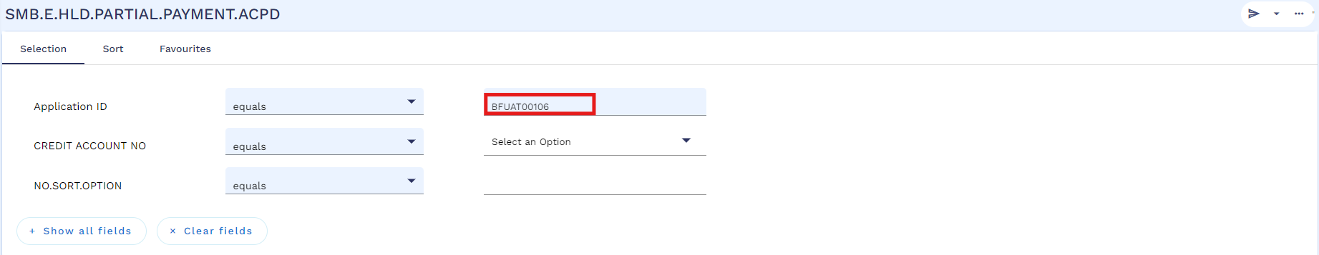
Below window will open, then user will click on the view icon to commit
User will validate and commit the record.
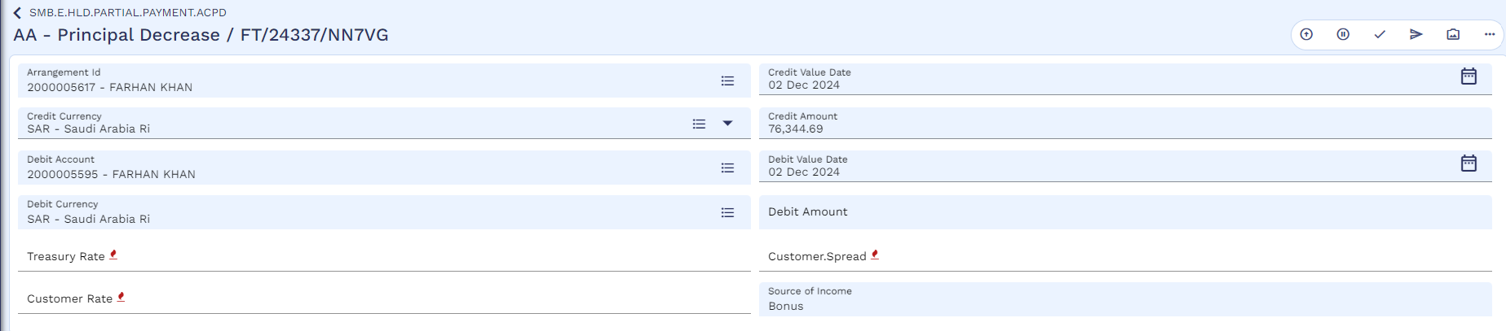

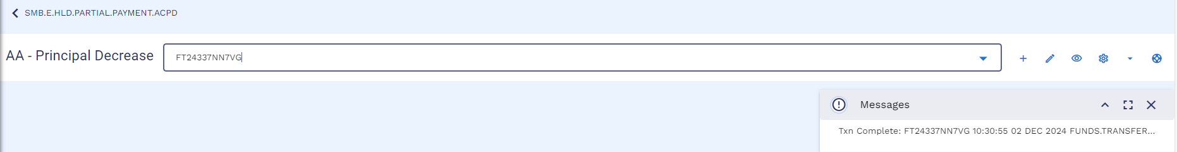
Now the authorizer will authorize the record by following below navigation
SMB Islamic Operation → Partial Settlement Principal Decrease → Authorize / Delete Principal Decrease
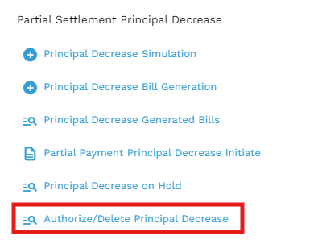
User will put the application id and click on the find icon
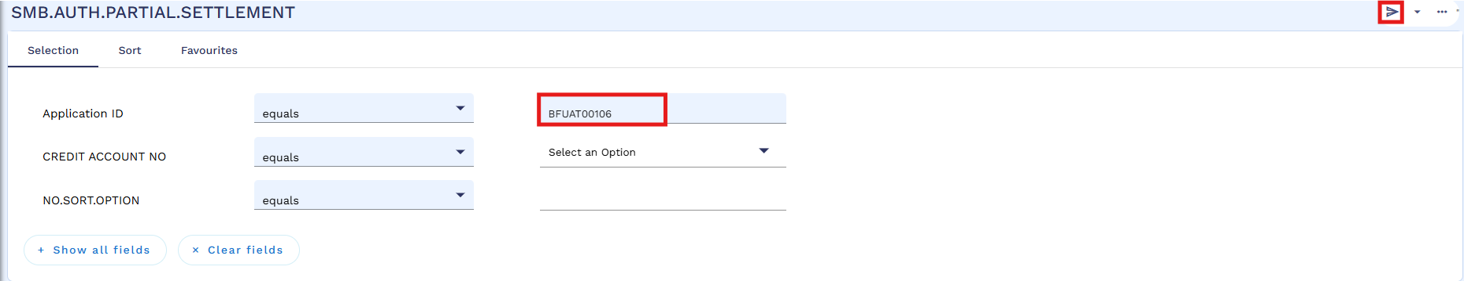
Then click on the view icon
Authorizer will validate and commit the record.
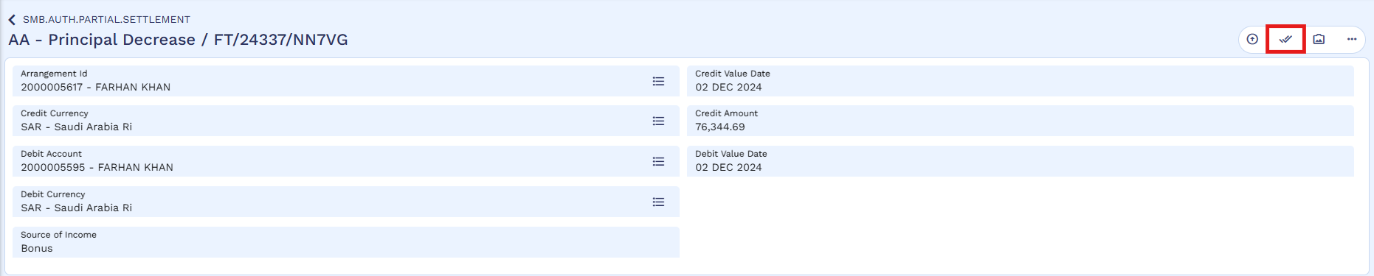
Authorization is completed.
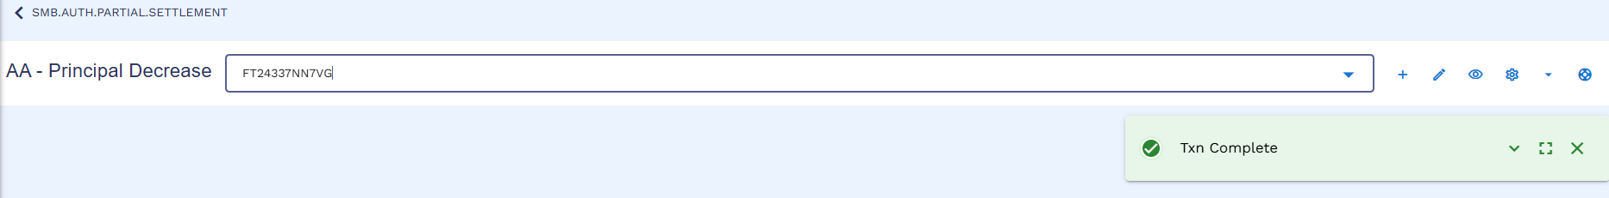
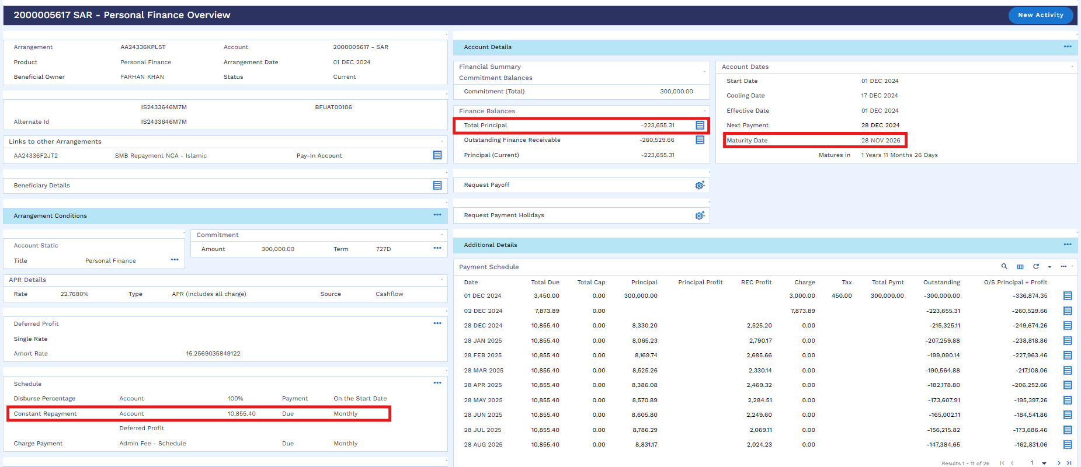

Worksheet details:
- File Name: Murabaha Working Sheet
- Sheet Name: “Principal Decrease - Installment-TA” and “Principal Decrease - Term-TA”.

Restructuring (WS03-MUR-13)
Below restructuring process is pertaining Murabaha product.
There will be four scenarios in restructuring:
- Principal Only
- Principal + Profit
- Top-up + Principal
- Top-up + Principal + Profit
Existing restructuring process requires several steps as shown below:
Customer CIF | 100630
IS Contract | IS23257Q00FR
Payin (Repayment) Account | 3000008035
Old Arrangement | AA23257ZLBPK, 3000008019

Request Stage
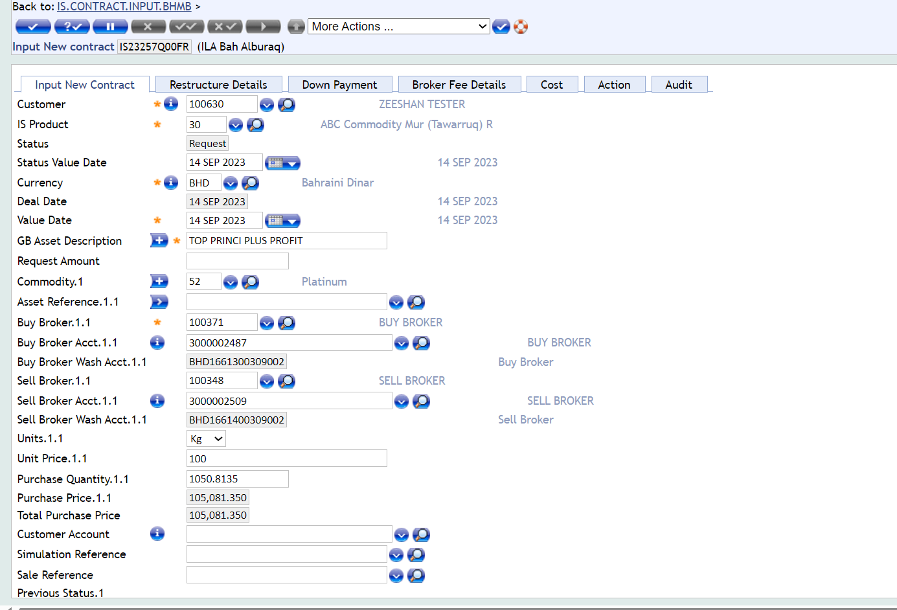

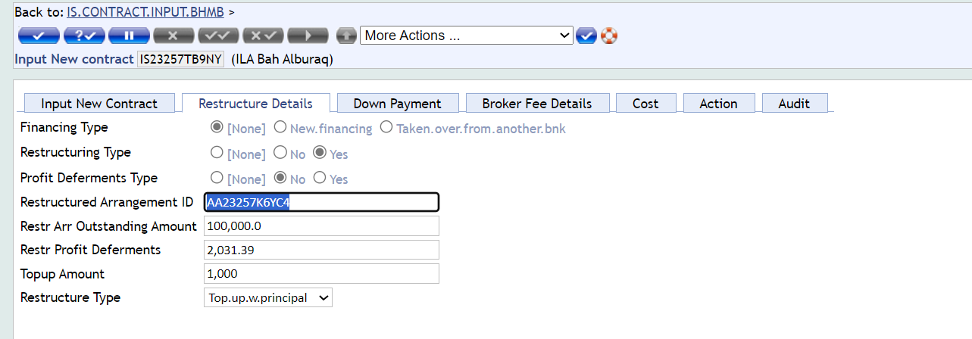
Authorization
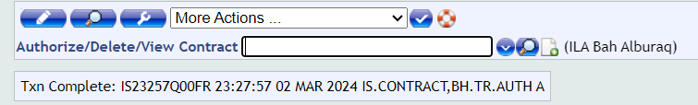

Approval Stage
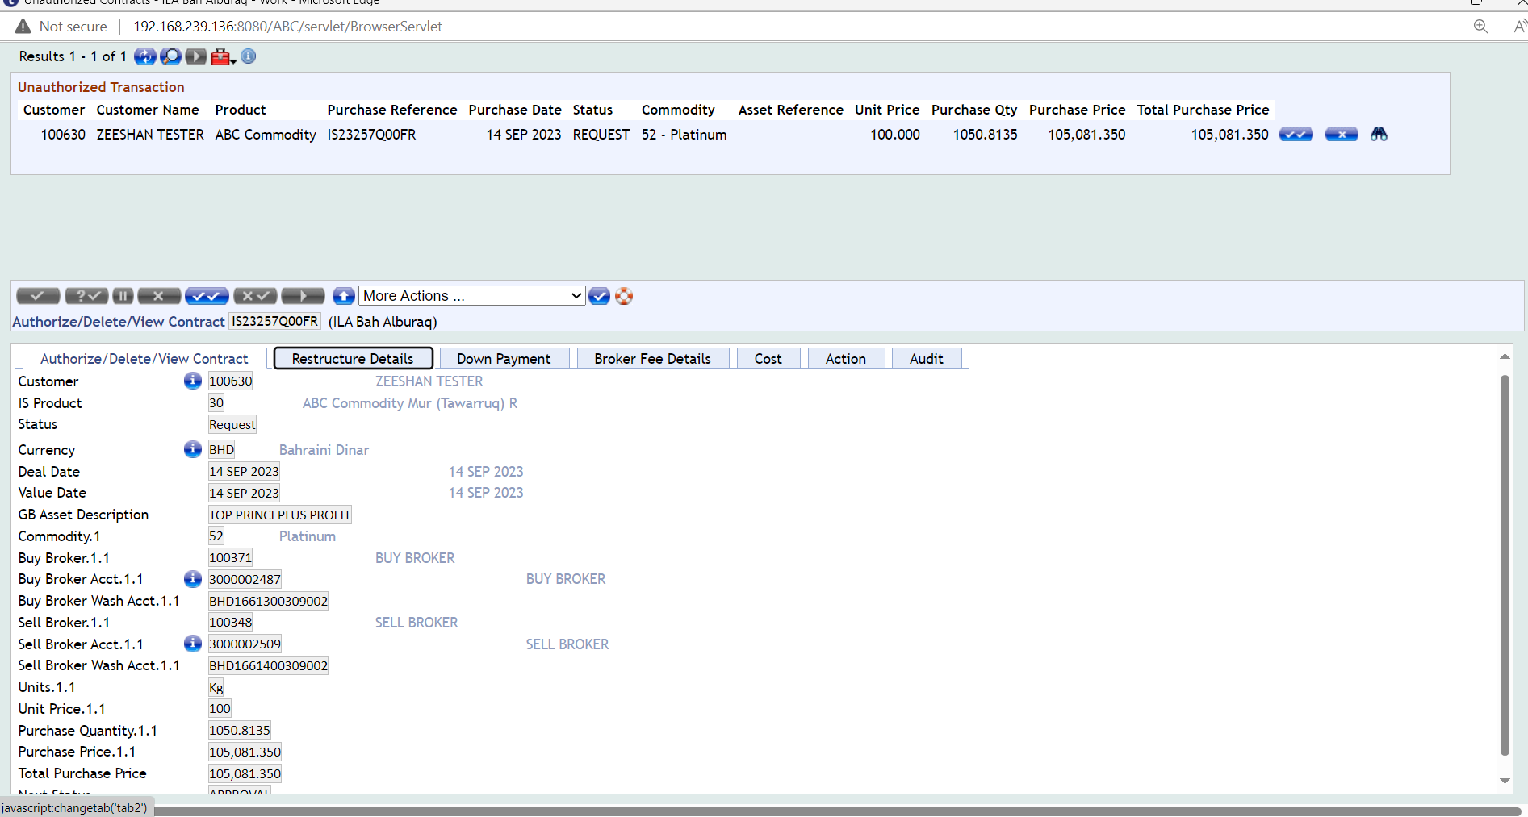
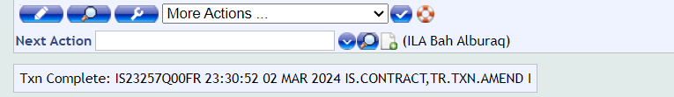
Authorization
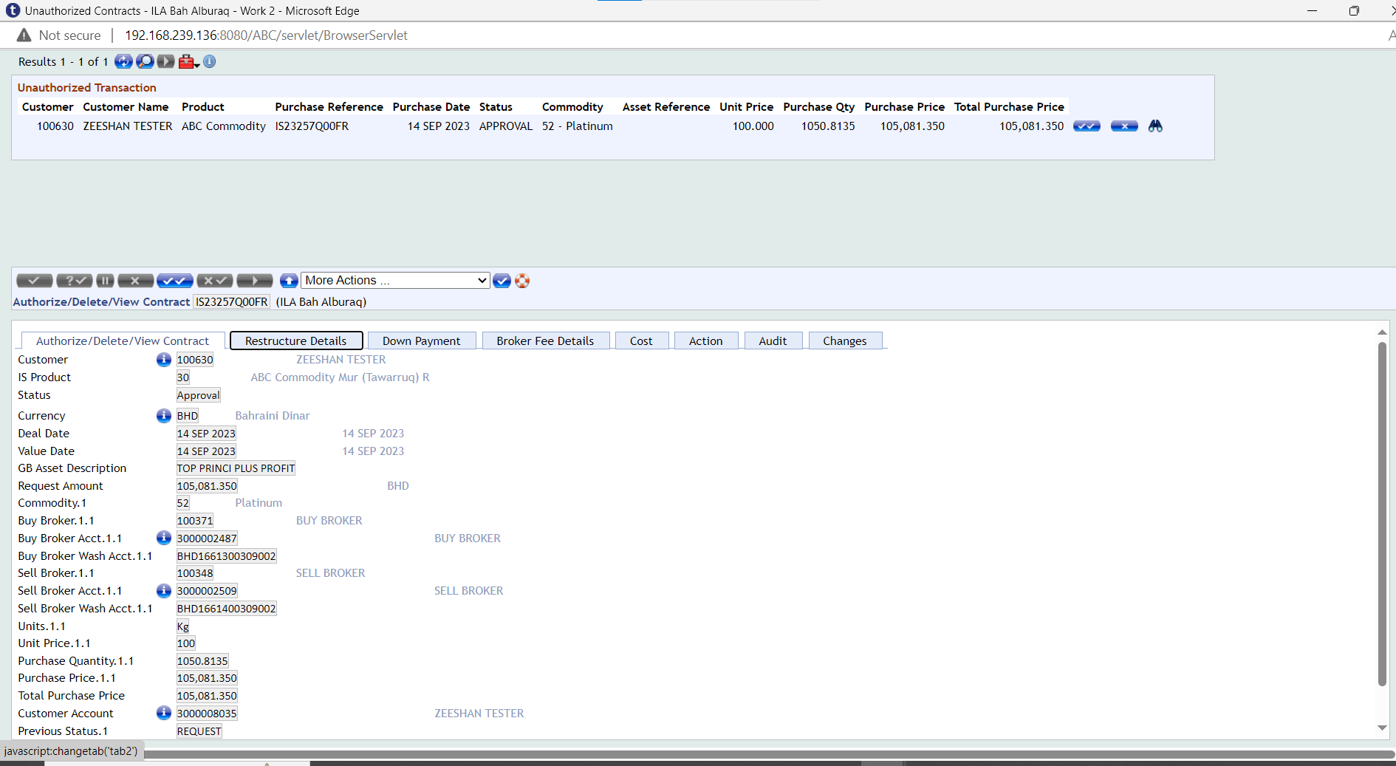
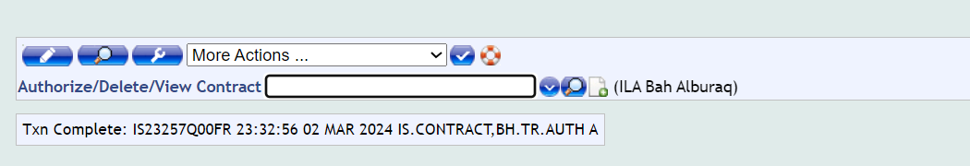

Purchase Stage
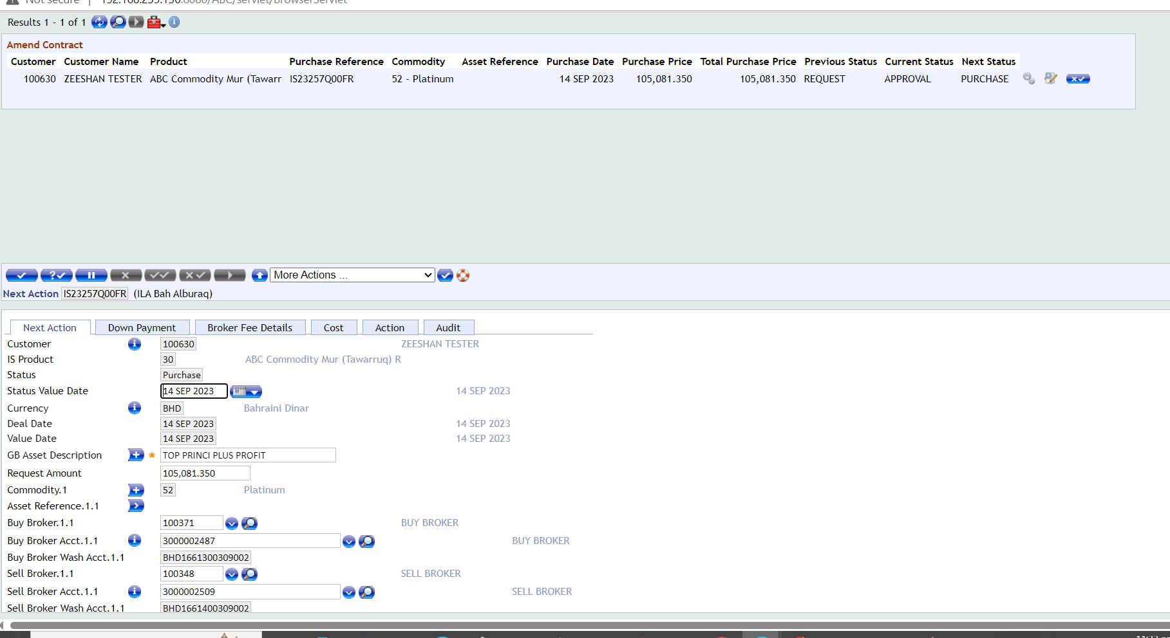

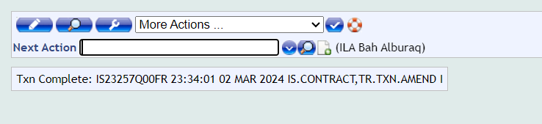
Authorization
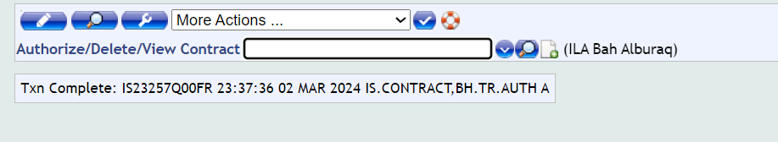

Arrangement Booking
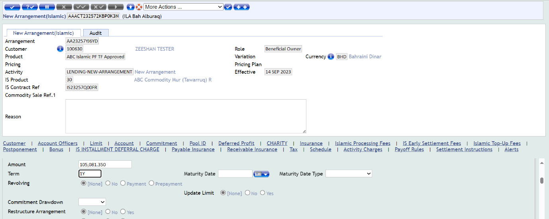
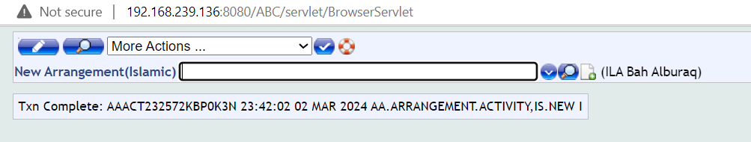
Authorization
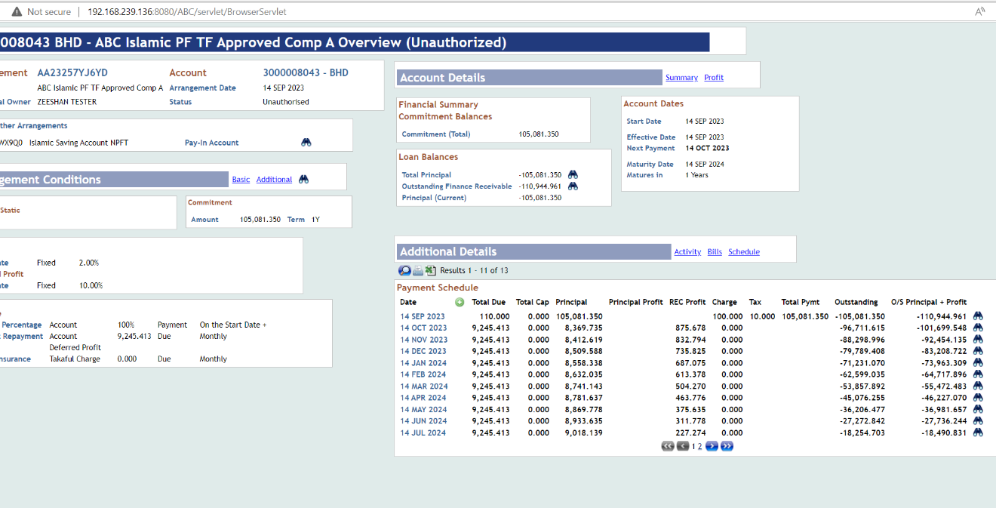
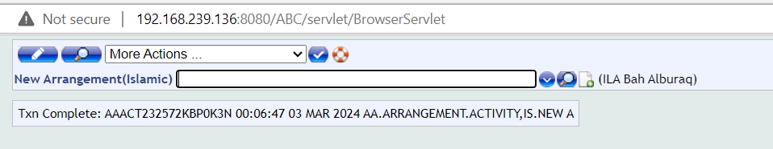

Commodity Restructuring Stage
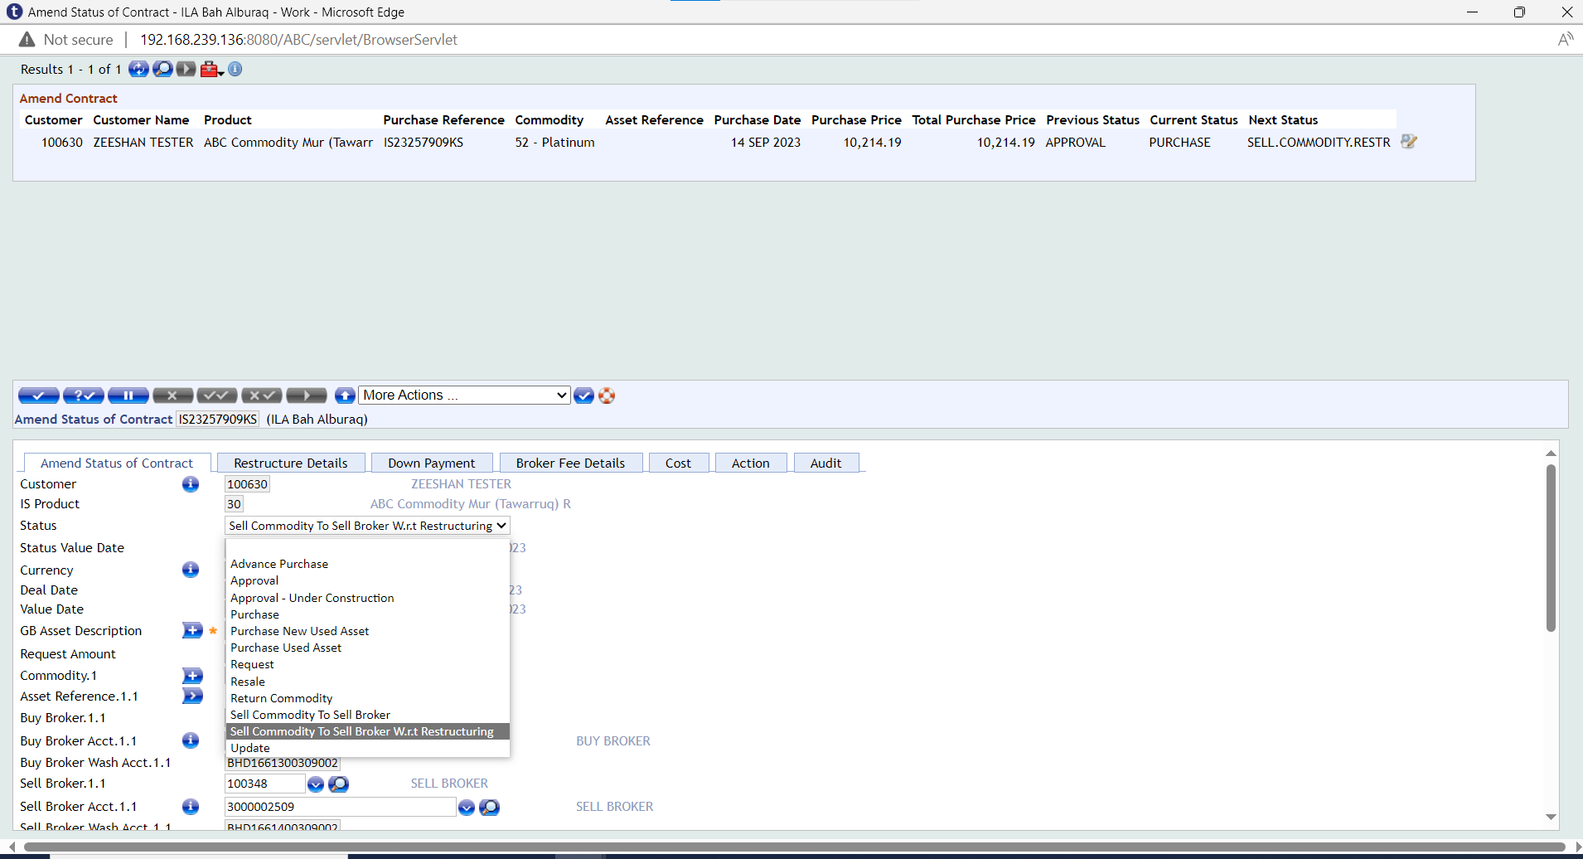
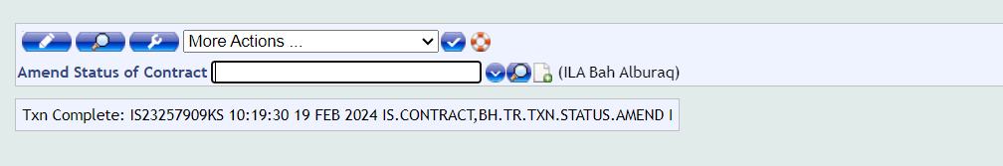
Authorization
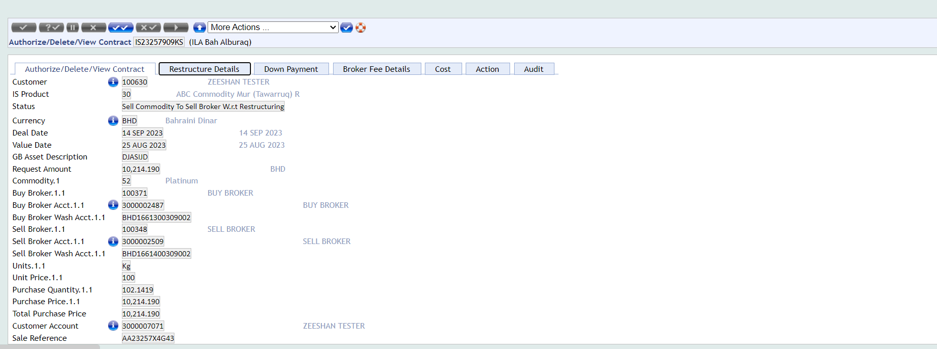
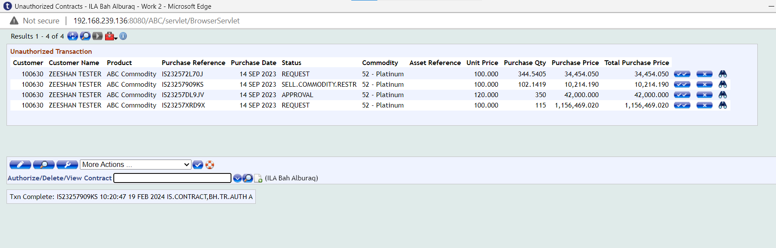

Financial Entries
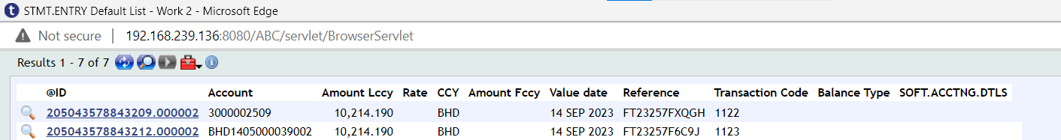
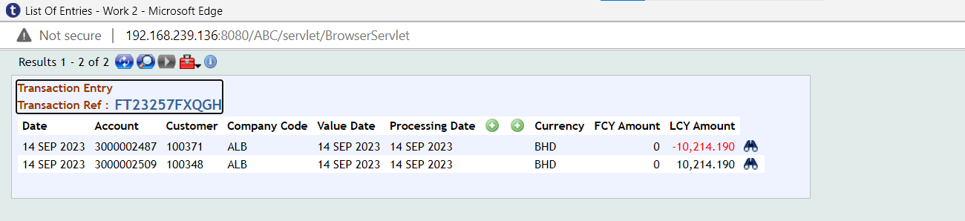
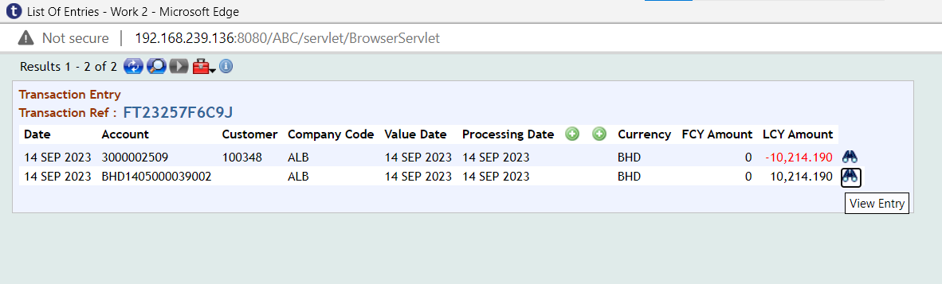

Enquiries (WS03-MUR-14)
Below enquiries are available in SMB.
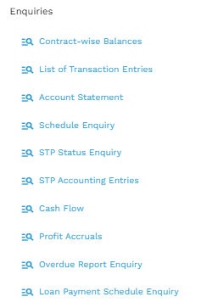
- Contract-Wise Balances
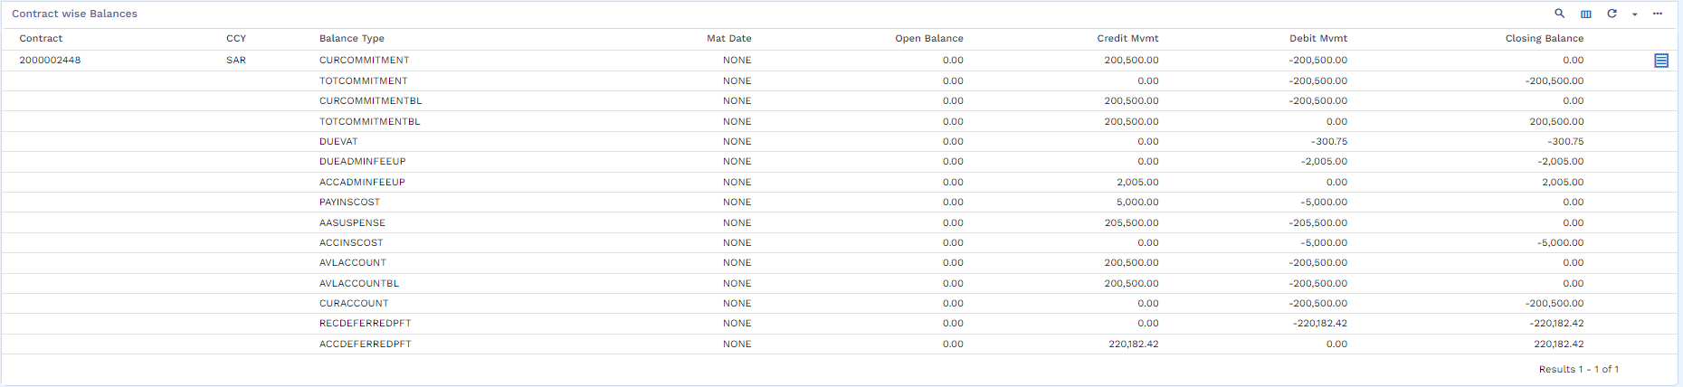
- List of Transaction Entries
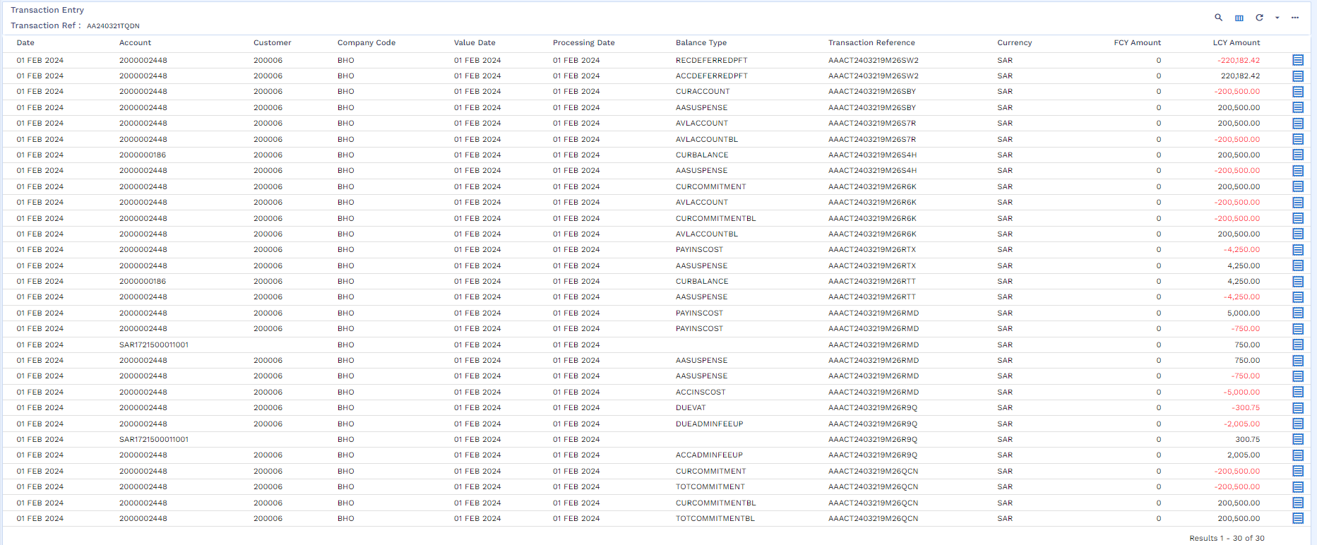

- Account Statement
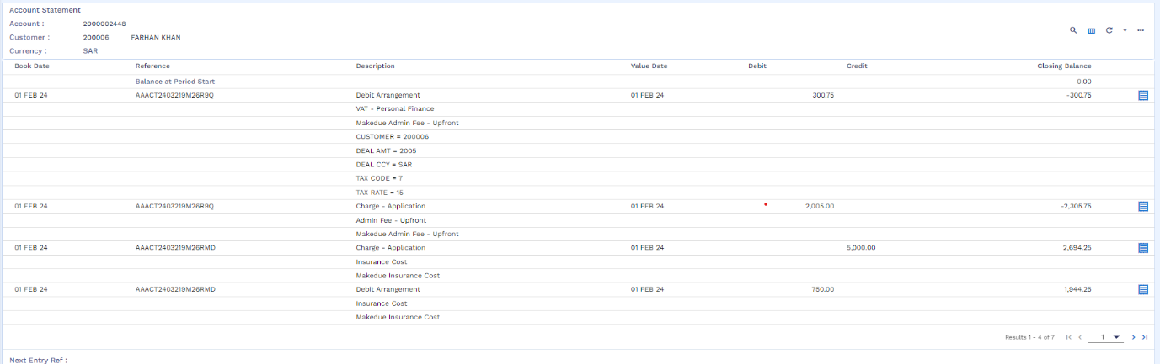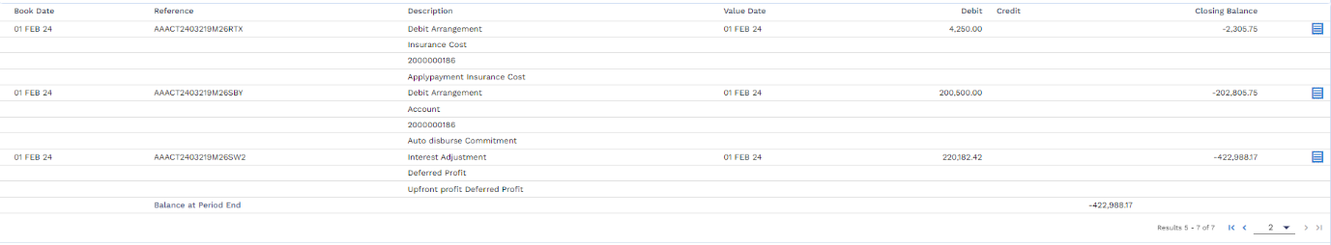
- Schedule Enquiry

- Cash Flow Enquiry
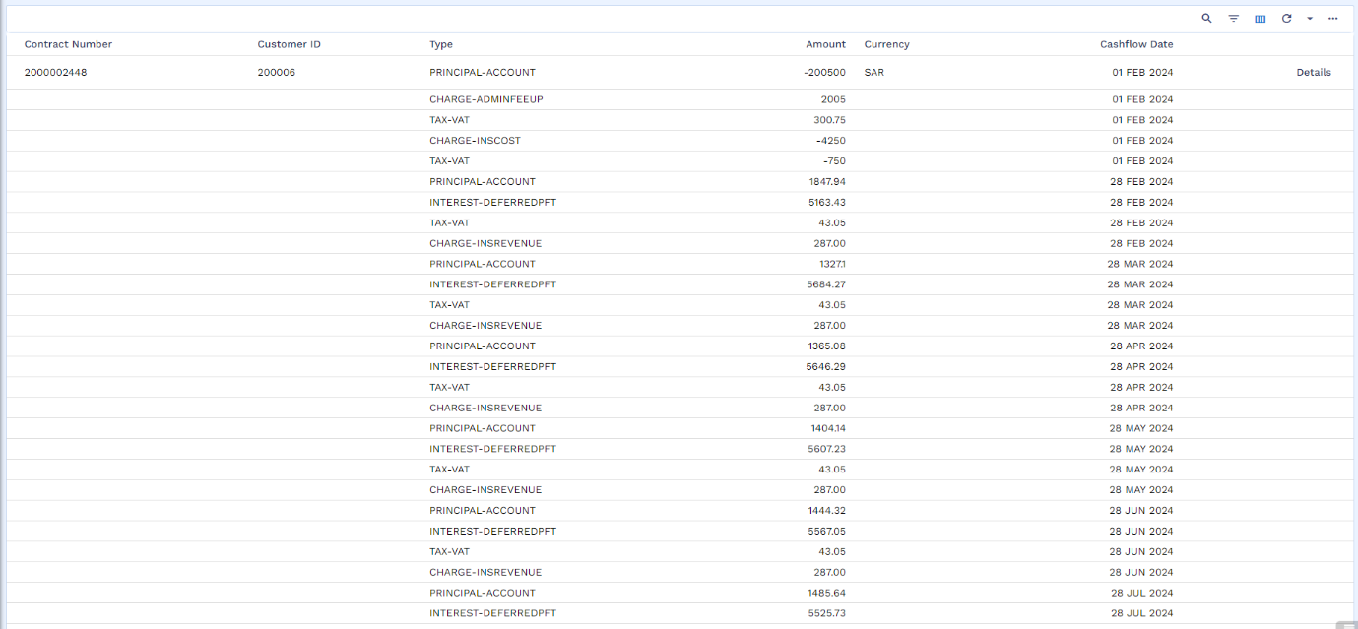
- Profit Accruals
- Overdue Report Enquiry
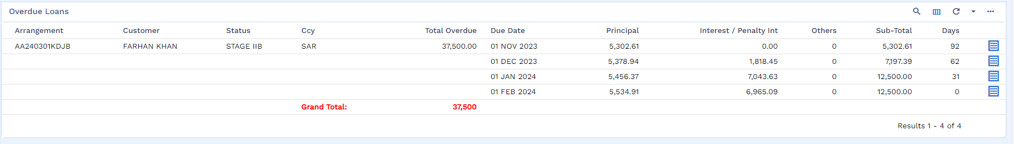
- Loan Payment Schedule Enquiry
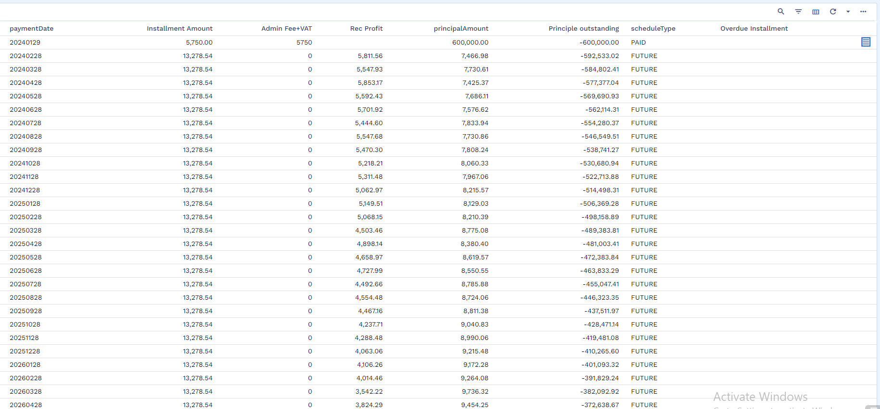

Deltas
Following gaps are captured in this document:
S. # | Gap Number | Gap Details
01 | WS03MUR-04-01 | List of Vendors
02 | WS03-MUR-02-01 | Validation for sufficient funds
03 | WS03-MUR-09-01 | Maintenance Activities
04 | WS03-MUR-03-02 | Assets Details
05 | WS03-MUR-05-01 | E – Invoice for VAT
06 | WS03-MUR-05-02 | STMT Transaction
07 | WS03-MUR-12-01 | Advance/ Partial Payment
08 | WS03-MUR-05-03 | Limit Attachment before Arrangement
09 | WS03-MUR-05-04 | Discount
10 | WS03-MUR-08-01 | Post Delivery Cancellation
11 | WS03-MUR-05-06 | Reversal of Admin Fee
12 | WS03-MUR-02-03 | Straight Through Process - STP
13 | WS03-MUR-13-01 | Restructuring
14 | WS03-MUR-02-04 | Offer Letter, Contract Generation & Other Letters
15 | WS03-MUR-11-01 | Post Write-Off Recovery
16 | WS03-MUR-10-06 | Bullet Payment & EPC
17 | WS03-MUR-05-06 | File Upload of Repayment through IBFT

Detailed Description of Deltas

List of Vendors - WS03-MUR-04-01
Tamweel Team will provide the Vendor list which needs to be added in Transact the vendor can be active or de-active. Each Vendor will have its own CIF and Repayment’s account.
- Category wise segregation is required Vendor e.g. Ijarah Vendor, Tawarruq Vendor or Murabaha Vendor etc.
- ID number for Vendor (TA please write length and data type)
- VAT Registration Number (TA please write length and data type)
- The TA (SAP) team will provide a unique SAP Vendor Number for each vendor. This number must be stored and associated with the corresponding vendor record in Temenos Transact.
- For Vendor CIF, Customer BSDD must be signed with above information. This BSDD is only for reference.
- Under the Product Group of Murabaha there will be an option to add multiple vendors.
- There are 2 types of financing (1) Voucher (2) Non-Voucher (PO Base Financing). For PO base financing there is separate vendor for each service.

Validation for sufficient funds - WS03-MUR-02-01
- For asset financing there is Admin as an optional. (This admin fee is based on service provider and therefore should be parameterize and will auto fetch from LOS)
- For voucher base financing there is no Admin Fee.
Upon acceptance of offer, Sadad bill will be sent to customer for admin fee plus VAT once the customer will be deposited than Finance contract will be initiated. This only for Assets base finance.
Before generation of Financing Agreement, a validation is required for sufficient funds in customers repayment accounts equivalent to Admin Fee plus VAT (if applicable).
Admin fee values are based on scheme whereas in product we will manage in GL till the time Finance contract not generated. This admin fee will park in customer repayment account till the time Finance Arrangement created in order to maintain APR.

Maintenance Activities - WS03-MUR-09-01
All maintenance activities will same as Tawarruq such as
- Partial Settlement
- Deferment
- Early termination of interest-bearing loan and non-interest bearing contract where there is no EPC of next three months
- Repayment process
- Waiver
- Generation of SADAD bill and Write-off.

Assets Details - WS03-MUR-02-02
Assets Details will include following information.
- PO Base Financing has below list of Assets.
- Furniture
- Home Appliances
- Cars
- Gift Cards
- Fashions
For above stated assets, only Asset Description is required even in case of Cars.
- Voucher base Financing has below Services
- Insurance Services
- Education Services
- Hospital Services
- Travel & Hotels Services
For above stated services only Description is required.
After the selection of above listed items there will be multiple vendors w.r.t selected option. Vendor List will be provided by TA. This asset description is input by customer in New Digital (ND). For assets / service description will be provided by ND based on the selected vendor along with the coupon reference. PO reference & Voucher reference will be treated as Coupon Reference.
A local ref will need to be added for Asset or Service offered under Murabaha. This filed will be mandatory and will have LOVs of all listed items. This local ref will eventually become as part of CAL Key to have separations of GL.
There will be separate profit & cost center for each service provider. This will take by Finance team of TA and SA.

E-Invoice for VAT - WS03-MUR-05-01
E-invoice is required to be issued for VAT amount which will be sent to the customer. This VAT will be applicable on insurance and admin fee.
File Name: VAT E-Invoice Template
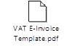

STMT Transaction - WS03-MUR-05-02
For every Transaction in STMT, TA needs IS CONTRACT, APPLICATION ID, SADDAD Reference. this is important for reporting purpose.

Advance/Partial Payment - WS03-MUR-12-01
There is a possibility that customer transfers funds from IBFT where there is no invoice number (It is treated as Advance Payment), in this case if any request of partial payment/ payoff is received the invoice/bill amount will be net off with this advance amount and in case, the resulted amount becomes zero then only simulated schedule will be sent to customer and upon the acceptance of this schedule entry will be passed.

Worksheet details:
File Name: Murabaha Working Sheet
Sheet Name: DayN-File Upload

Limit Attachment before Arrangement -WS03-MUR-05-03
Limits need to attach before creating Arrangement. This should be auto populated on arrangement level as part of STP.

Discount - WS03-MUR-05-04
Discount from Vendor
- A Discount Percentage will be provided by LOS, as mentioned in E2E Accounting Entries. TA needs to decide whether this % will come from LOS or it should be set on parameters. Accordingly, solution will be provided.
- LO will share Total Amount, Discount Percentage, Discount Amount and Net Amount. Discount is part of scheme.
- Discount from vendor will be amortized over financing term. SA team will revert on it.
Discount from Tamweel:
There is possibility that customer will get discount for example first two instalment are free, means TA will settle these accounts internally from Marketing Expense
TA is giving any free instalment to customer (settling the first N bills through their internal account), in this case there wouldn’t be any changes in customer’s APR. Moreover, since this is instalment free period for customer no SADAD bill should be generated. Free Instalments number should be communicated by LOS to LMS. This free instalment has no impact on APR.

Worksheet details:
File Name: Murabaha Working Sheet
Sheet Name: Proposed E2E Ent. Discount.

Cooling period Cancelation - WS03-MUR-08-01
    - Cancellation of Asset
  - Cooling period cancellation - There is 10 days cooling period, but it is not part of ND. Customer may come to TA branch or through call center. this cancelation will execute without the reversal of Admin fee.
  - Treatment of Vandor Discount - Vendor discount will be be reversed in case of cancellation during cooling period.

    - Cancellation of Voucher
- There is no admin fee, therefore no reversal is required.
- Cooling period cancellation is also applicable for voucher same as above
- There is no unredeemed voucher concept in product.

Reversal of Admin fee - WS03-MUR-05-05
The reversal of admin fee + VAT will be occurred in the below scenarios:
- Rejection of financing contract
- Rejection of promissory note
- Rejection by customer on IVR authentication
Stage | Debit/Credit | Accounting Entries | Description
Reversal of Admin Fee | DR | Customer A/c. | Disbursement /Repayment Account
Reversal of Admin Fee | CR | TA Bank A/c. | TA Bank Account
Reversal of Admin Fee | DR | Customer A/c. | Disbursement/Repayment Account
Reversal of Admin Fee | CR | TA Bank A/c. | TA Bank Account

Straight Through Process - STP - WS03-MUR-02-03
- LO will send list of fields to LM to get simulated schedule from LM, which will be used for Qarrar and offer letter generation.
- Post offer acceptance, LO will push complete list of fields related to customer in response LM will create the CIF and Repayment account of customer. For CIF related information please refer to Customer’s documents.
- Bill will be generated for admin fee plus VAT. Upon payment of bill Credit Admin will issue the PO and sent it to vendor manually for assets base financing.
- No admin fee for voucher base financing.
- Contract will be generated through ND (if rejected/declined Reversal of admin fee)
- Promissory Note creation and acceptance by customer through NAFITH (Reversal of admin fee)
- IVR call to be responded by the customer, IVR authentication if customer reject offer then Reversal of admin fee)
- IS Contract Stage: Auto process will trigger for GLs entries as mentioned in entries of Murabaha Working sheet. (Asset Capture and IS Contract creation – Auto Creation)
- Delivery Stage: AA will be created automatically. Repayment Schedule with APR effective from delivery date will be generated on the same stage. From the same date the accrual of profit will start, during EOD process.

Restructuring - WS03-MUR-13-01
This internal buy-out where Murabaha will be converted into Tawarruq. There is only one possibility from Murabaha to Tawarruq for all kind of Murabaha contract.

Offer Letter, Contract Generation and Other Letters- WS03-MUR-02-04
` S.no | File Name | Document
1 | Clearance letter
2 | Murabaha contract - SAMA | Format to be shared by TA

In order to generate synch APR on contract and loan account, it was agreed that TA will be generating contract on daily basis till the expiry of offer. There is no impact on offer generation, offer will contain maximum APR. There is no change in first instalment date calculation, which is based on offer expiry date.
The sheet contains calculation of schedule and APR rate. Please note the current setup is based on receiving the Interest rate as IRR and then creates schedule however, based on the need system can also calculate instalment amount based on Flat rate where the Instalment amount is different from previous one. Moreover, this sheet contains two different schedule, one that is generated at the time of offer letter and other at the time of contract creation (at disbursement). Since there is a time leg between offer letter and contract creation (at disbursement) therefore, the simulated schedule (offer letter) is being generated with the assumption that customer will accept this offer at last day of expiry, as a result of this a maximum APR is communicated to customer on finance agreement whereas system stores both the APR on same contract. A comparison of all factors is given in this excel for better understanding.

Worksheet details:
File Name: Murabaha Working Sheet
Sheet Name: APR with Flat Rate

Post Write-Off Recovery- WS03-MUR-11-01
In current design, once the case goes for write-off the loan account status becomes pending closure as mentioned in section 6.6.4. therefore, in order to recover the amount in future, system should maintain each balance component that were waived / written-off. TA needs to elaborate how the payment of such cases will be executed. Either IBFT or SADDAD.
TA needs to explain if write-off is required on different business events with different PL, else one screen will be given with default GL.
In addition to this bulk write-off is also required as mentioned in section 6.6.4.

Bullet Payment and EPC (Early Payoff Charges) WS03-MUR-10-06
If a customer wants to pay rest of the amount in last instalment, then in this case a bullet schedule will be generated. This information will come from LOS. The EPC charge / penalty now needs to be enhanced. Presently it’s taking current month profit to Ijarah Income and upcoming 3 months instalment profit in EPC. Now same routine will take current month profit in Ijarah income whereas since there is no EMI instalments therefore upcoming 3 months profit will be taken in ECP charge. Same enhancement will work for quarterly and semi-annually repayment cases.

File Upload of Repayments through IBFT – WS03-MUR-05-06
For all those customers’ that will manually transfer payment through IBFT, a file upload process will be used to execute the payment in transact. This will enable to settlement accounts to get funds and to process loan bills. Below is the agreed file format.
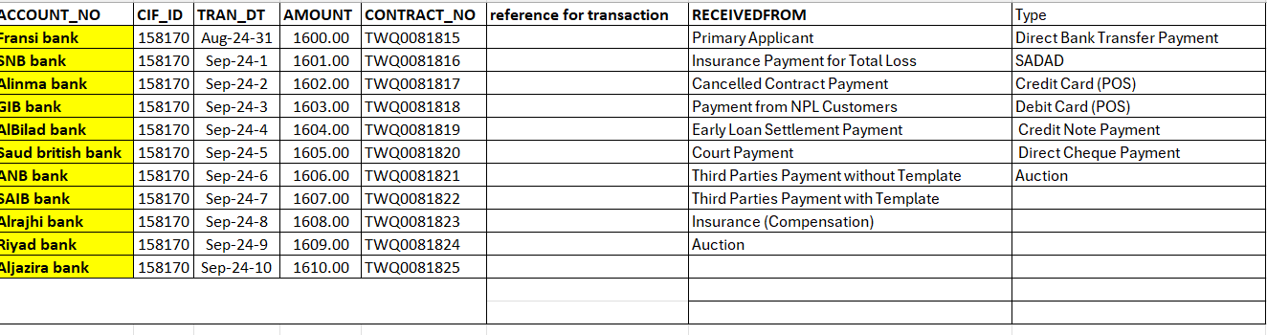

Worksheet details:
File name =Murabaha Working Sheet
Sheet name = DayN-File Upload

